Section 1.3 Extra Practice
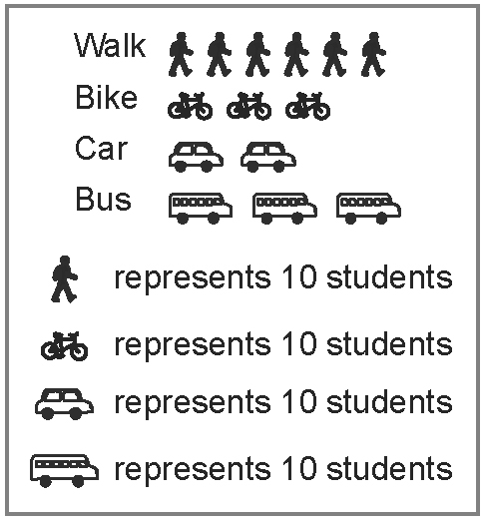
1. This graph shows how students get to school.
a) Is a pictograph effective to display the data about
how students get to school? Explain.
b) Is the data represented accurately? Explain.
c) What improvement(s) do you recommend for
representing the data?
d) Is the graph informative? Make a suggestion
for making it more informative.
e) Recommend another type of graph to represent the data. Give an advantage of using this graph.

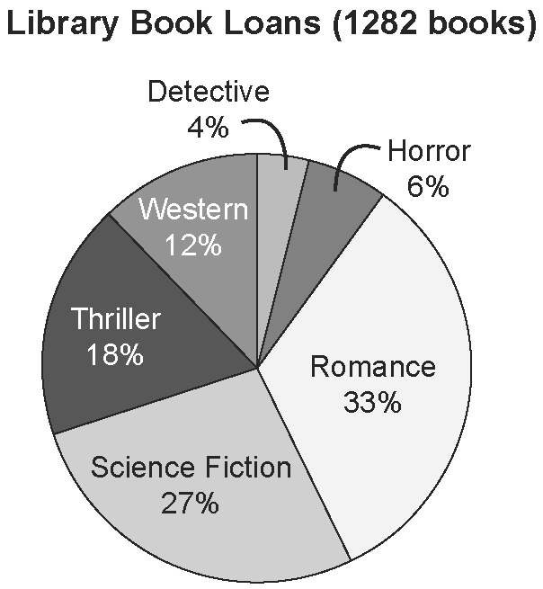
2. The school librarian wants to order books based
on the most popular genres. After recording the
book loans for a period of two months, she
presented the data in a circle graph.
a) Is this graph an effective way to help the librarian
order books based on popular genres? Explain.
b) If the librarian displayed the data on a bar graph,
what information would be communicated more
easily?

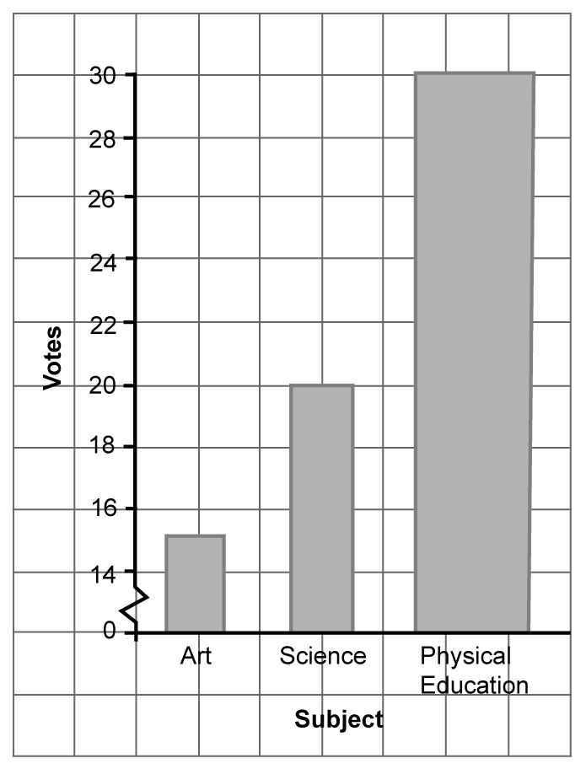
3. Critique this graph using the three factors you
learned about in this section. In your critique,
suggest any improvements to the graph.

Use a table such as the one shown here to
organize your answer.
Factor | Critique
a)
b)
c)

