Chapter 1 Test
For #1 to #5, choose the best answer.

1. Which type of graph is best for showing changes in data over time?
A bar graph B circle graph C line graph D pictograph

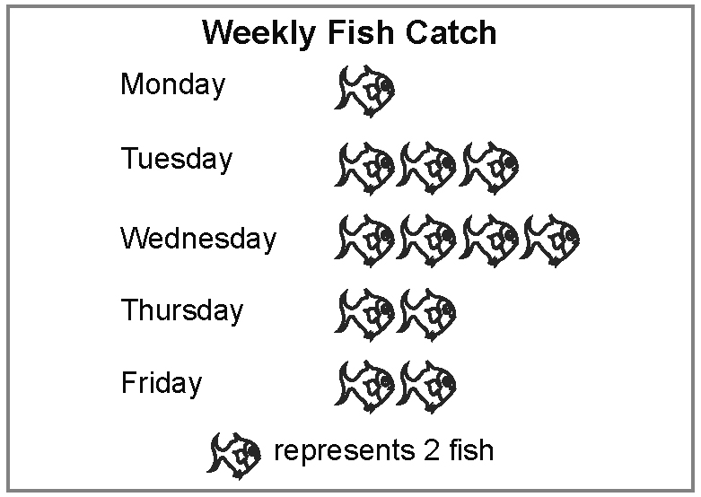
2. What type of graph is this?
A bar graph
B circle graph
C line graph
D pictograph

3. Which type of graph uses percents to compare categories to the whole?
A bar graph B circle graph C line graph D pictograph

4. Bill represented the data about hours of sunshine in several cities using a bar graph. How is this graph misleading?
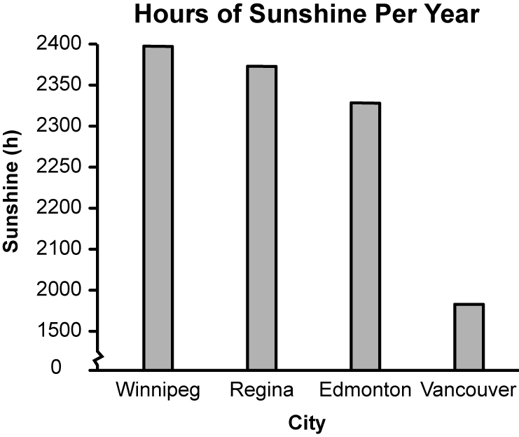
City | Sunshine (h)
Winnipeg | 2379
Regina | 2367
Edmonton | 2305
Vancouver | 1920

A The bars on the graph are not wide enough.
B The horizontal scale is not labelled properly.
C The intervals on the vertical scale are not equal.
D The scale starts at 0.

5. Which type of graph is best used to compare this data across categories?
A bar graph
B circle graph
C line graph
D pictograph

Wake-Up Time | Grade 8 Students
6:30 a.m. | 12
7:00 a.m. | 34
7:30 a.m. | 28
8:00 a.m. | 16

Short Answer

6. a) Redraw the bar graph in #4 to display the data accurately.
b) State two conclusions you can make based on the graph.
c) State an advantage of representing the data on a bar graph.

7. Todd recorded the results of a survey of grade 8 students about what kind of movies they like best.
a) Display the data using a circle graph.
b) Display the data using a bar graph.
c) Which graph best shows the most popular type of movie? Explain.
d) Which graph best shows that comedy is twice as popular as drama? Explain.

Movie Category | Votes
Comedy | 36
Drama | 18
Action | 26
Romance | 20

Extended Response

8. Two teams are competing for a trophy based on the most wins over four seasons.
a) Create a graph to display their records over the past four seasons.
b) Use the same data to create a graph that is misleading. Explain how it is misleading.

Team | Games Won
Team | Season 1 | Season 2 | Season 3 | Season 4
Thunder Hawks | 38 | 32 | 43 | 29
Range Riders | 35 | 37 | 28 | 41

