Chapter 1 BLM Answers

BLM 1–1 MathLinks 8 Scavenger Hunt
1. Chapter 4 Understanding Percent
2. Integers 3. page 442 4. Chapter Opener
5. a) The purpose is to make connections
between the math and the real world or to what
you already know. b) The purpose is to make
connections with math and personal experiences.
6. 3 7. a) the beginning of an activity called
Explore the Math b) an Example
8. a) Key Ideas: It provides the summary of the
main new concepts. b) Communicate the Ideas:
Students talk or write about the concepts to
make sure they understand the ideas.
9. a) Check Your Understanding
b) Practise, Apply, and Extend
10. Problem Solving 11. a) Understand b) Plan
c) Do It! d) Look Back
12. a) Model It b) Draw a Diagram c) Make an
Organized List or Table d) Work Backwards
e) Guess and Check f) Look for a Pattern
g) Estimate and Check h) Solve a Simpler
Problem i) Identify All Possibilities j) Use a
Variable k) Solve an Equation l) Make an
Assumption 13. Foldable
14. Math Games and Challenge in Real Life
15. Rolling Ratios 16. Life of a Bush Pilot
17. a) Chapter Review and Practice Test
b) They help review the material in a chapter to prepare for a test.
18. a) Review of Chapters 1 to 4 and a Task
b) at the end of Chapters 8 and 12
19. Glossary; page 517
20. Index: It provides an alphabetical list of the
book’s contents, with page references.
BLM 1–2 Chapter 1 Math Link Introduction
1. a) Rap was the favourite type of music.
b) Classical was the least favourite type of music.
c), d) Answers will vary. Look for a comparison between students’ data and the data presented on the circle graph. Example: No, my classmates prefer country music to rap music.
2. a) Answers may vary. Example: $18 000
b) Answers may vary. Example: CD sales dropped from 152 000 in 2006 to 120 000 in 2007.
c) Answers may vary. Example: Over time, CD and DVD sales are likely to continue to drop, given the popularity of online music and movies.
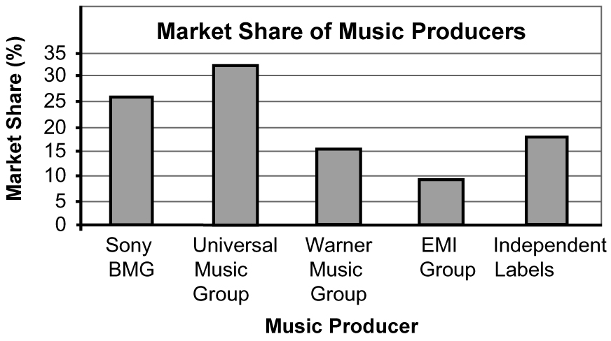
3. a)

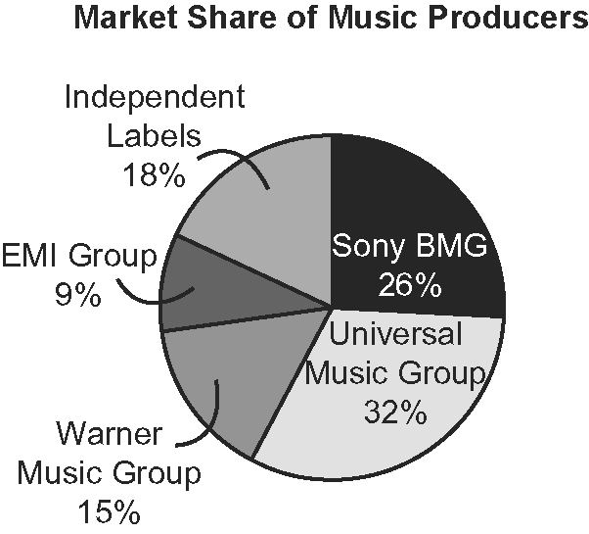
b)

c) Circle graph. It lets you compare the percent of each producer’s market share to the entire market.
BLM 1–3 Chapter 1 Get Ready
1. a) 9
b) Answers will vary. Example: The location of the axes will change. The number of books will be along the x-axis; the type of books will be along the y-axis. The number of books for each bar will stay the same.
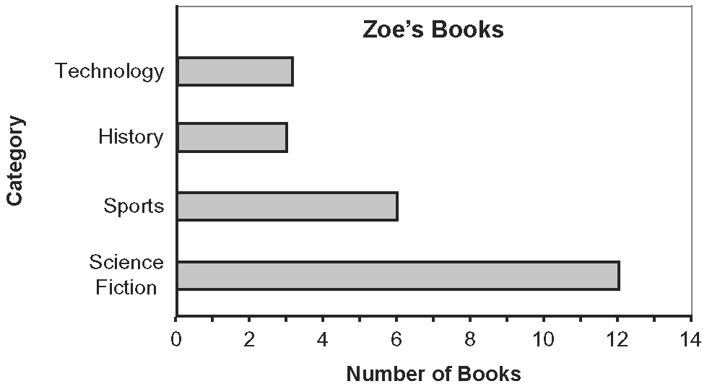2. a) 4 b) 10
c) Answers will vary. Example: Who has the most books in total? They have the same number of books.
3. a) Chat Lines, 10 h b) 7.4 h c) 75%
d) Answers may vary. Example: No, because there is no legend so the reader would not know what each sector of the graph represented.
4. a) July b) between April and May
c) Answers will vary. This could be either between June and July or July and August.
d) Answers will vary. Example: Yes, the trend will continue because of the seasons.
5. a) 40 b) 150
c) Answers may vary. Example: I added the total of full T-shirts and multiplied that by 10. Then, I added the half T-shirts and multiplied that by 5. Then, I added the two figures together.
BLM 1–4 Chapter 1 Warm-Up
Section 1.1
1. circle graph 2. 20%

3. Answers will vary. Example: 25% of students prefer hockey or hockey and soccer are the most popular sports.
4. bar graph 5. 24 6. one quarter 7. 180°
8. 30, 35, 40, 45, 50, 55, 60
9. 20, 40, 60, 80, 100, 120, 140, 160, 180, 200
10. 100, 125, 150, 175, 200, 225, 250, 275, 300
Section 1.2
1. the types of video games preferred by 200
students
2. Answers may vary. Example: appears to be
the same information as the graph in #1
3. 34. Answers may vary. Examples:
• The circle graph is more precise because it involves a calculation, whereas you are estimating when using the bar graph.
• The bar graph shows this information more clearly using the height of the bar. You would have to calculate 17% of 200 to get this information from the circle graph.
4. A line graph would not be useful since the data
do not show changes over time.
5. a pictograph 6. 25 7. 60
8. a) 7 b) 8.4 or 9. 90° 10. 270°
Section 1.3
1. Charlottetown: 5, Québec City: 7, Toronto: 4
2. Answers will vary. Example: It looks as though
Québec City is more popular than the other two destinations put together. It looks like this because the graph does not start at zero so the bars are comparatively shorter than they otherwise would be.
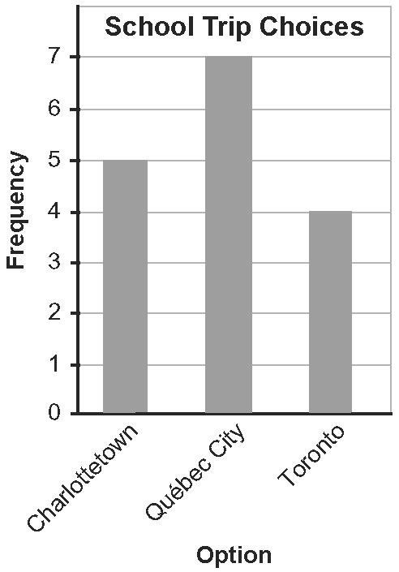
3.

4. Answers will vary. Example: More students do
prefer Québec City over each of Charlottetown and
Toronto; however, the total number of students
who prefer Charlottetown and Toronto is greater
than those who prefer Québec City.
5. Answers will vary. Example: A pictograph
could be used to clearly show how many students
prefer each choice.
6. Answers may vary. Example: The visuals
should be the same size and spaced evenly apart.

7. 0. Answers may vary. Example: If the vertical
scale does not start at zero and is not continuous,
the data may be distorted.
8. Look for either one of the following symbols.
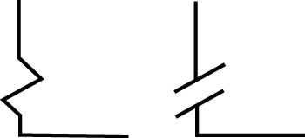
9. Answers will vary. Example: The chef should use each symbol to represent the same number of sales. 10. 180°

BLM 1–5 Chapter 1 Problems of the Week
1. Answers will vary. Expect students to choose
an appropriate graph for two situations. Example:
a) double bar graph b) circle graph
c) bar graph or pictograph. Note that a circle graph would likely be inappropriate since students may choose from a wide variety of flavours. d) bar graph or pictograph
2. a) The graph is distorted. Look for an
explanation such as the following: The graph
creates the impression that Dana spent more
time doing homework than being with friends.
b) Answers may vary. Example: Dana could use the graph to her advantage by giving the misleading impression that she spent more time on homework than either of the other activities.
c) Look for a circle graph, bar graph, or pictograph.
3. a) 140°
b) Look for a graph based on the following data:

Score Range | Number | Percent of Total | Central Angle
0–59 | 4 | 22% | 79°
70–79 | 7 | 39% | 140°
80–89 | 5 | 28% | 101°
90–100 | 2 | 11% | 40°

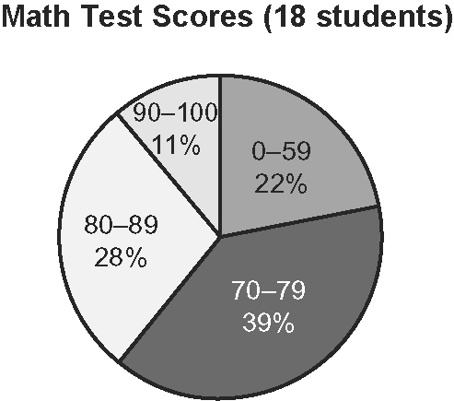
c) Answers may vary. Students should support their opinion. Examples:
• It is an unfair way to represent the data because the scores from 50–59 were put together with scores below 50.
• The graph represents the data accurately. Each sector is labelled with the category and the percent, and the title includes the number of students.

4. a) Answers may vary. This graph is misleading
for several reasons:
• The title for Business is larger than the other titles.
• The bar for Business is twice as large as the other bars.
• The title may cause people to draw false conclusions.
b) Look for improvements such as the following:
• Make all titles the same size font.
• Make all bars of equal width.
• Change the title to reflect the data accurately. Example: Business Graduates Represent 22% of All Graduates
BLM 1–7 Compare a Bar Graph and a Pictograph
Organizers may differ. Look for at least two similarities and differences.
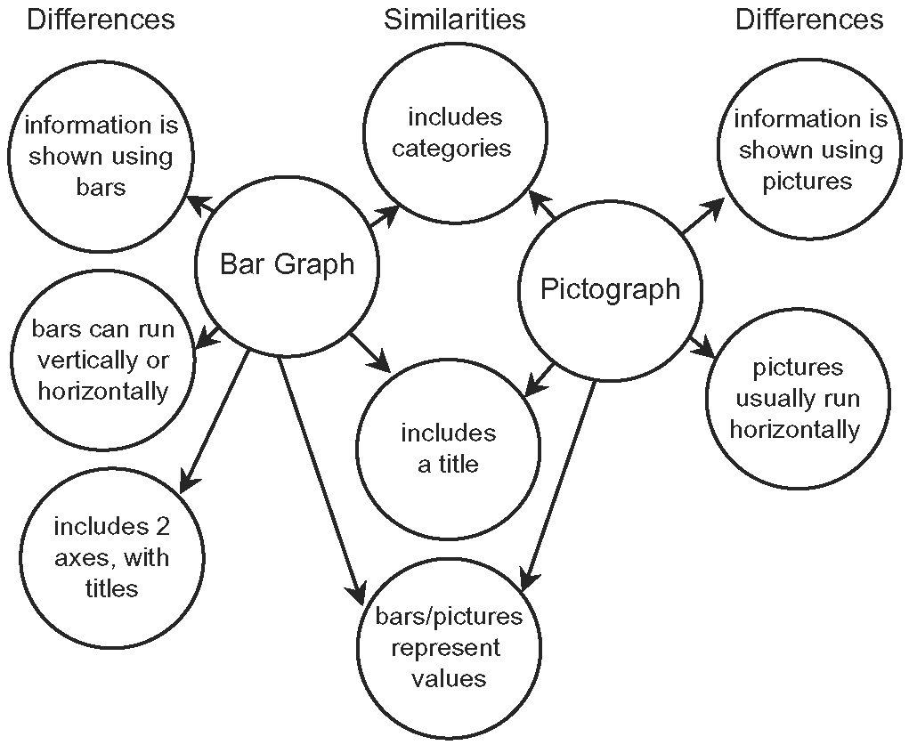
BLM 1–8 Section 1.1 Extra Practice
1. pictograph 2. bar graph 3. circle graph
4. double bar graph 5. line graph
6. a) circle graph b) A circle graph would show
each category as a percent of all of the students.
7. a) line graph b) A line graph would show the
change in growth over time.
8. a) line graph; data is continuous over time
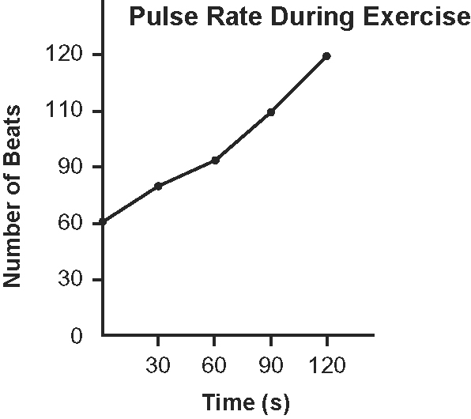
b)

c) Yes. A second set of data could be added to the line graph to make a double line graph.

BLM 1–9 Section 1.1 Math Link
1., 2. Answers will vary. Look for a survey
question, a tally chart, and a frequency table.
Example:

Type of Music | Tally | Frequency
Rap |  | 8
Country |  | 6
Classical |  | 1
Rock |  | 3
Punk |  | 10
None of the above |  | 2

3. Graphs will vary. Example:
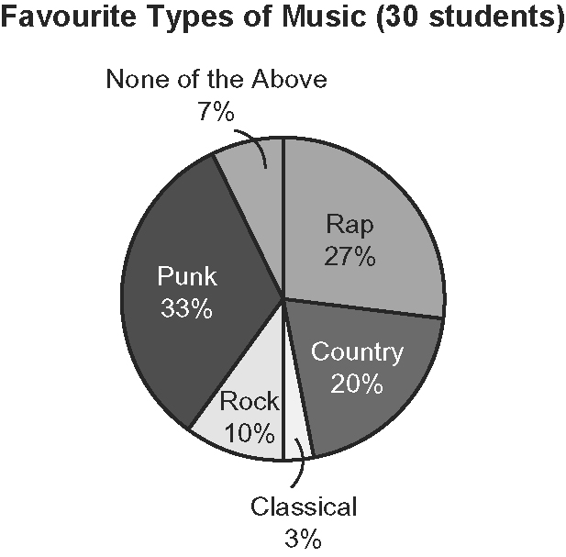
4. Answers will vary.
a) Example: An advantage of a circle graph is that you can easily see what percent of the class prefers each type of music.
b) A disadvantage of a circle graph is that you must perform calculations to determine how many students prefer each type of music.

BLM 1–10 Section 1.2 Extra Practice
1. Look for the following ideas in any order.
a) distorting the scale
b) distorting the information by using visuals of different sizes
2. a) Company A sold 105 houses. Company B
sold 115 houses.
b) Company B. The bar for B looks two times as
tall as the bar for A. The scale on the vertical axis
creates this impression.
c) The graph should be redrawn with a continuous scale that starts at zero.
d) Look for an accurate conclusion. Example: Company B sold ten more houses than Company A in one month.
3. a) Look for a graph that distorts the scale or
uses bars of different widths. See example graph on next page.
b) Answers will vary depending on the graph. Example based on the graph in a): There is a break in the vertical scale.

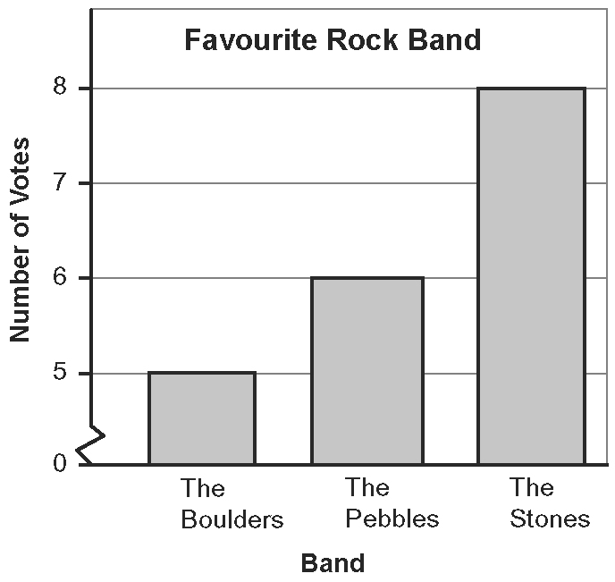
BLM 1–11 Section 1.2 Math Link
1. a), b) Answers will vary depending on artist
chosen.
c) Arguments will vary. Example: Daniel Powter had the top sales for a digital song in 2006.
2. a) Graphs will vary. Example:
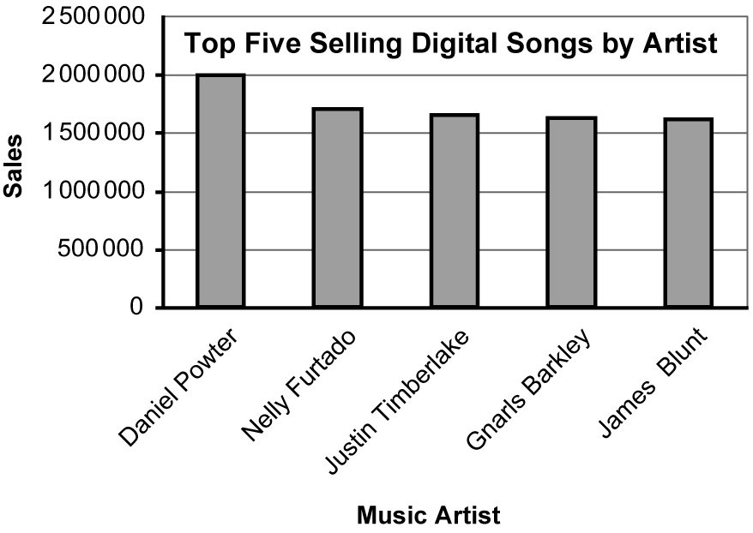
b) Answers will vary. Example: An opposing argument could be that the sales of digital songs of the top five artists are quite close.
c) Answers will vary. Example based on b): The graph could be redrawn using bars twice as wide for sales of the other artists or the intervals could be decreased so that the bars all appear to be closer in height.
BLM 1–12 Section 1.3 Extra Practice
1. Answers may vary. Examples:
a) Yes, a pictograph is an appropriate way to
represent data about how students get to school.
b) No, the graph creates the impression that most students get to school by bus.
c) Make all the symbols the same size and uniformly spaced apart on the line.
d) Yes, the graph is informative and easy to read. It would be more informative if there was a title. Add a title such as How Students Get to School.
e) Answers will vary. Example: A circle graph would indicate the percent of the whole that each category represents.
2. a) Answers may vary. Example: Yes, the circle
graph clearly shows the popularity of different
genres.

b) A bar graph would indicate the actual number of book loans per genre.
3. Answers may vary for the critique. Sample
answers are provided.
a) Graph type: The bar graph is appropriate to display this data.
b) Graph format: The graph is misleading because the scale is distorted and the size of the bars is distorted. Redraw the graph with a continuous scale that starts at zero and make all of the bars the same width.
c) Graph usefulness: The title is missing so the graph is less informative than it could be. Add a title such as Grade 8 Favourite Subjects.

BLM 1–13 Section 1.3 Math Link
1. The circle graph shows what percent each
performer’s sales are of the total sales.
2. The double bar graph shows the number of
sales for each performer in each month of a six-
month period.
3. Answers will vary. Example: Performer A
seems to be gaining popularity, and could well be
the better choice even though performer B has
sold more albums over the six-month period.
BLM 1–14 Chapter 1 Test
1. C 2. D 3. B 4. C 5. A
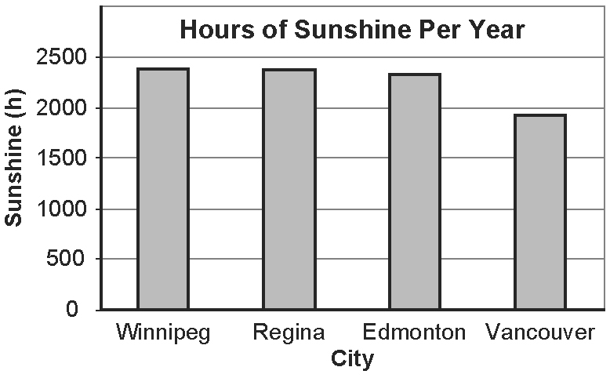
6. a)

b) Answers will vary. Look for two conclusions such as the following:
• Vancouver has the fewest hours of sunshine per year.
• Winnipeg, Regina, and Edmonton have about the same number of hours of sunshine per year.
c) Answers will vary. Look for one advantage such as the following: A bar graph makes it easy to compare data across categories.
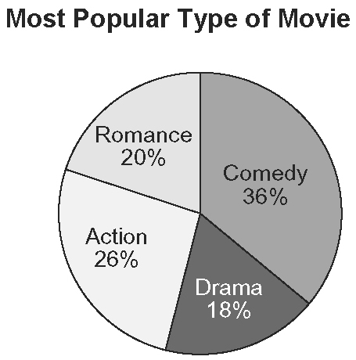
7. a)

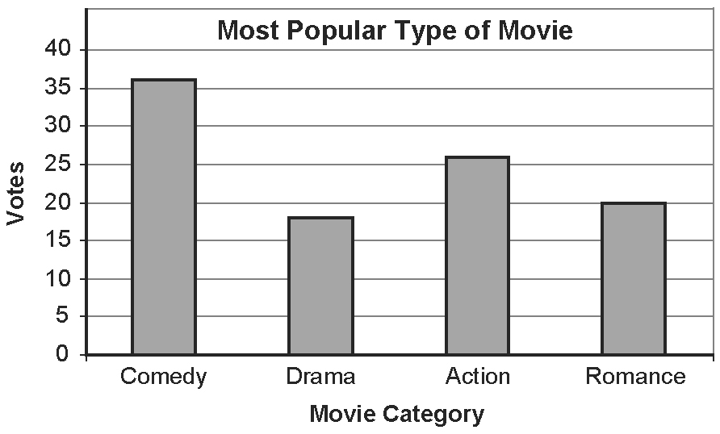
b)

c) the circle graph because it compares each category to the whole
d) the bar graph because it is easy to compare the numbers (36 to 18)
8. Answers will vary.
a) Expect to see a graph that represents the data appropriately.
b) Expect to see a graph that misrepresents the data. Make sure students explain how their graph is misleading.
BLM 1–15 Chapter 1 Wrap It Up!
1.–3. Topics and resulting data tables will vary.
Example:

Artist | Song | Sales  ($ millions)
Daniel Powter | Bad Day | 1.94
Gnarls Barkley | Crazy | 1.63
Fray | Over My Head | 1.52
Sean Paul | Temperature | 1.5
Hinder | Lips of an Angel | 1.37

4. a) Answers will vary. Example: Bar graph. The
top five digital songs are close in total sales.
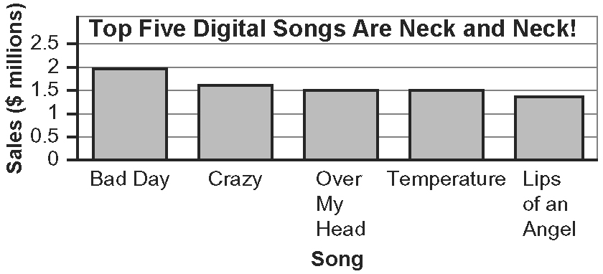
b)

5. Answers will vary.
a) Example: Bar graph. Bad Day is very clearly the top seller.
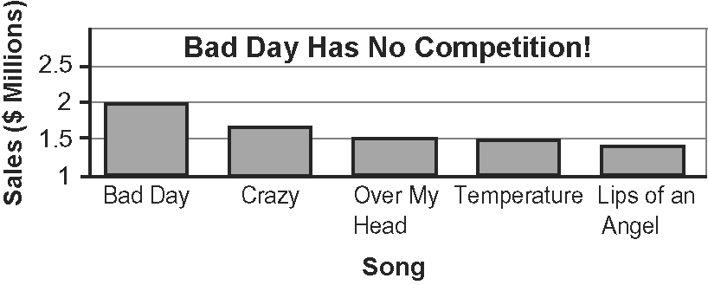
b)

6. a) Answers will vary. Example: Top Five Digital Songs Are Neck and Neck! The headline reinforces that the top five digital songs are close in total sales.
b) Answers will vary. Example: Bad Day Has No Competition! The headline highlights that Bad Day is the top seller.

