Writing Ratios
A ratio is a comparison of quantities that have the same units. The order of the words in a sentence indicates the order of the numbers in the ratio. Ratios can be written in several ways.

The ratio of black balls to the total number of balls can be expressed using:
Words: three compared to nine or 3 to 9
Ratio Notation: 3 : 9
Fractions:

1. For the diagram shown above, write each ratio. Express your answer three different ways.  a) black balls to white balls  b) black balls to the total number of balls | c) white balls to total balls  2. For the diagram shown above, what does each of the following ratios represent?  a) 6 : 3 b) 6 : 9
Equivalent Fractions
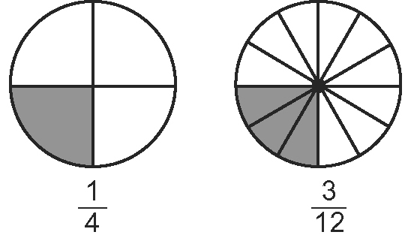

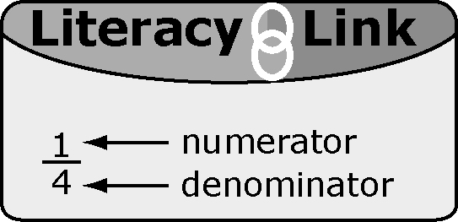
The fractions and are equivalent fractions.
They are different names for the same fraction.

Two fractions are equivalent if you can multiply or divide the numerator and denominator of one fraction by the same number to get the second fraction. | × 3 ÷ 3  × 3 ÷ 3

3. Are the following fractions equivalent? Show how you know.  a) and b) and  c) and d) and  4. List two equivalent fractions for each of the following.  a) b) c) d) | 5. Identify the missing value to make an equivalent fraction. Show how you calculated each value.  a) b)  c) d)
Comparing Quantities

A fraction can represent part of a whole.
One-half of the rectangle is shaded.

The top line is of the
bottom line.
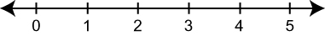
Think of the number line labelled as .
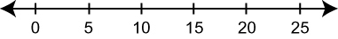
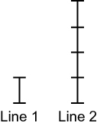
Think of the number line labelled as .
How could you label a number line to represent ?
You can use a multiplier to compare two quantities.
In the diagram, Line 2 is 4 times as long as Line 1.
The multiplier of Line 2 compared to Line 1 is 4 or the ratio .

6. Give three equivalent fractions that compare the top line to the bottom line.
a)

b)

7. What is the multiplier from Figure 1 to Figure 2?
a) | 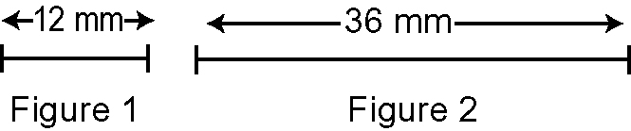 | b) | 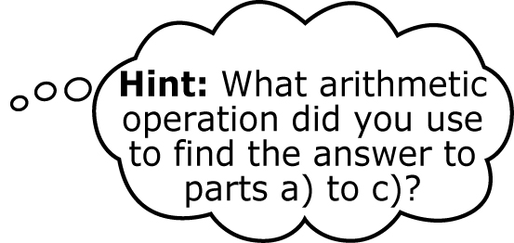  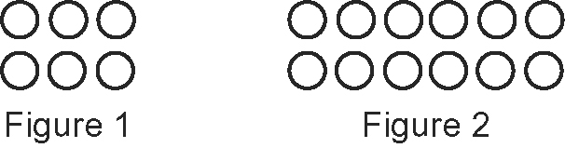
c) | 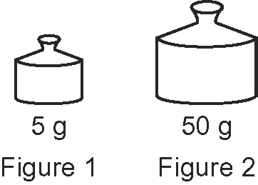 | d) | 