Chapter 2 Warm-Up
Section 2.1

1. What kind of graph is this?  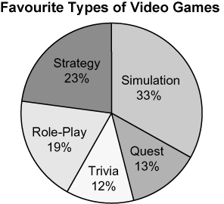  2. A librarian kept track of the number of fiction and non-fiction books taken out of the library.  a) Sketch a graph you could use to display this data.  b) Justify your choice.  3. Use an organizer to compare a bar graph and a pictograph.    4. a) What does this symbol  mean when it is  on a graph?  b) When might you use it? |  | 5. How could this graph be misleading?  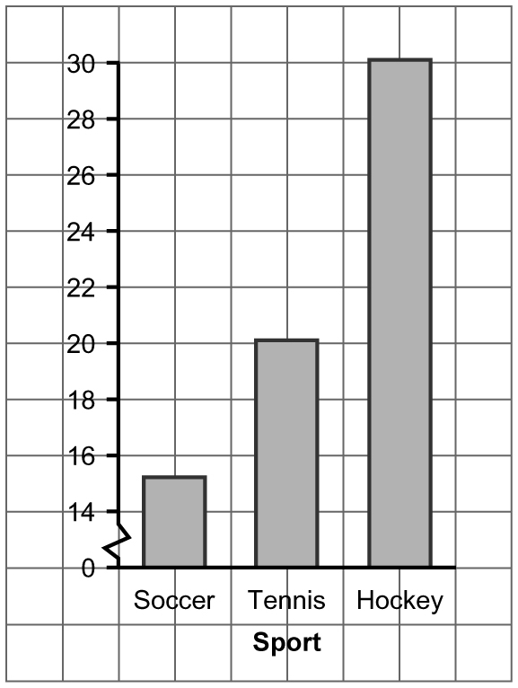  Mental Math  6. You want to show on a circle graph. What fraction of the circle graph do you colour?  7. You want to show on a circle graph. How many degrees do you need for your sector angle?  8. You want to show on a circle graph. What fraction of the circle graph do you colour?  9. You want to show on a circle graph. How many degrees do you need for your sector angle?  10. You want to show on a circle graph. How many degrees do you need for your sector angle?
  Type of Book | Frequency
  Fiction | 1250
  Non-fiction | 5000
Section 2.2  1. What kind of graph is this?  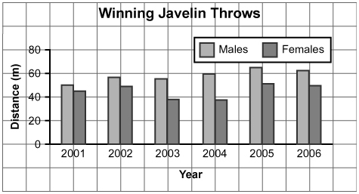  2. How can the format of a graph be distorted?  Use this visual to answer #3 to #5.  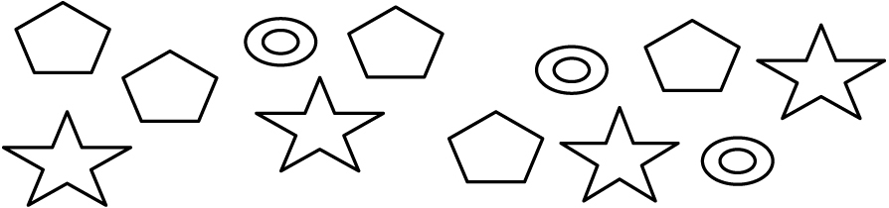  3. What is a two-term ratio of stars to circles? | 4. What shapes are represented by the ratio 4 : 5?  5. Write the three-term ratio comparing the stars, circles, and diamonds.  Mental Math  6. You want to show on a circle graph. What fraction of the circle graph do you colour?  7. You want to show on a circle graph. How many degrees do you need for your sector angle?  For #8 to #10, express the ratio as a fraction, a decimal, and a percent.  8. 5 : 40  9. 9 : 12  10. 14 : 28

Section 2.3

1. What kind of graph is this?  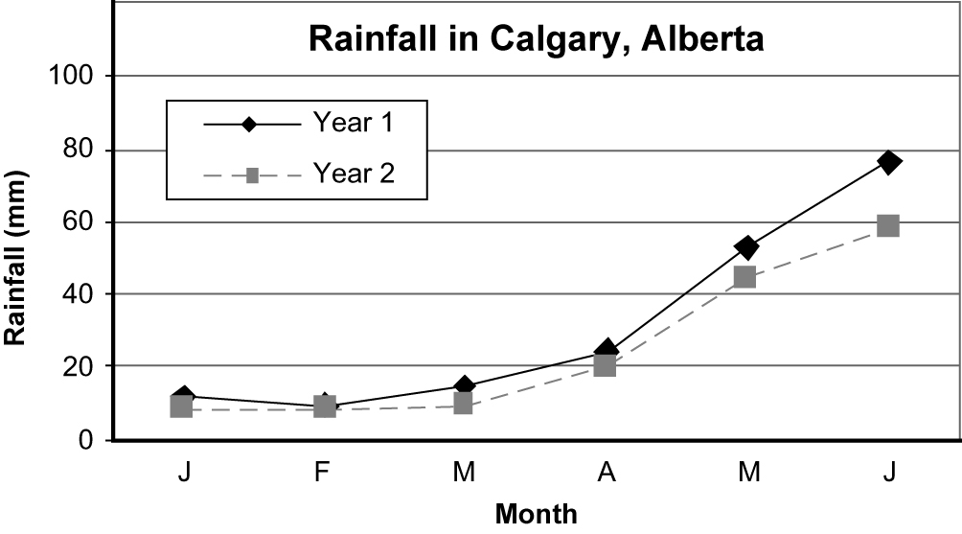  2. The graph in this advertisement shows the results of a taste test.  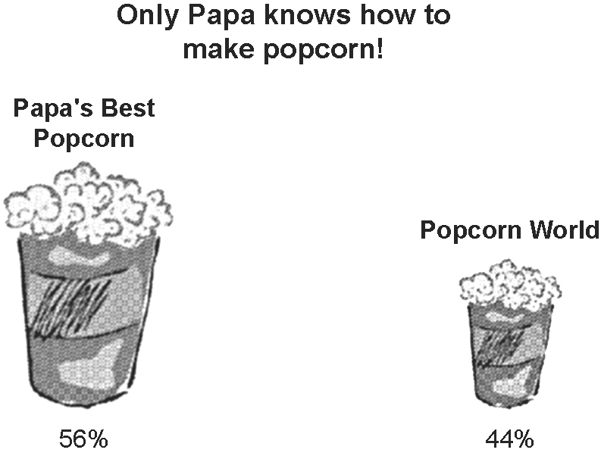  a) Which brand of popcorn seems to be the most popular? Explain.  b) How is the graph misleading?  c) How should the graph be redrawn to represent the data more accurately? | 3. Javier ran 600 m in 2 min. What is the unit rate?  4. Sesame butter costs $5.49 for  750 g or $1.99 for 250 g.  a) Estimate the cost per 100 g for each jar.  b) Calculate the better buy.  5. It takes you 10 min to keyboard one quarter of your 1000-word essay.  a) Determine the unit rate.  b) At this rate, how much could you type in 15 min?  Mental Math  6. One brand of pasta costs $0.99 for 700 g. Another brand costs $1.29 for 1250 g. Estimate the better buy.  For #7 to #10, mentally estimate the unit rate. Show your thinking.  7. Chris runs 200 m in 30 s.  8. A brand of dog food is priced 3 cans for $4.99.  9. Jess earns $75 for 7 hours work.  10. Juice costs $2.75 for 946 mL.

