Section 2.1 Math Link
This worksheet will help you with the Math Link on page 54.

Create a logo as part of the front of your invitation to the international meal.
A logo is an identifying symbol used in advertising.

1. Your logo must show each of the following ratios in its design:
• 4 : 3
• 2 : 3 : 4
Use colour or measurements on your logo to show each ratio.

Look at these examples of ratios.

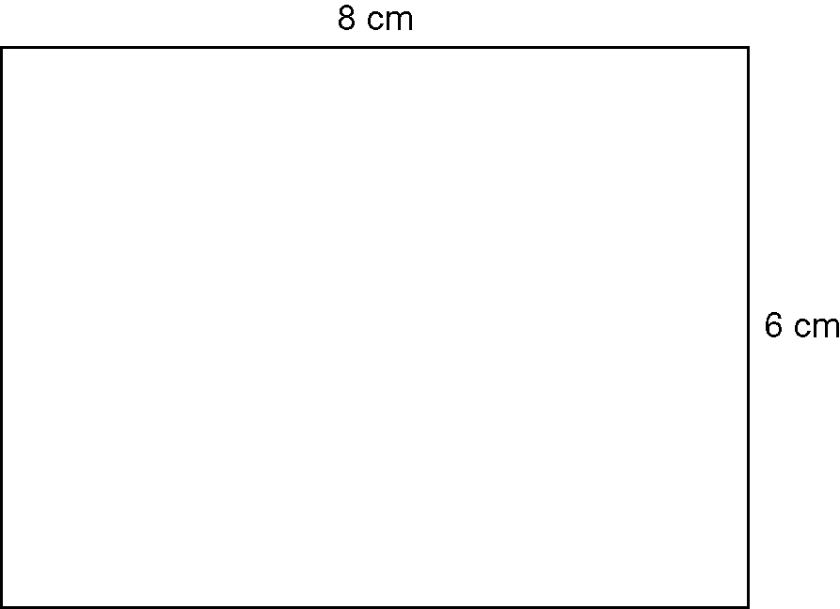 | 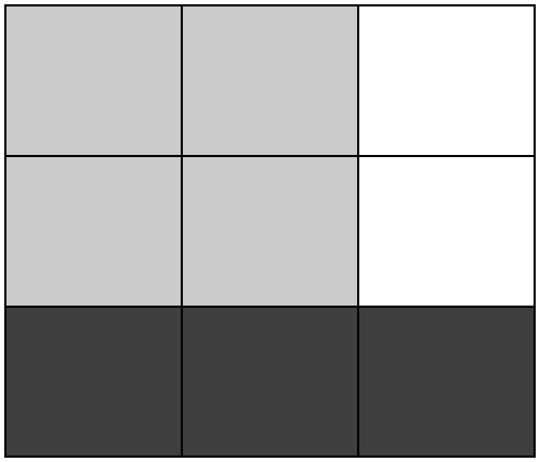
What is the length to width ratio?  ____________________ | What is the white to black to grey ratio?  ____________________

a) On your logo, how will you show the ratio 4 : 3?

b) How will you show the ratio 2 : 3 : 4?

2. Draw the logo on a 36 cm² section of centimetre grid paper.
• Consider using shapes made of straight lines.
• Decorate and colour your logo.
• Label the two ratios.

