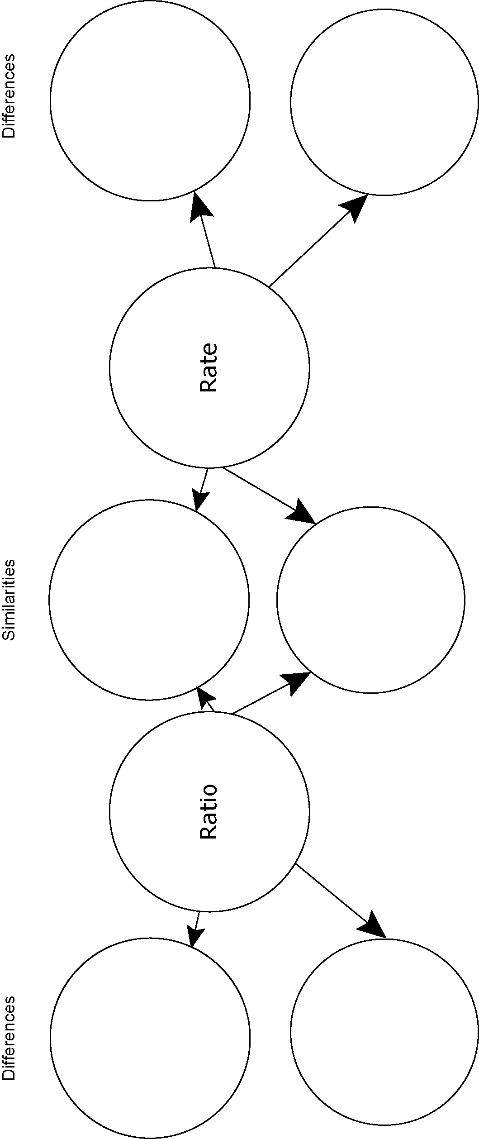
Compare a Ratio and a Rate

