Section 2.2 Math Link
This worksheet will help you with the Math Link on page 62.

Kheer is a traditional rice pudding made in India and Pakistan. Pakistani kheer tends to be thicker than the Indian version. Look at the recipe for kheer.

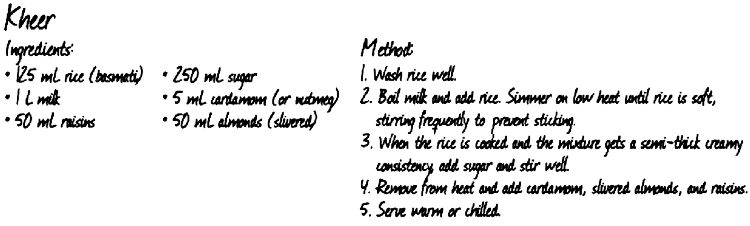

1. The recipe for kheer serves four people. Use the table on the following page and calculate the quantity of each ingredient that you need to serve 10 people. Use ratios or rates to support your reasoning.

The quantity of rice is done for you using ratios and rates.

Ratios | Rates
Step 1 Use ratios.  Step 2 Make an equivalent fraction.  × 2.5  × 2.5  The amount of rice needed to serve 10 is 312.5 mL. | Step 1 Find the unit rate.  ÷ 4  ÷ 4  Step 2 Multiply the unit rate by the number of servings.  31.25 × 10 = 312.5  The amount of rice needed to serve 10 is 312.5 mL.

Ingredients | Step 1 | Step 2
1 L milk
50 mL raisins
250 mL sugar
5 mL cardamom
50 mL almonds

2. Use your calculations in #1 to fill in the missing quantities in the table below.

Kheer
Ingredients | Amount to Serve 4 | Amount to Serve 10
rice (basmati) | 125 mL | 312.5 mL
milk | 1 L
raisins | 50 mL
sugar | 250 mL
cardamom (or nutmeg) | 5 mL
almonds (slivered) | 50 mL

