Chapter 2 Test
For #1 to #4, choose the best answer.

1. The ratio of Monica’s coloured pencils to Harry’s coloured pencils is 3 : 5. If Harry has 40 coloured pencils how many coloured pencils does Monica have?
A 16 B 21 C 24 D 32

2. Seven kilograms of salmon cost $101.50 at the fish market. What is the unit price of the salmon?
A $13.75/kg B $14.50/kg C $15.00/kg D $16.25/kg

3. What percent of the fish in the tank below are goldfish?
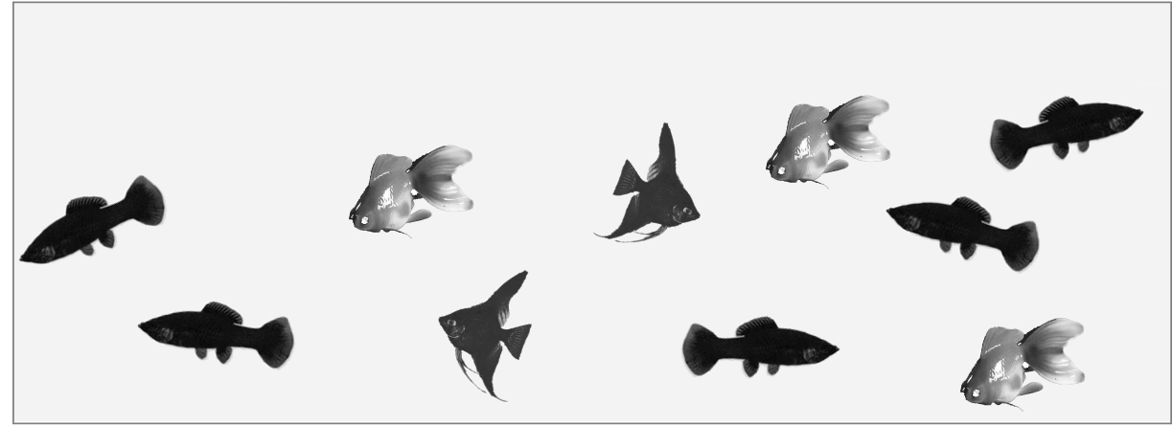
A 30%
B 36%
C 40%
D 48%

4. The food bank provides 28 cans of soup, 12 packages of pasta, and 15 cans of vegetables in each food basket. If there are 336 packages of pasta, how many cans of soup and vegetables will be needed to make food baskets?
A 392 cans of soup and 210 cans of vegetables
B 728 cans of soup and 390 cans of vegetables
C 784 cans of soup and 420 cans of vegetables
D 1568 cans of soup and 840 cans of vegetables

Short Answer

5. Use these coins to help you answer the following questions.

a) What is the ratio of quarters to dimes?  b) What is the ratio of loonies : total coins?  c) What is the ratio of loonies to dimes to quarters?  d) Identify two equivalent ratios for the answer in part a).  e) What percent of coins are dimes?  f) What fraction of the coins are quarters? | 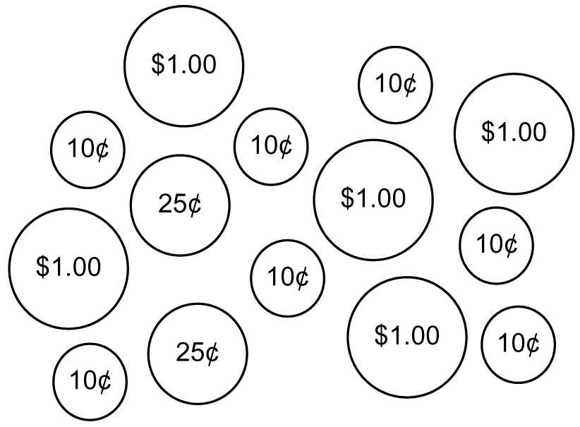

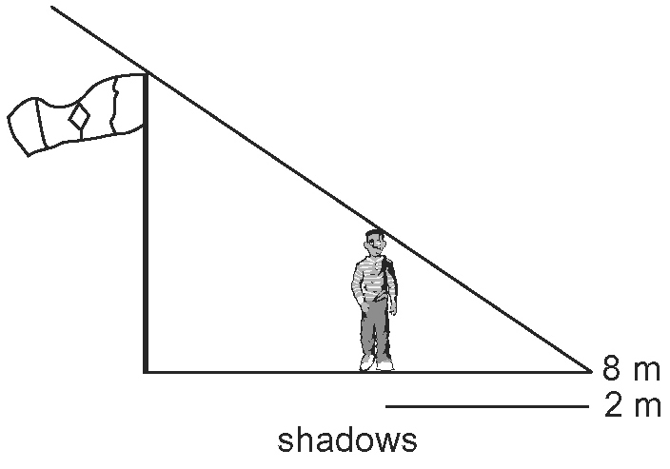
6. At noon, the end of Laura’s shadow
matches the end of the school’s flagpole
shadow. If she is 1.6 m tall, how tall is
the flagpole? Give your answer to the
nearest centimetre.

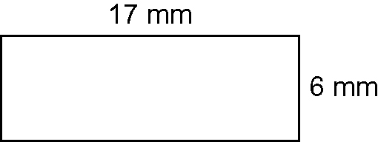
7. Ian made an enlargement of the rectangle
below using a multiplier of 2.5. What is the
area of the rectangle in the enlargement?

8. Determine the unit rate in each situation.
a) A cruise ship plans 21 808 meals for 376 passengers.
b) A pitcher allows 126 earned runs in 28 games.
c) A sprinter travels 200 m in 25 s.

9. Eve is shopping for soup. Her favourite brands are on sale. Brand A is priced $8.96 for 8 cans. Brand B is priced $11.89 for 12 cans. Calculate to find the better buy. Show your work.

10. Use proportional reasoning and a variable to solve each problem.
a) On a map, 1 cm represents 250 km. On the map, how many kilometres does 7 cm represent?
b) Four pens cost $4.96. What is the cost of seven pens?

Extended Response

11. Employer A pays $9.25/h for the first 30 hours and $15.00/h for overtime. Employer B pays $9.75 for the first 20 hours and $10.25/h for overtime. If you plan to work a 40-hour week, which employer pays a greater average hourly rate? Show your work.

12. A copier has settings to reduce an object by 50% or enlarge an object by 150%, 200%, or 300%. Explain two different ways to create a line 18 cm in length from a line 4 cm in length. Show your work.

