Chapter 2 BLM Answers

BLM 2–1 Chapter 2 Math Link Introduction
1. a), b) Answers will vary.
2. a) Answers may vary. Example: Use rounding
and divide the attendance by the number of
pavilions.
b) 500 000 ÷ 40 ≈ 12 000. An estimated 12 000 people visited each pavilion.
c) Look for at least one assumption. Example: Approximately the same number of people visited each pavilion.
3. a) Answers may vary. Example: Divide $12 by
30.
b) The cost per person is $0.40.
c) 12 000 × 4 = 4800. The estimated cost to
serve 12 000 people is $4800.
d) Multiply the average number of visitors by the cost per person.
4. a)–c) Answers will vary. Look for the
estimated cost for each of 2 dishes for 10 visitors.
5. a) Answers may vary. Example: 10 000
b) 10 000 : 12 000 or 5 : 6
c) , 0.83, 83%
BLM 2–2 Chapter 2 Get Ready
1. a) 3 to 6; 3 : 6;
b) 3 to 9; 3 : 9;
c) 6 to 9; 6 : 9;
2. a) white balls to black balls
b) white balls to total balls
3. a) Yes, because reduces to
b) Yes, because reduces to
c) No, because there is no common multiple of the numbers in the two fractions
d) Yes, because reduces to
4. Answers will vary. These are examples.
a) b) c) d)
5. a) 15 b) 6 c) 15 d) 4
6. Answers will vary. These are examples.
a) b)
7. a) 3 b) 2 c) 10 d)

BLM 2–3 Chapter 2 Warm-Up
Section 2.1
1. circle
2. a) Look for a sketch of a circle graph with
fiction taking up of the circle and non-fiction
taking up of the circle.
b) Answers may vary. Example: A circle graph shows the comparative number of books of each type taken out.
3. Organizers may differ. Look for the following
information.
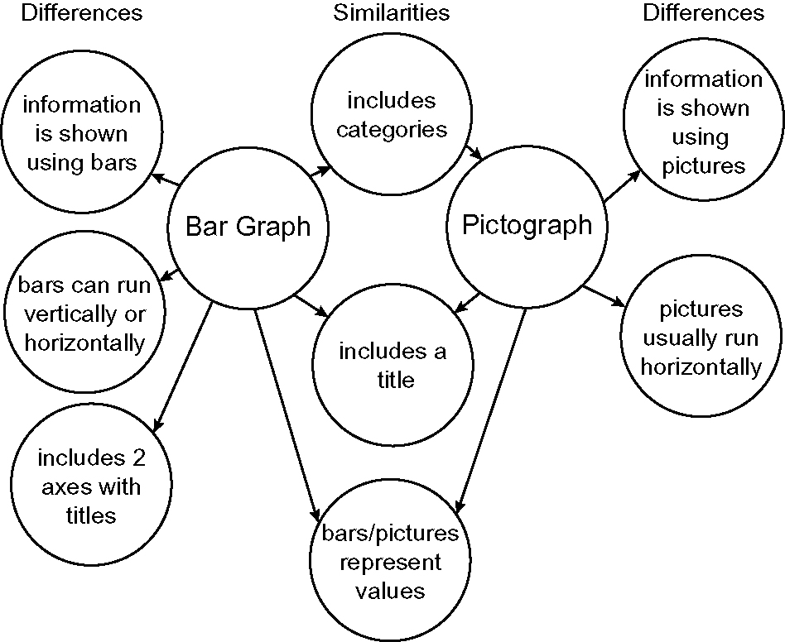
4. a) The length of the axis has been shortened.
b) Answers may vary. Example: You might use a break symbol when all of the data is well above a certain number.
5. Answers may vary. Example: The graph gives
the impression that hockey is at least four times
as popular as soccer. The data indicates that
hockey is twice as popular as soccer. Students
should note that the scale is distorted and the
graph is missing a title.
6. 7. 180° 8. 9. 270 10. 144°
Section 2.2
1. double bar graph
2. Answers may vary. Example: The format of a
graph can be misleading if it distorts the scale or
the information by using visuals of different sizes.
3. 4 : 3 4. stars to diamonds 5. 4 : 3 : 5
6. 7. 90° 8. , 0.125, 12.5%
9. , 0.75, 75% 10. , 0.5, 50%

Section 2.3
1. double line graph
2. a) Papa’s Best Popcorn. It has the larger visual
and shows 56%.
b) Answers may vary. Example: The visual for Papa’s Best Popcorn is proportionally larger than the one for Popcorn World.
c) Answers may vary. Example: The two popcorn visuals should be close to the same size. The one from Popcorn World should be a little smaller, but not this much smaller.
3. 300 m/min
4. a) $5.49 for 750 g ≈ $5 for 700 g ≈ $0.70 per 100 g; $1.99 for 250 g ≈ $2 for 200 g ≈ $1 per 100 g
b) $5.49 for 750 g = $0.007 per g or $0.73 per 100 g; $1.99 for 250 g = $0.008 per g or $0.80 per 100 g. $5.49 for 750 g is the better buy.
5. a) 25 words/min b) 375 words
6. $0.99 for 700 g ≈ $0.15 per 100 g; $1.29 for
1250 g ≈ $0.10 per 100 g. The brand with the
larger amount is the better buy.
7. 200 m in 30 s ≈ 210 m in 30 s ≈ 7 m/s
8. $4.99 for 3 cans ≈ $4.80 for 3 cans ≈ $1.60
per can
9. $75 for 7 hours ≈ $10.50/h
10. $2.75 for 946 mL ≈ $2.75 for 1000 mL ≈
$0.003/mL or $3/L
BLM 2–4 Chapter 2 Problems of the Week
1. Answers will vary depending on the 10-speed
bike. Most 10-speeds have 52 teeth and 29 teeth
on the two larger pedal sprockets. The five
smaller wheel sprockets may have 28, 24, 20, or
17 teeth. The greatest ratio would be 52 : 17.
The smallest ratio would be 29 : 28. Larger ratios
are used when you are looking for speed on a
downhill ride and smaller ratios are used when
riding uphill or on rough terrain.
2. The ratio of 1 : 2 compares apples to peaches.
Kelsey picked 10 apples and 20 peaches. The
fractioncompares the number of one colour of
apple to the total number of apples.
b) Answers may vary. Example: No, Kelsey picked 10 apples out of 30 pieces of fruit. This does not represent 50% as the 1 : 2 ratio might suggest.
3. a) 16 : 20 or 4 : 5 or 80%
b) Answers may vary. Example: No, rates cannot be expressed as a percent because a rate compares two quantities measured in different units.
4. Answers may vary. Example: Although both
trees grew 0.5 m, if you compare the growth rate
of each tree, the spruce tree grew faster than the pine tree. Spruce tree: 3 ÷ 2.5 = 1.2 or 120%; Pine tree: 4 ÷ 3.5 = 1.14 or 114%. Therefore the spruce tree grew faster.

5. Think of the trip in equal time periods.

Distance (km) | 100 | 25 | 25 | 25 | 25
Time (h) | 1 | 1 | 1 | 1 | 1

6. The age ratio is 30 to 6 or 5 to 1. This age
ratio will never happen again. Explanations may
vary. Example: No other combination of ages that
are equivalent to a 5 to 1 ratio work out for a 25-
year difference in age.
7. The plane’s average speed over the first three
hours was 800 km/h.
BLM 2–5 Section 2.1 Extra Practice
1. a) F. A part-to-whole ratio compares one part
of a group to the whole group.
b) F. The ratio 3 : 1 can also be written as 3 to 1.
c) T
d) F. Two-term and three-term ratios compare quantities measured in the same units.
2. a) = 1 b) = 100
c) = 20 d) = 5
3. a) 10 : 15 b)
c) d) %
4. a) 3 to 4 or 3 : 4 b)
c) = 0.75 d) 0.75 = 75%
5. a) 9 to 10 or 9 : 10 b)
c) d) 0.9 = 90%
BLM 2–7 Compare a Ratio and a Rate
Organizers may differ. Look for the following information.

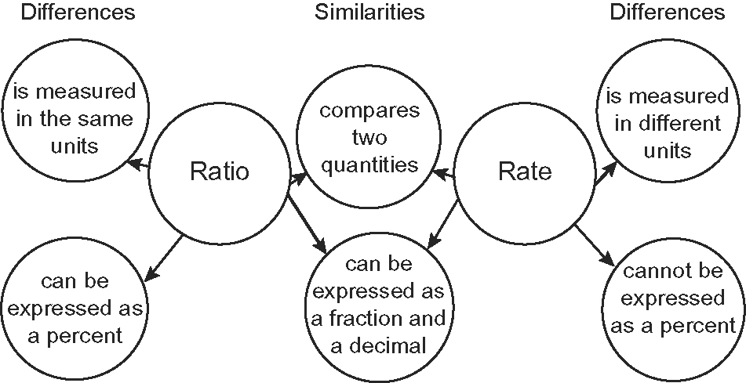
BLM 2–8 Section 2.2 Extra Practice
1. a) ratio b) rate c) rate d) unit rate
2. a) 5 h/day b) 47 tickets/day
3. a) $2.50/roll b) $2.45/roll c) Brand B
4. a) $0.78/pack b) $0.75/pack c) Brand B
5. a) Car A: 0.0704; 7.04 L/100 km
b) Car B: 0.1163; 11.62 L/100 km

BLM 2–9 Section 2.2 Math Link
1. Answers are shown for ratios and rates.
Ratio | Rate
milk: ;  x = 2.5 L  raisins: ;  x = 125 mL  sugar: ;  x = 625 mL  cardamom: ;  x = 12.5 mL  almonds: ;  x = 125 mL | milk: ;  .25 × 10 = 2.5 L  raisins: ;  12.5 × 10 = 125 mL  sugar: ; 62.5 × 10 = 625 mL  cardamom: ; 1.25 × 10 = 12.5 mL  almonds: ; 12.5 × 10 = 125 mL

2. rice: 312.5 mL; milk: 2.5 L; raisins: 125 mL;
sugar: 625 mL; cardamom: 12.5 mL; almonds: 125 mL
BLM 2–10 Section 2.3 Extra Practice
1. a) 80 km/h b) 12¢/copy
c) 28 students/class d) 12 mm/day
2. a) Multiply; 3 b) Divide; 11
c) Divide; 4 d) Multiply; 8
3. a) 90 b) 4 c) 16 d) 128
4. a) b) x = 84
c) There were 84 boys.

5. a) b) x = 80
c) Eighty cookies can be made.
BLM 2–11 Section 2.3 Math Link
1. The unit price is $0.63.
2. Answers will vary depending on the recipe that
students choose.
BLM 2–12 Chapter 2 Test
1. C 2. B 3. A 4. C
5. a) 2 : 7 b) 5 : 14 c) 5 : 7 : 2
d) Look for equivalent ratios for 2 to 7. Example: 4 to 14 and 8 to 28
e) 50% f)
6. The flagpole is 6.4 m tall.
7. 17 × 2.5 = 42.5; 6 × 2.5 = 15;
42.5 × 15 = 637.5 mm²
8. a) 58 meals/passenger
b) 4.5 earned runs/game c) 8 m/s
9. The unit price for Brand A is $1.12. The unit
price for Brand B is $0.99. Brand B is the better
buy.
10. a) 1750 km b) $8.68
11. Employer A pays $277.50 + $150.00 = $427.50. Employer B pays $195.00 + $205.00 = $400.00. $427.50/40 h is a rate of $10.69/h. $400.00/40 h is a rate of $10/h. Employer A pays a greater average hourly rate.
12. Look for any two correct solutions. Examples:
• 4 × 1.5 = 3 × 3 = 9 × 2 = 18
• 4 × 3 = 12 × 2 = 24 × 1.5 = 36 × 0.5 = 18
• 4 × 3 = 12 × 3 = 36 × 0.5 = 18
• 4 × 2 = 8 × 3 = 24 × 1.5 = 36 × 0.5 = 18

