Chapter 3 Math Link Introduction
This worksheet will help you with the Math Link introduction on page 79.

Playing Leader is a peg board game. The board design for Playing Leader includes squares and triangles. In this game, two players compete against each other. One player controls 13 green pegs, and the opponent controls the leader peg, which is a different colour. All of the pegs start at the top of the board and are moved one hole at a time along the lines on the board. The 13 green pegs may be moved left, right, or down. The leader peg may be moved left, right, up, or down. The green pegs try to surround the leader peg so that it cannot move to another position. The leader peg tries to capture all of the green pegs or advance to the bottom of the board. The leader peg captures a green peg by jumping over it to an empty space. Captured pegs are removed from the board.

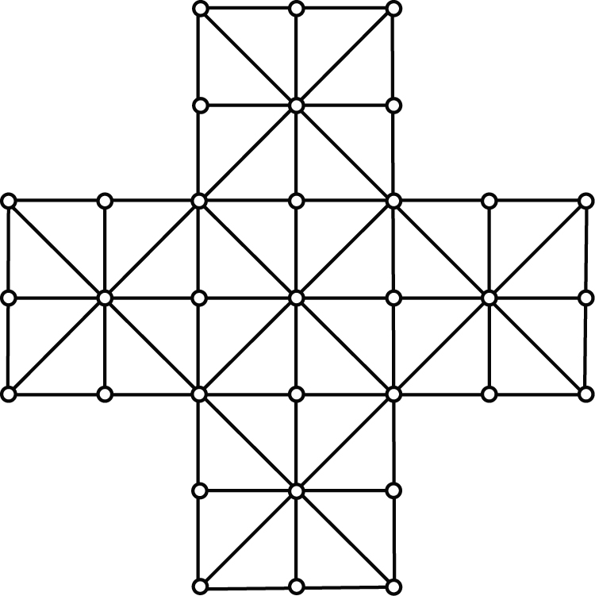

1. On the diagram above, show how to place the 13 green pegs and one leader peg so that the leader peg cannot move. Use coloured pencils or markers.

2. Start at a hole at the top of the board. Moving down one space at a time, what is the maximum number of moves you can make with one peg in a straight line vertically? Remember, vertically means up and down. _____

3. The horizontal or vertical distance between two peg holes is 5 cm.
a) Use a coloured pencil to outline all of the 5 cm × 5 cm squares you can find. How many are there? _____
b) Use a different coloured pencil to outline all of the 10 cm × 10 cm squares you can find that do not overlap. How many are there? _____
c) What is the total number of squares from a) and b)? ____ + ____ = ____

4. What words could you use to describe the triangles on the board, for example, isosceles, equilateral, scalene, acute, right, obtuse?
______________________________________________________________
In the space below, draw and label the triangle(s) to show why you used the words you did.

5. Determine the area of the game board in two different ways.
Method 1:
• What is the area of a 5 cm × 5 cm square? ____________________
• How many 5 cm × 5 cm squares are there on the board? Hint: Look at your
answer to #3a). ____
• What is the total area of the board? ____________________
Method 2:
• What is the area of a 10 cm × 10 cm square? ____________________
• How many separate 10 cm × 10 cm squares are there on the board?
Hint: Look at your answer to #3b). ____
• What is the total area of the board? ____________________
How does the total area using Method 1 compare to the total area using
Method 2? Explain your answer.
________________________________________________________________
________________________________________________________________
________________________________________________________________

