Factors
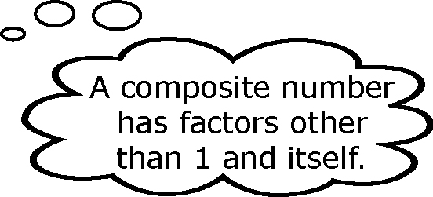
Factors are numbers that are multiplied to produce a specific product.
For example, 2 and 5 are factors of 10, since 2 × 5 = 10.
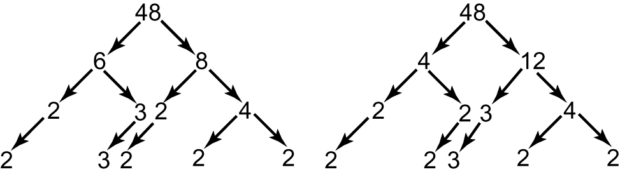
You can use a factor tree to write a composite number
as the product of its prime factors. Different factor
trees are possible for many composite numbers.
It depends upon which factor pair you start
with. Here are two possible factor trees
for the number 48.
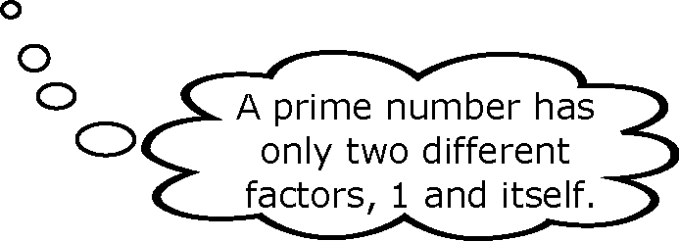
Therefore, 48 can be expressed
as a product of its prime factors.
48 is 2 × 2 × 2 × 2 × 3.
The factor pairs of 48 are
1 and 48 2 and 24 3 and 16
4 and 12 6 and 8

1. a) Use a factor tree to write 60 as a product of prime factors.  b) Make a factor tree for 60 that begins with a different factor pair. | c) List the factor pairs of 60.  2. List the factor pairs of 12. Show your thinking.
Perimeter and Area
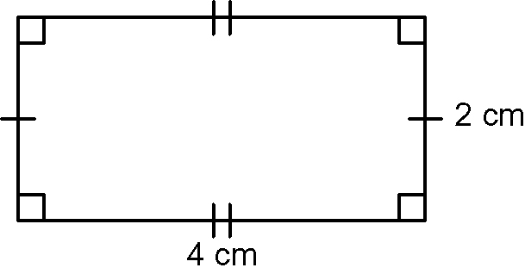
The perimeter of a polygon is a measure of the
distance around the geometric shape.
The area of an object is a measure of how much
space a two-dimensional surface covers.
Find the perimeter and area of the rectangle shown.
P = 2l + 2w A = lw
P = 2 × 4 + 2 × 2 A = 4 × 2
P = 8 + 4 A = 8
P = 12 The area is 8 cm².
The perimeter is 12 cm.

3. Find the perimeter of each of the following polygons.
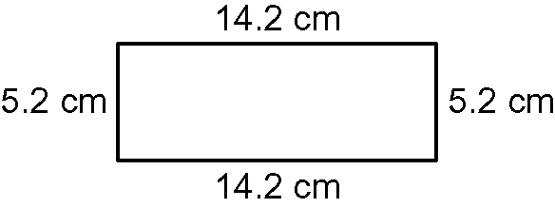
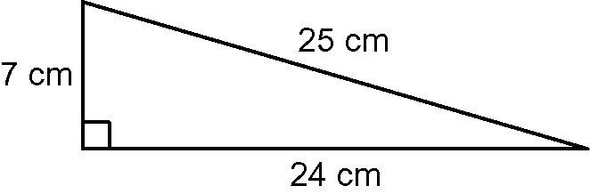
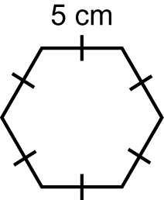
a) b) c)

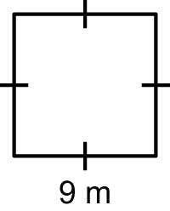
4. What is the area of each of the following polygons?
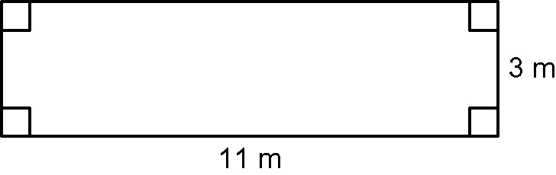
a) b)

Numbers Between
The whole numbers between 9 and 16 are 10, 11, 12, 13, 14, 15.
The difference between 9 and 16 is 7. 16 − 9 = 7
Half of this difference is 3.5. 7 ÷ 2 = 3.5
The number 12.5 is halfway between 9 and 16. 9 + 3.5 = 12.5

5. List the whole numbers between  a) 4 and 9 b) 25 and 36  6. What number is halfway between each of the numbers in #5? | 7. Is the number in the box closer to the number on the left or the number on the right? Show how you know.  a) 49 54 64  b) 81 91 100  c) 121 132 144
Solving Equations

An equation contains a variable, or unknown value. Simple algebraic equations can be solved using mental math. This method of solving is known as inspection.
x + 5 = 8
x = 3
To solve an equation, isolate the variable on one side of the equal sign. When undoing the operations performed on the variable, follow the reverse order of operations:
• subtract and add
• multiply and divide
5x + 7 = 22
5x + 7 − 7 = 22 – 7 Reverse the addition of 7 by subtracting 7.
5x = 15
Reverse the multiplication of the variable with 5 by
dividing by 5.
x = 3

8. Solve by inspection.  a) x + 4 = 11 b) 2x = 32 | 9. Solve for x.  a) 3x = 18 b) 4x + 1 = 13

