Chapter 3 Warm-Up
Section 3.1

1. Determine the missing value if each rate is equivalent.
a)
b)
2. Late in the day, a 3-m post casts an 8-m shadow. Using the same ratio, what length of shadow does a 12-m tower cast?
3. A fridge that runs for 300 h uses $15.14 in electricity. Calculate the hourly unit cost. Show the answer to four decimal places.
4. How far can a biker who pedals
at a rate of 25 km/h travel in 3.25 h?
5. Lemons cost 3 for 99¢. What is their unit price?

Mental Math
6. You want to show on a circle graph. What fraction of the circle graph do you colour?
7. You want to show on a circle graph. How many degrees do you need for your sector angle?
8. You want to show on a circle graph. What fraction of the circle graph do you colour?
9. You want to show on a circle graph. How many degrees do you need for your sector angle?
10. You want to show on a circle graph. How many degrees do you need for your sector angle?

Section 3.2

1. List the first five perfect squares. Show how you know.
2. Use prime factorization to show whether 120 and 196 are perfect squares.
3. What is the area of a square picture with a side length of
22 cm?
4. What is the square root of 625? Show how you know.
5. How is the following graph misleading? Describe a better way to display the information.
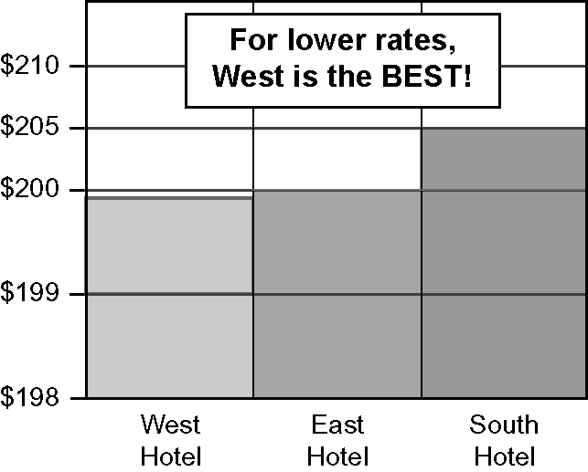

Mental Math
For #6 to #10, determine the value.
6. 7² 7. 10²
8. 9.
10.

Section 3.3

Use the visual to answer #1 to #3.
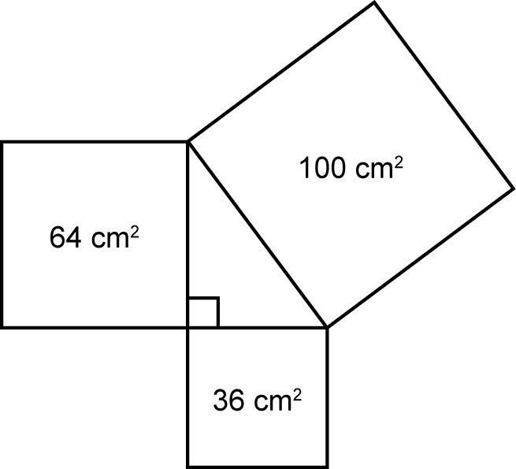
1. List the areas of the three squares, from smallest to largest.
2. Calculate the side length of each of the squares.
3. Write an addition statement with the areas of the three squares.
4. Is the triang le shown below a right triangle? Explain your reasoning.
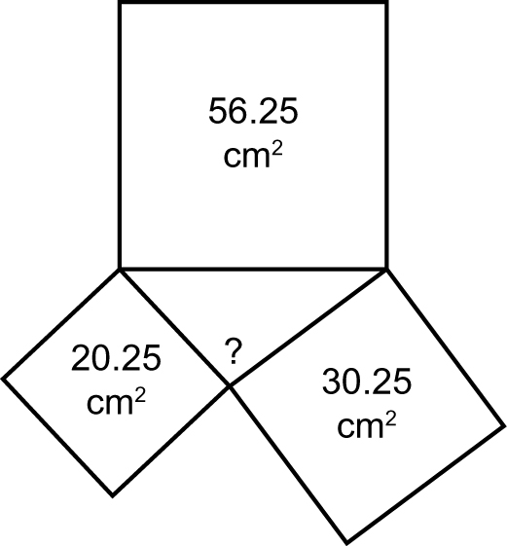
5. A racehorse won five of its eight races and placed in the rest. What is the horse’s win, place, race ratio?

Mental Math
6. Use prime factorization to
calculate .
Identify the missing numbers in #7 to #10.
7. 7² =
8.
9.
10.

Section 3.4

1. Estimate to one decimal place. Check with a calculator.
2. List the numbers with a square root between 10 and 11.
3. A mat is 30 m². Use perfect squares to estimate the side length to one decimal place. Show your thinking.
4. Use a calculator to check your answer to #3.
5. Show 10 : 5 : 15 in lowest terms.

Mental Math
6. Use prime factorization to calculate .
7. Mentally estimate .
Identify the missing numbers in #8 to #10.
8. 13² =
9. =
10.

Section 3.5

1. What is the length of the hypotenuse in the triangle shown? Give your answer to the nearest tenth of a centimetre.
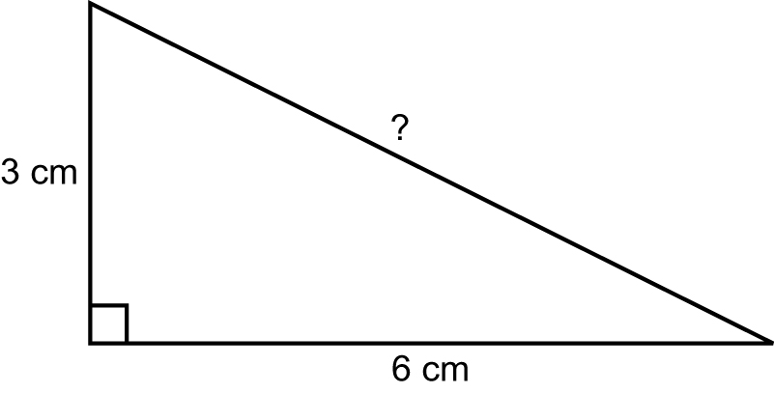
2. What is the length of the leg in the triangle shown? Give your answer to the nearest tenth of a metre.
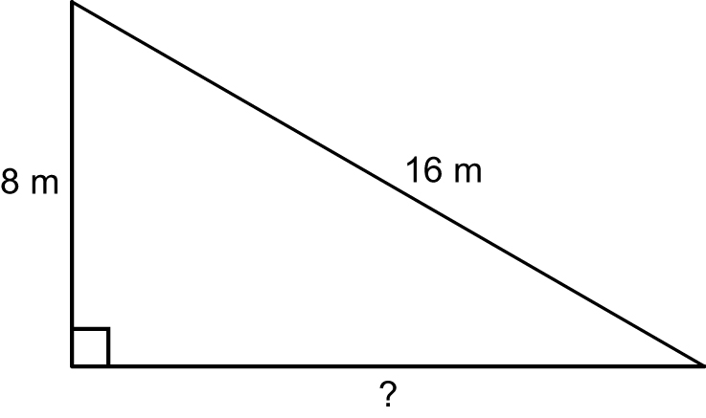

3. A square garden has an area of 40 m². What is the length of each side, to the nearest hundredth of a metre?
4. How long is a path running diagonally across the garden in #3? Show your answer to the nearest hundredth of a metre.
5. Show the ratio of stars to triangles to circles in lowest terms.
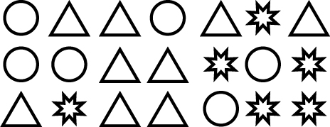
Mental Math
6. Use prime factorization to calculate .
7. Use prime factorization to calculate .
8. Mentally estimate .
For #9 and #10, determine the value.
9. 9² 10. 12²

