Section 3.1 Math Link
This worksheet will help you with the Math Link on page 87.

Chess is played on a square board. The chessboard is made up of 32 white squares and 32 dark squares.

1. The total number of squares on a chessboard is ____ + ____ = ____.

2. You decide to make your own chessboard. You are going to cut the chessboard out of a piece of wood with dimensions 42 cm × 50 cm.
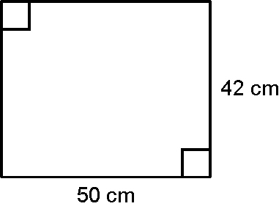
Copy and fill in the table to determine all of the possible dimensions of the chessboard you can make. Add as many rows to the table as you need. Each white or dark square on the chessboard must be a perfect square. Each of these squares can be no smaller than 9 cm². Check the different sizes of chessboard that you can make to see what sizes will work. A 42 cm × 42 cm design is shown in the first row as an example.

Dimensions of Square Board (cm) | Area of Board (cm²) | Number of Squares on Board | Area of Each Square (cm²) | Area Greater Than  9 cm²? | Perfect Square?
42 × 42 | 1764 | 64 | 27.56 | yes | no

3. How does the table help you to determine which dimensions will work?

4. List all of the possible dimensions for the chessboard.

5. Is there a pattern among your answers? If yes, what is it?

