Section 3.2 Extra Practice
1. Write down the words that fill in the blanks.
In a ____________________ triangle, the sum of the areas of the
____________________ attached to the legs equals the area of the square
attached to the ____________________.
2. a) Trace the right triangle below. Label the hypotenuse with t. Label the other legs of the triangle with r and s.
b) Draw a square attached to each side of the triangle.
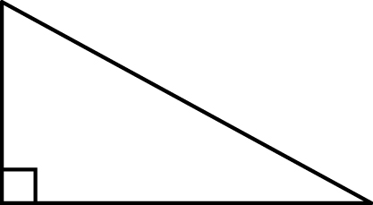
c) Write the relationship of the areas of the
squares, using variables and symbols.

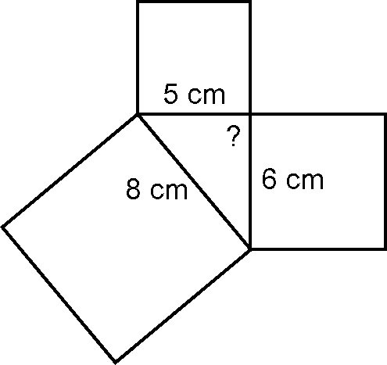
3. a) Calculate the areas of the three
squares shown.
b) Is the triangle a right triangle? Explain.

4. Calculate the missing area of each square. Show your work.

a) | 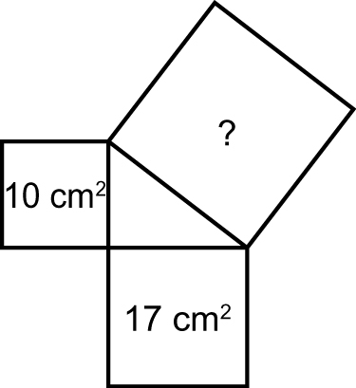 | b) | 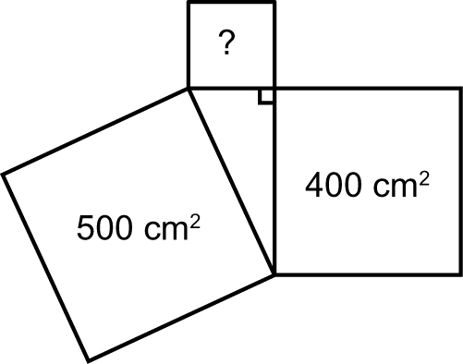

5. Determine the area of the square that would be attached to the hypotenuse of each right triangle.

a) | 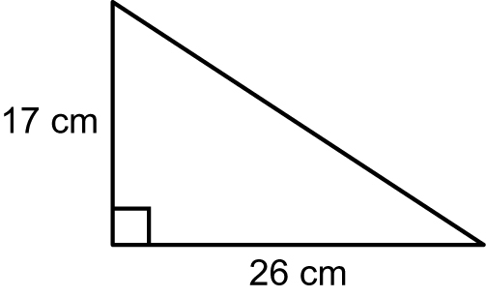 | b) | 