Section 3.2 Math Link
This worksheet will help you with the Math Link on page 94.

Identify the pieces that complete this Pythagorean puzzle. The missing pieces are three squares and one right triangle.

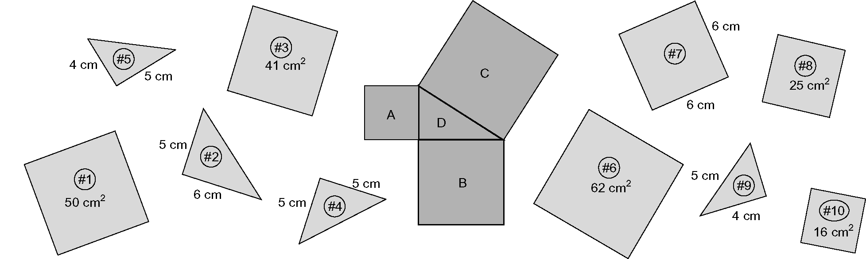

1. Fill in the table to help you determine the missing pieces of the puzzle. Remember, you can use each piece only once. Triangle 2 is shown in the first row as an example.

D A B C
Triangle | Length of First Triangle Side (cm) | Area of Square on First Side (cm²) | Square With This Area | Length of Second Triangle Side (cm) | Area of Square on Second Side (cm²) | Square With This Area | Sum of the Areas of the Squares(cm²) | Square With This Sum
#2 | 5 | 25 | #8 | 6 | 36 | #7 | 61 | none
#4
#5
#9

2. a) Circle the triangle that fits with three square pieces to complete the
puzzle.
Triangle #2 Triangle #4 Triangle #5 Triangle #9
b) Identify the three square pieces that fit together with this triangle.
Square #_____ Square #_____ Square #_____

