Section 3.3 Extra Practice
1. Fill in the blanks.
The first step in estimating the square root of a number that is not a perfect
square is to think of the ____________________ ____________________ less than and greater than the number.

2. Complete the table.

Number | Perfect Square Less Than the Number | Perfect Square Greater Than the Number | Perfect Square Number Is Closer To
33 | 25 | 36 | 36
11
47
6
70
116

3. Estimate the square root of each number in #2. Then, check your answers with a calculator. Express your answers to one decimal place.
 | Estimate | Check
a) | _____ | _____
b) | _____ | _____
c) | _____ | _____
d) | _____ | _____
e) | _____ | _____
f) | _____ | _____

4. Estimate the square root of each number. Then, check your answers with a calculator. Express your answers to one decimal place.
 | Perfect Square Less Than  the Number | Perfect Square Greater Than  the Number | Perfect Square Number Is  Closer To | Estimate | Check
a) | _____ | _____ | _____ | _____ | _____
b) | _____ | _____ | _____ | _____ | _____
c) | _____ | _____ | _____ | _____ | _____
d) | _____ | _____ | _____ | _____ | _____

5. Identify all of the possible whole numbers with a square root greater than 3 and less than 4.
______________________________________________________________
6. The square has an area of 10 cm².
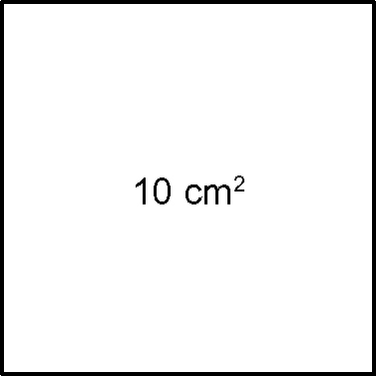
a) Use perfect squares to estimate the side length of the square, to one decimal place. Show your work.

b) Use a ruler to measure the side length of the square, to the nearest tenth
of a centimetre. _______________

