Section 3.4 Extra Practice
1. Fill in the blanks to find the length of the hypotenuse of the right triangle.

t ² = r ² + s²  t ² = ____² + ____²  t ² = ____ + ____  t ² = ____  t =  t = ____ | 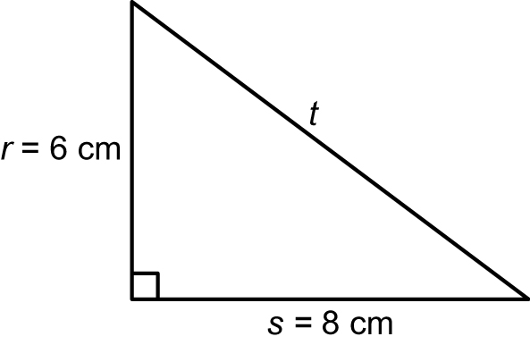

The length of the hypotenuse is ____ cm.

2. Fill in the blanks to find the unknown leg length of the right triangle.

e² + f ² = g²  e² + ____² = ____²  e² + ____ = ____  e² + ____ – ____ = ____ – ____  e² = ____  e =  e = ____ | 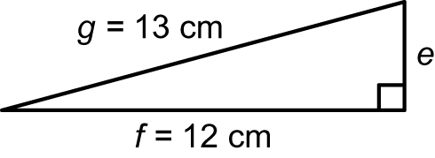

The length of leg e is ____ cm.

3. What is the length of the hypotenuse of each right triangle? Show your work. Give your answer to the nearest tenth of a centimetre.
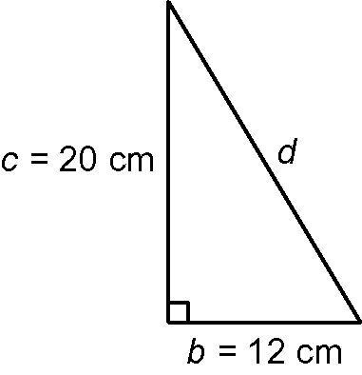  a) | 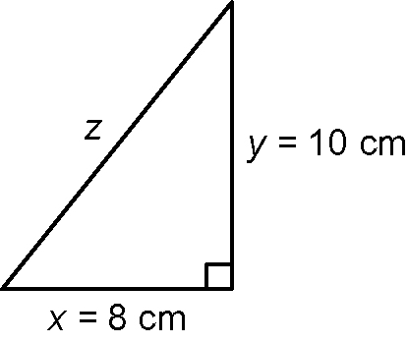  b)

4. Use the Pythagorean relationship to determine the unknown leg length of each right triangle. Give your answer to the nearest metre. Show your work.
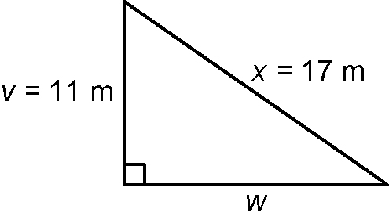  a) | 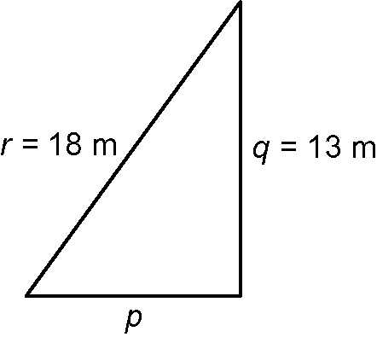  b)

