Section 3.4 Math Link
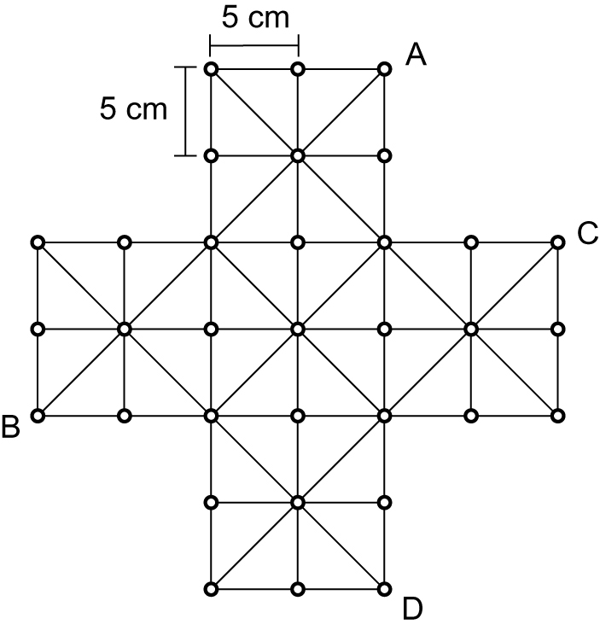
This worksheet will help you with the Math Link
on page 105.

1. a) Use a red pencil to trace a direct line from
A to B.
b) Think of the red line as the hypotenuse of a
right triangle. Use a blue pencil to trace the
legs of the right triangle on the game board.
c) What is the length of each blue leg in the
right triangle that you traced?
d) Substitute these values into the Pythagorean
relationship to determine the length of the
red hypotenuse, to the nearest tenth of a centimetre. Show your work.
e) What is the distance from A to B, expressed to the nearest tenth of a centimetre?

2. a) Following the lines on the game board, use a green pencil to trace the
shortest distance between C and D.
b) Determine how the parts of the distance that you drew could be legs or hypotenuses of right triangles. Sketch and label the right triangles.
c) Using the Pythagorean relationship, determine the length of the distance that you traced in part a), to the nearest tenth of a centimetre. Show your work.

3. a) Use a different coloured pencil to draw the shortest distance between
C and D. This time, you do not need to follow the lines on the game board.
b) Can the line that you drew in part a) be the hypotenuse of a right triangle?
If yes, sketch and label the right triangle. If no, try redrawing the shortest distance so that the line could be the hypotenuse of a right triangle. Then, sketch and label the right triangle.
c) Using the Pythagorean relationship, determine the length of the line that you drew in part a), to the nearest tenth of a centimetre. Show your work.

