Section 3.5 Math Link
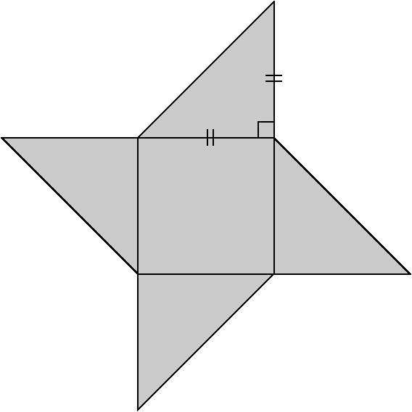
This worksheet will help you with the Math Link
on page 111.

Give your answers to the following questions to the
nearest tenth of a centimetre where appropriate.
1. a) How do you find the side length of a square
if you know the area?
b) What is the side length of the central square
in the game board if it has an area of 225 cm²?
c) How is the side length of the central square related to
the length of each leg of the right triangles?
d) What is the length of each leg of the right triangles?
e) What is the length of the hypotenuse of the right triangles? Show your work.
f) On the diagram above, label all of the leg lengths and hypotenuse lengths around the perimeter of the game board. What is the perimeter of the game board?

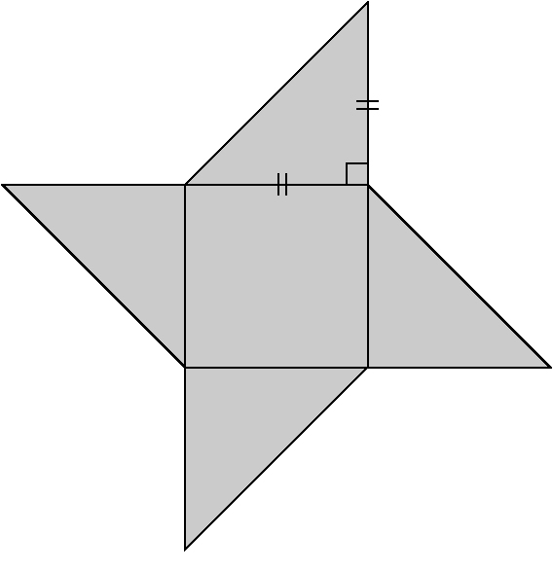
2. The game will be packaged in a box with
a square base.

a) On the diagram, draw the smallest square box
that you can around the game board. The square
box should just touch each outside vertex of the
four triangles.
b) Draw a diagonal line through the square box.
c) Using the diagonal line as the hypotenuse, draw a
right triangle over the diagram. Draw the legs of the
right triangle so that you will be able use the known
measurements of the game board to determine the length of each leg.
d) Determine the length of each leg of the right triangle. Show your work.
e) On the diagram, label the length of each leg of the right triangle.
f) Use the Pythagorean relationship to determine the length of the diagonal line. Show your work.

