Chapter 3 Test
For #1 to #5, select the best answer.

1. Which number is not a perfect square?
A 9 B 16 C 55 D 121

2. A square has a side length of 9 mm. What is the area of the square?
A 18 mm² B 36 mm² C 49 mm² D 81 mm²

3. The square root of 63 is closest to which whole number?
A 5 B 6 C 7 D 8

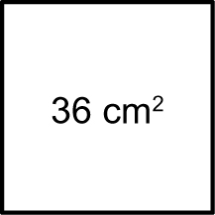
4. What is the side length of the square in the diagram?
A 5 cm B 6 cm C 9 cm D 12 cm

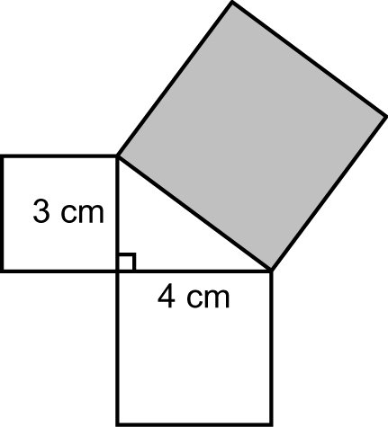
5. What is the area of the shaded square?
A 25 cm² B 36 cm²
C 49 cm² D 60 cm²

Short Answer

6. What is the area of a square with the following side length?
a) 8 cm b) 11 m c) 50 mm d) 13 cm

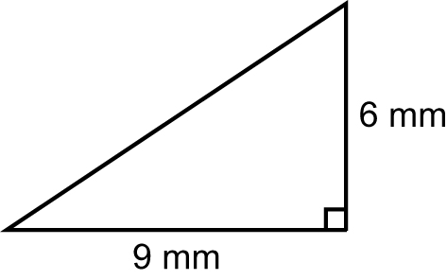
7. Find the value of the missing side length,
to the nearest tenth of a millimetre.

8. Is a triangle with side lengths measuring 8 m, 6 m, and 10 m a right triangle? Show all of your work, and explain your reasoning.

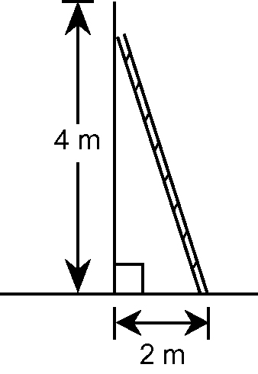
9. How long is the ladder to the
nearest tenth of a metre?

10. Estimate the square root of the following numbers, to the nearest tenth. Show your thinking.
a) 39 b) 137 c) 175 d) 420

11. In your own words, describe what the formula c² = a² + b² tells about
the relationship among the sides in a right triangle.

Extended Response

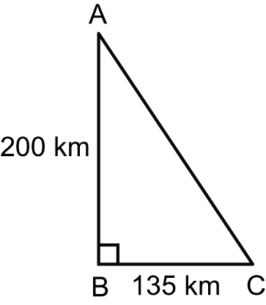
12. Two cars leave A at the same time. Martin’s car
travels directly from A to C at a constant rate of
80 km/h. Kathleen’s car travels from A to B at a
constant rate of 100 km/hour, and then continues
to C at a constant rate of 90 km/h.
a) Who will arrive at C first?
b) How many minutes later will the second person arrive?

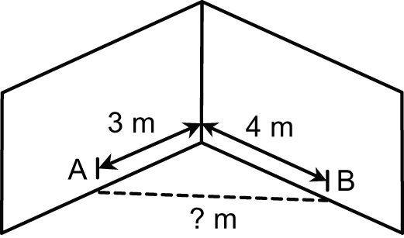
13. Carpenters are checking to see if two walls meet
in a corner to form a 90º angle. They measure 3 m
from the corner along one wall to point A and 4 m
from the corner along the other wall to point B.
a) If the angle is 90º, what is the distance from
A to B?
b) Why do you think it is important for the two
walls to create a 90º angle?

14. Can a perfect square less than 1000 ever have a last digit that is 2, 3,
7, or 8?
• If your answer is no, explain why it is not possible.
• If your answer is yes, justify your answer and provide an example.

