Percents

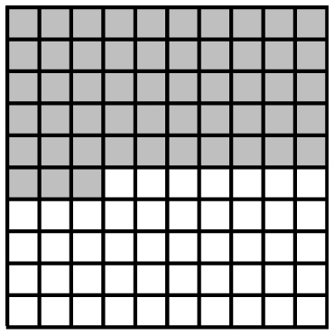
Percent means out of 100.
A percent can be represented by
shading on a hundred grid.
This grid represents 53%.

1. What percent is shown on each grid?
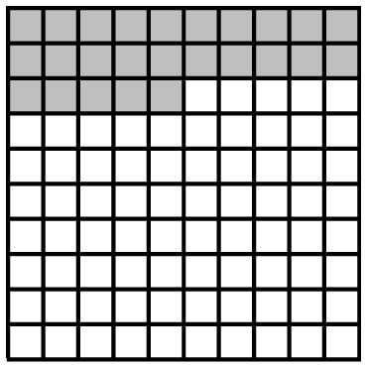
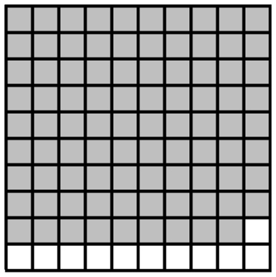
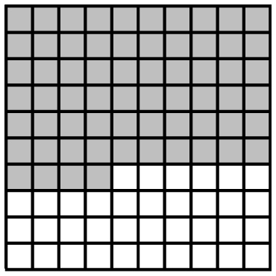
a) ) b) c)

2. Shade hundred grids to represent each percent.
a) 3% b) 46% c) 97%
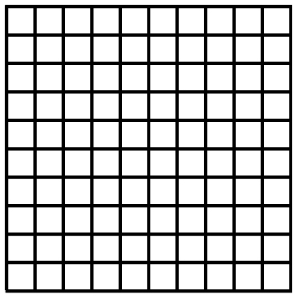

Fractions, Decimals, and Percents
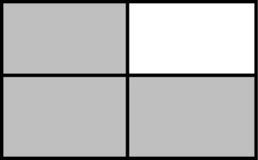
This diagram represents .

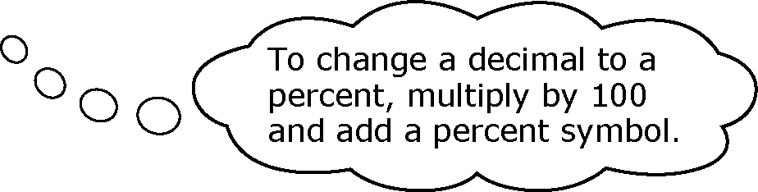
This fraction is 0.75 or 75%
of the square.

3. Show each diagram as a fraction, a decimal, and a percent.
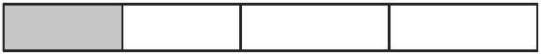
a) b)
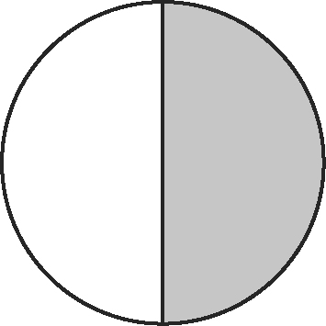
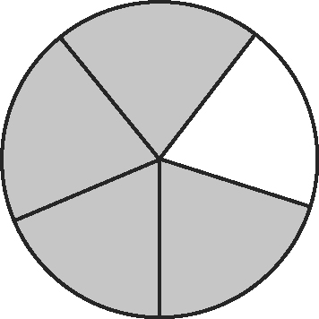
c) d)

Repeating Decimals

A repeating decimal contains one or more digits that repeat over and over without ending.



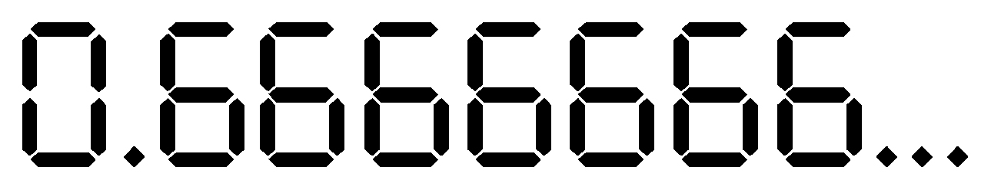
= 2 3
Use a bar to show the repeating part.
To show as a percent, multiply the decimal by 100 and add a percent symbol.
=

4. Show as repeating decimals.  a) 0.3333333  b) 0.4545454  c) 0.2727272 | 5. Show each fraction as a repeating decimal and as a percent.  a) b) c)
Estimating Percents
To estimate the percent of a number, use percents you know.
52% of 250 is about 50% of 250.
50% of 250 is half of 250 or 125.
12% of 60 is about 10% of 60.
10% is about one tenth of 60 or 6.

6. Estimate each percent of a number.
a) 22% of 85 b) 48% of 102 c) 75% of 70 d) 82% of 91

