Section 4.1 Extra Practice
1. Fill in the blanks.
a) Percent means out of ______.
b) To represent a percent, you can shade squares on a
____________________ ____________________
c) To represent a percent greater than 100%, shade
____________________ than one grid.
d) A percent that includes a portion of a percent is a
____________________ percent.
e) To represent on a hundred grid, divide one square into ____ sections and shade ____ of the sections.

2. One completely shaded grid represents 100%. What percent does each diagram represent?

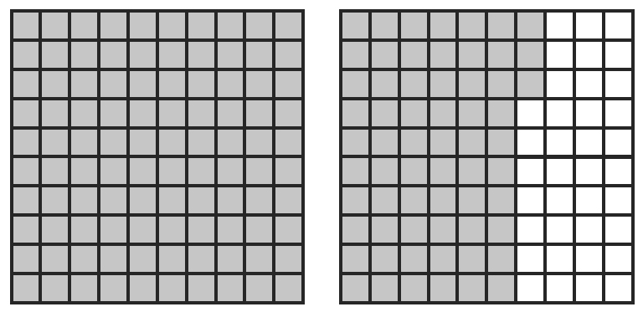  a) | 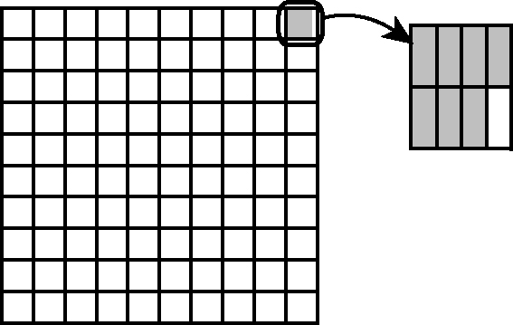  b)

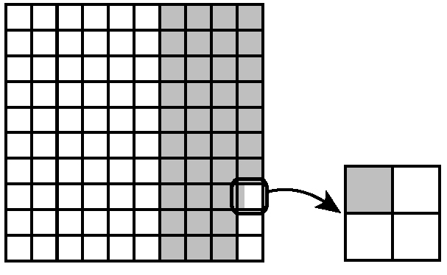  c) | 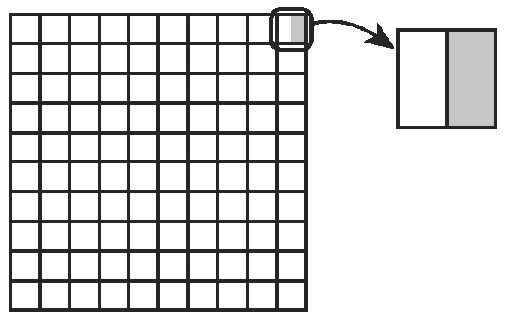  d)

For #3 and #4, use the grids that follow to answer the questions. Label the grid(s) you use.

3. Shade grids to represent each percent.
a) 175% b) c) 0.2% d)

4. Shade grids to represent the percent in each statement.
a) Attendance at the science fair decreased by 5.4% last year.
b) 0.3% of Earth’s fresh water is found in lakes and rivers.
c) The length of the St. Lawrence River is about 150% of the length of the Columbia River.
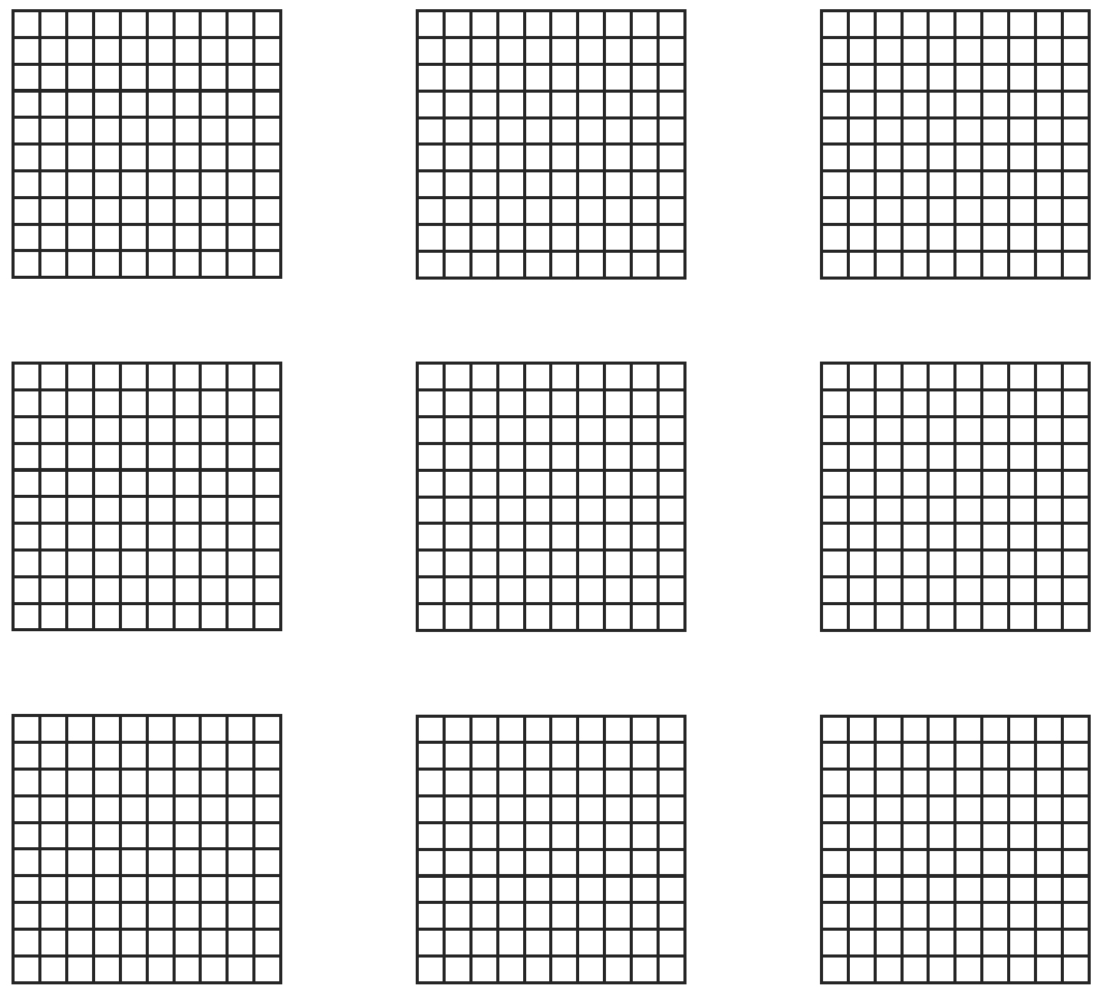
5. How many hundred grids are needed to show each percent?
a) 235% ____ b) 789% ____ c) 1630% ____

