Section 4.1 Math Link
This worksheet will help you with the Math Link on page 129.

Use hundred grids to represent the following data.

1. 97.5% of Earth’s Water is Salt Water  How many squares will you shade?  ____  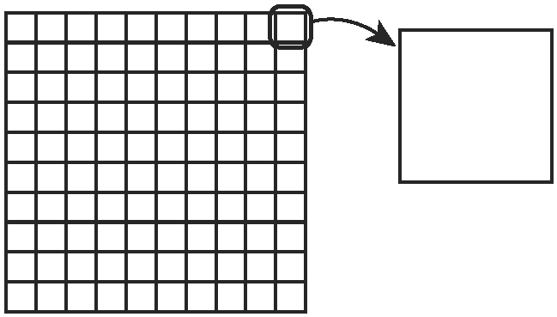 | 2. 2.5% of Earth’s Water is Fresh Water  How many squares will you shade?  ____  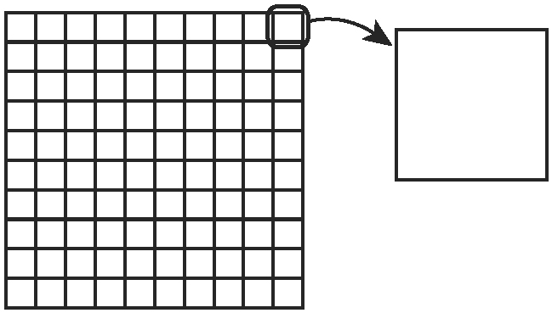

3. of Fresh Water Found in Lakes and Rivers
a) What part of one square on the hundred grid will you shade? ____
b) Zoom in on one square of the grid. Into how many parts will you need to
divide the enlarged square? ____
How many small squares will you shade? ____

4. 0.04% of Fresh Water Found in Earth’s Atmosphere
a) Write 0.04 as a fraction:.
How many small squares will you shade on the enlarged square? ____
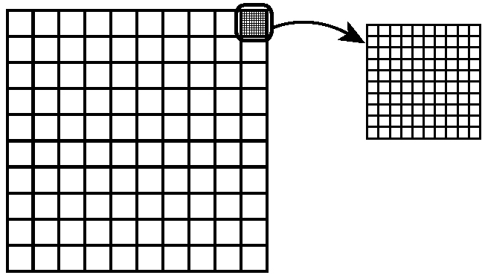
b) Write 0.04 as a fraction in lowest terms:.
Explain how to represent this new fraction using a hundred grid.
_____________________________________________________________

5. 0.007% of Fresh Water Accessible for Drinking Water
a) Write 0.007 as a fraction:.
If you zoom in on one square of the thousand grid, how many small
squares will you shade? ____
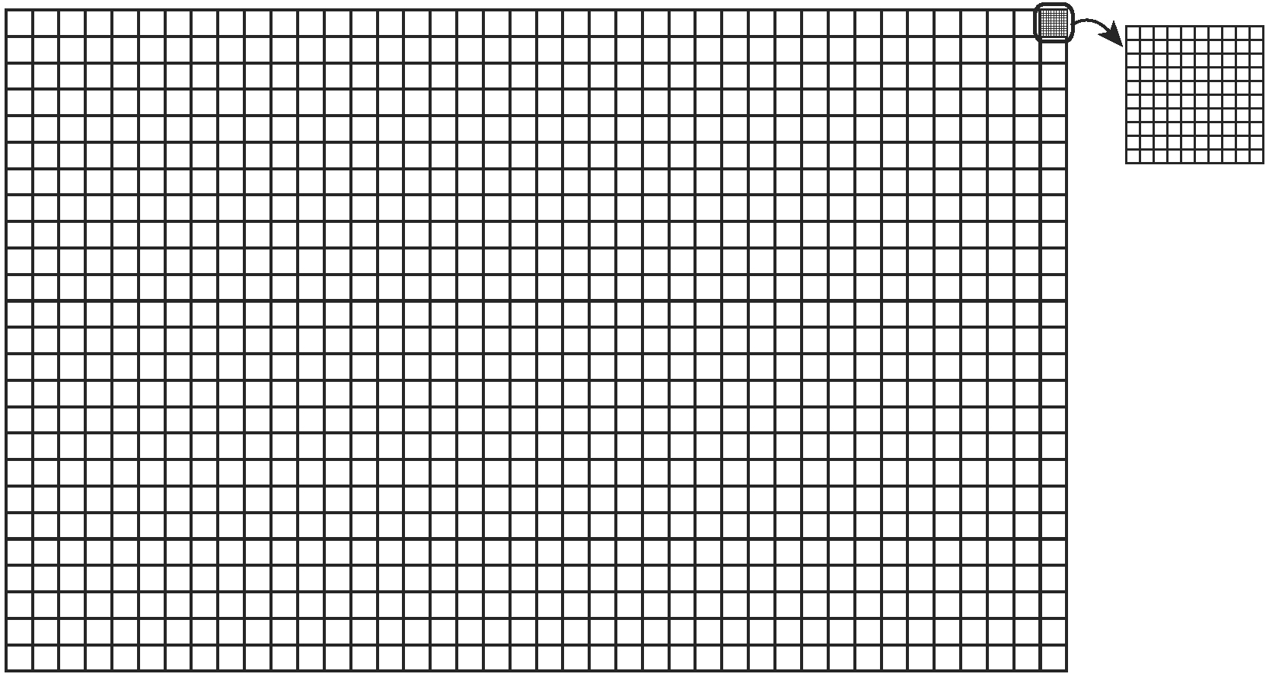
b) Explain another way to represent 0.007 on a hundred grid.
Hint: Let each square on the hundred grid represent ____.

