Chapter 4 Test
For #1 to #5, choose the correct answer.

1. What is 78.2% as a decimal?
A 0.782 B 7.82 C 78.2 D 782

2. What is as a percent?
A 1.875% B 18.75% C 187.5% D 1875%

3. What is 12.5% as a fraction?
A B C D

4. What is 3.194 as a percent?
A 3.194% B 31.94% C 319.4% D 3194%

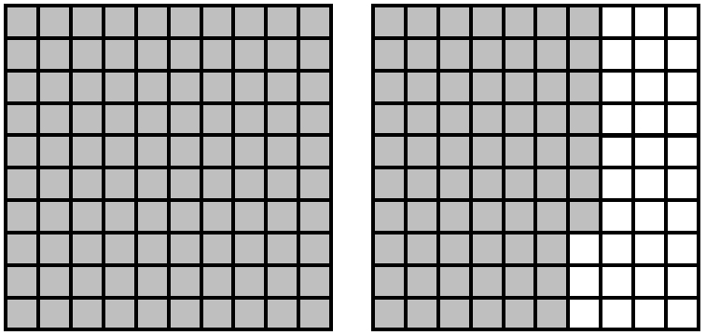
5. One completely shaded grid represents
100%. What percent does the diagram
represent?
A 0.167%
B 1.67%
C 16.7%
D 167%

Short Answer

6. Convert each of the following:
a) 48% to a decimal and a fraction in lowest terms
b) 3.375 to a percent and a fraction in lowest terms
c) to a decimal and a percent

7. Determine the following. Write your answer to the nearest tenth.
a) 94% of 63 b) 146.3% of 300
c) 7 out of 12 as a percent d) 18 out of 80 as a percent
e) 60% of 78 f) 0.05% of 1000

8. Use hundred grids to represent each percent.
a) 0.25% b) 110% c) 33% d) 106.5%

9. Mary is blowing up a birthday balloon. After the first breath, the balloon has a 5-cm diameter. The diameter increases at a constant rate of 20% each second. What is the diameter of the balloon after 3 s?

10. During this basketball season Trey took 250 shots and made 72 baskets. What was his shooting percentage?

11. A bus company offers a 15% discount on bus tickets one day and then an additional 10% off the sale price the next day. Lily wants to buy a bus ticket that has a regular price of $175. What will she pay for it after the discounts?

Extended Response

12. You have won a shopping spree worth $200. You must buy at least 4 items of your choice. Each item is offered at a 25% discount.
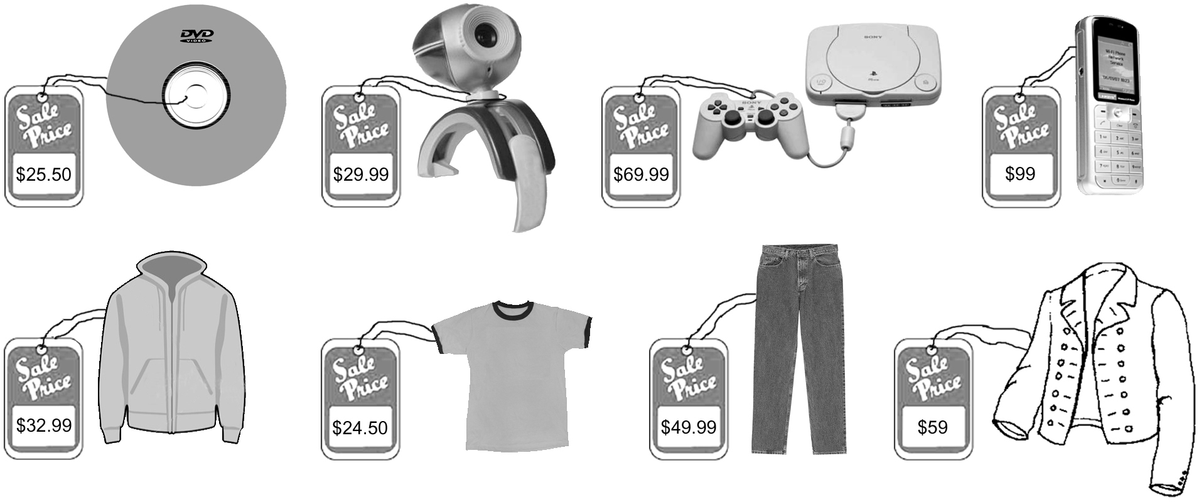
a) Use a table such as the one shown here to determine the total cost of each item you choose including 5% GST and 6% PST. Show your work.
b) Total the cost of all of your items and calculate your change from the
$200 you won.

