Chapter 4 BLM Answers

BLM 4–1 Chapter 4 Math Link Introduction
1. Answers will vary. Example: Tourism during the summer causes the water consumption rates to double.
2. Answers will vary. Look for at least two reasons such as the following:
• A drought may cause water supplies to dwindle.
• A new manufacturing plant may use a lot of water.
• The water supply may become contaminated and need to be replaced.
3. a) No watering of gardens and lawns, and no washing of sidewalks, driveways, and vehicles.
b) Answers will vary. Example: Water restrictions might include shutting down car washes and requiring homeowners and businesses to install water-conserving toilets and showerheads.
4. a) = 12 b) = 85 c) = 15
5. There may be a 5% savings in water.
6. There may be a 15% savings in water.

BLM 4–2 Chapter 4 Get Ready
1. a) 25% b) 89% c) 64%

2. a)



b) c)

3. a) , 0.25, 25% b) , 0.375, 37.5%
c) , 0.50, 50% d) , 0.80, 80%
4. a) b) c)
5. a) , b) ,
c) ,
6. Answers will vary. a) 17 b) 51 c) 52 d) 72
BLM 4–3 Chapter 4 Warm-Up
Section 4.1
1. No. Answers will vary. Example: The sum of
the square on the hypotenuse is greater than the
sum of the squares on the other two sides. 25 +
4 ≈ 30 2. 40 m
3. 65, 66, 67, 68, 69, 70, 71, 72, 73, 74, 75, 76,
77, 78, 79, 80
4. 6.2 cm 5. 10.2 6. 36
7. 100 8. 121 9. 5 10. 8
Section 4.2
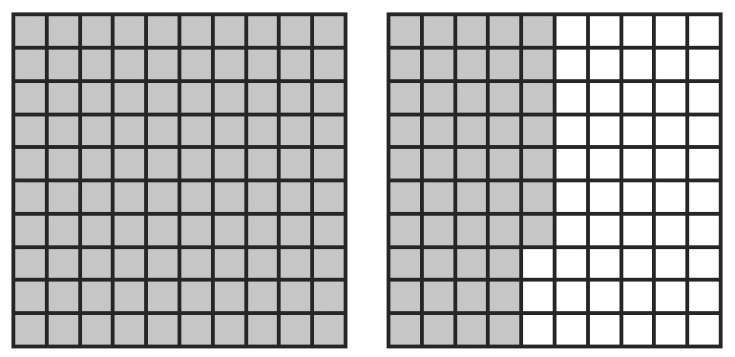
1. a) 161% b)
2. a)

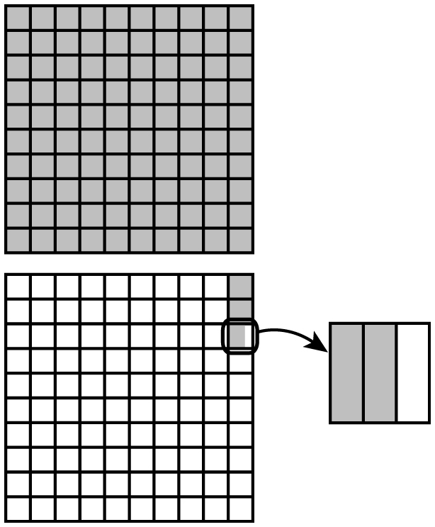
b)

3. 1000 mL is the better buy at 0.0015¢/mL,
compared to 500 mL at $0.0019¢/mL.
4. 200 m/25 s = 8 m/s; 300 m/35 s = 8.6 m/s;
The 200 m runner is faster.
5. 12 rolls/min
6. a little more than 7 because 7² = 49
7. a little less than 5 because 5² = 25
8. = 3 9. = 1 10. = 150
Section 4.3
1. a) 0.08, 8% b) 0.297, 29.7%
c) 1.22, 122.2%
2. a) 100.5%, or
b) 475%, or
3. a) 2.25, or
b) 0.0092, or
c) 0.458,

4. 250% 5. a) $60, $59.94
b) ; x = $29.97
6. 7. 8.
9. 74.8%, , 0.748
10. 125.5%, , 1.255
Section 4.4
1. 4.8 2. 366 3. $562.50 4. 0.003%
5. a) $70 b) $100 c) Answers will vary.
Example: The scale on the y-axis creates the
misleading impression that the prices seem much
further apart than they actually are.
d) Answers will vary. Example: Redraw the graph with a continuous scale that starts at zero.
6. 12 7. $10 8. $350 9. 10. 24
BLM 4–4 Chapter 4 Problems of the Week
1. a) In July the discount price for the dress is $79.99 − $7.99 = $72.00. In August, the discount price for the dress is $72.00 − $14.40
= $57.60.
b) No. If the dress was actually for sale at 30% off, it would cost $55.99.
2. The original price of the lawn mower was $150.00. ; x = $150.00
3. a) Answers will vary depending on the tax rates where students live. Yes, combining the cost and the tax percents works. Example: In Saskatchewan, the cost of an item (1) plus the combined tax (0.10) is equal to multiplying the cost of the item by 1.10.
b) Brian determines the final cost by subtracting what is left after the discount. 100 − 35 = 65. The sale price is 65% of the original price.
c) Answers will vary depending on PST and GST rates. Example: In Saskatchewan: 1699.00 × .80 × 1.10 = 1495.12. The total cost is $1495.12.
4. a) Calculating taxes separately: 39.98 + 3.75 = 43.73; PST = 2.19; GST = 2.19. The total cost is $48.11. Combining tax percents: 39.98 + 3.75 = 43.73; 43.73 × .10 = 4.37; 43.73 + 4.37
= $48.10. The total cost is $48.10. There is no difference in price.
b) The total cost in other provinces will vary. Alberta will be the least expensive (no PST) and Newfoundland will be the most expensive.
5. Answers will vary but may include that 0.76 is greater than 0.75 by 0.01, and so should be greater by 0.05.
6. 5² ÷ 4² = 25 ÷ 16 = 1.4525 ≈ 1.6%
7. 12.5% × 30 = 3.75. The head should be 3.75 cm.
8. 8% of 2800 = 224; 224 + 126 = 350. The Henri family spent $350 on clothing. 350 ÷ 2800 = 0.125 or 12.5%. The Henri family’s clothing purchases represented 12.5% of their monthly budget.
BLM 4–5 Section 4.1 Extra Practice
1. a) 100 b) hundred grid
c) more d) fractional e) 4, 3
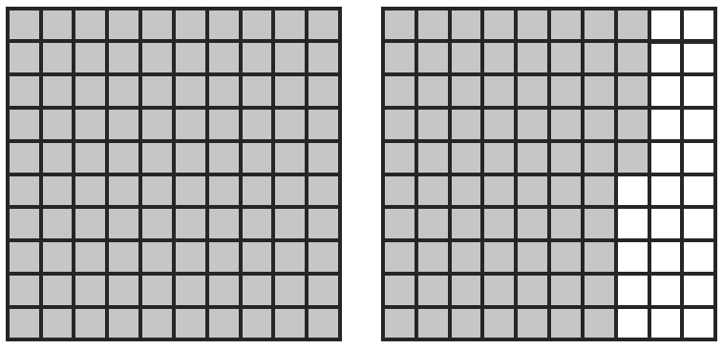
2. a) 163% b) c) 37 d) 0.5%
3. a)

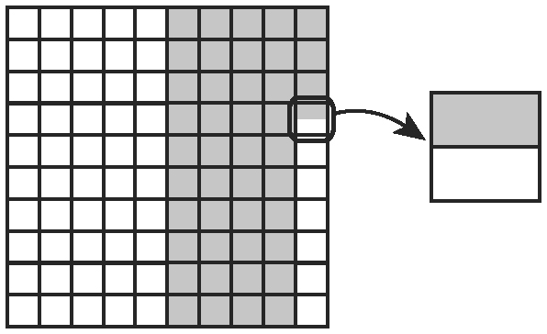
b)

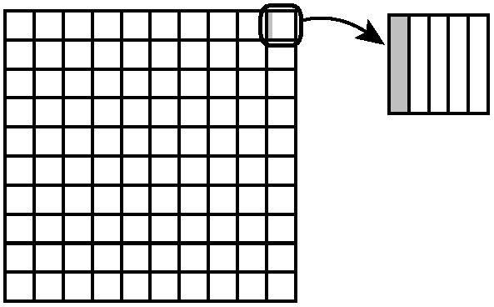
c)

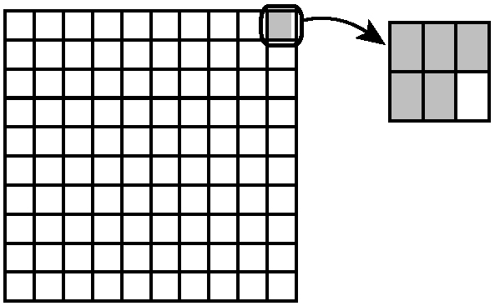
d)

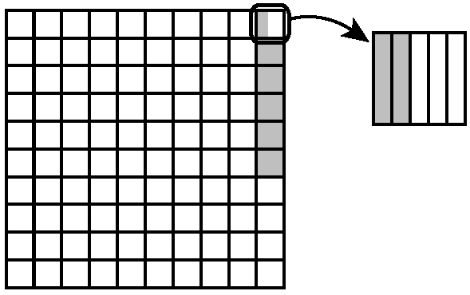
4. a)

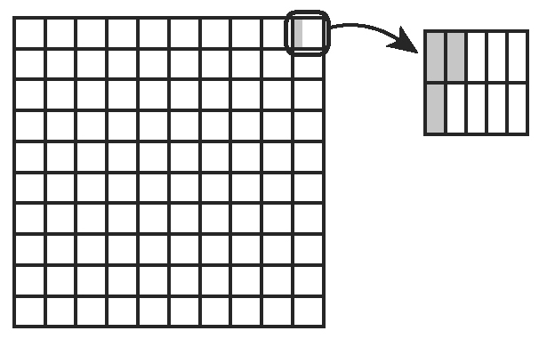
b)

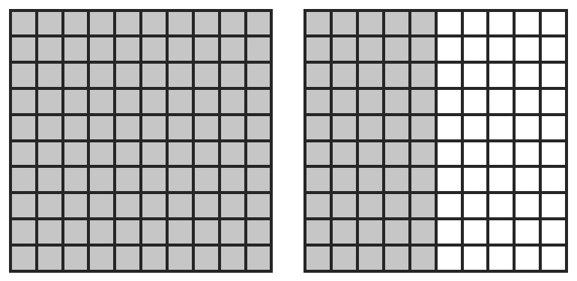
c)

5. a) 3 b) 8 c) 17
BLM 4–6 Section 4.1 Math Link
1. 97.5 squares
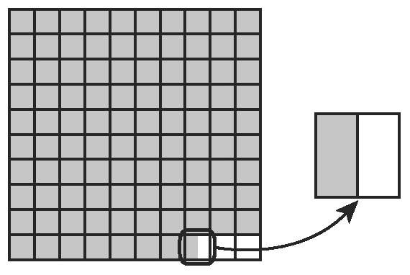
2. 2.5 squares
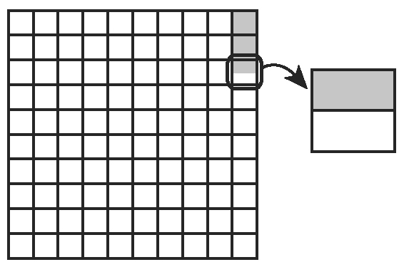
3. a) of 1 square b) 10, 3
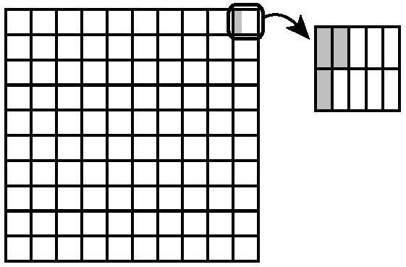
4. a) , 4. Alternatively, students might let each square on a hundred grid represent one hundredth and then shade four squares.
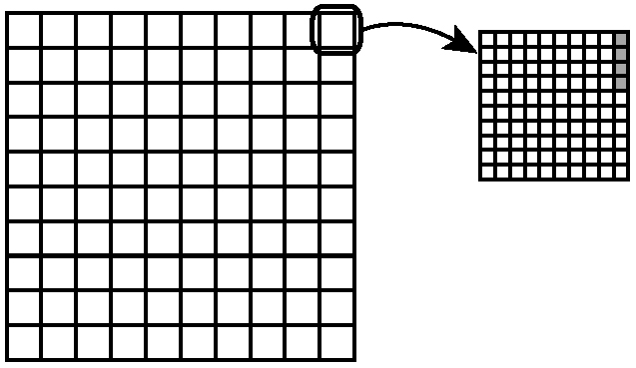
b) . If you zoomed in on one square of the hundred grid, you would divide the enlarged square into 25 parts and shade one part.

5. a) , 7
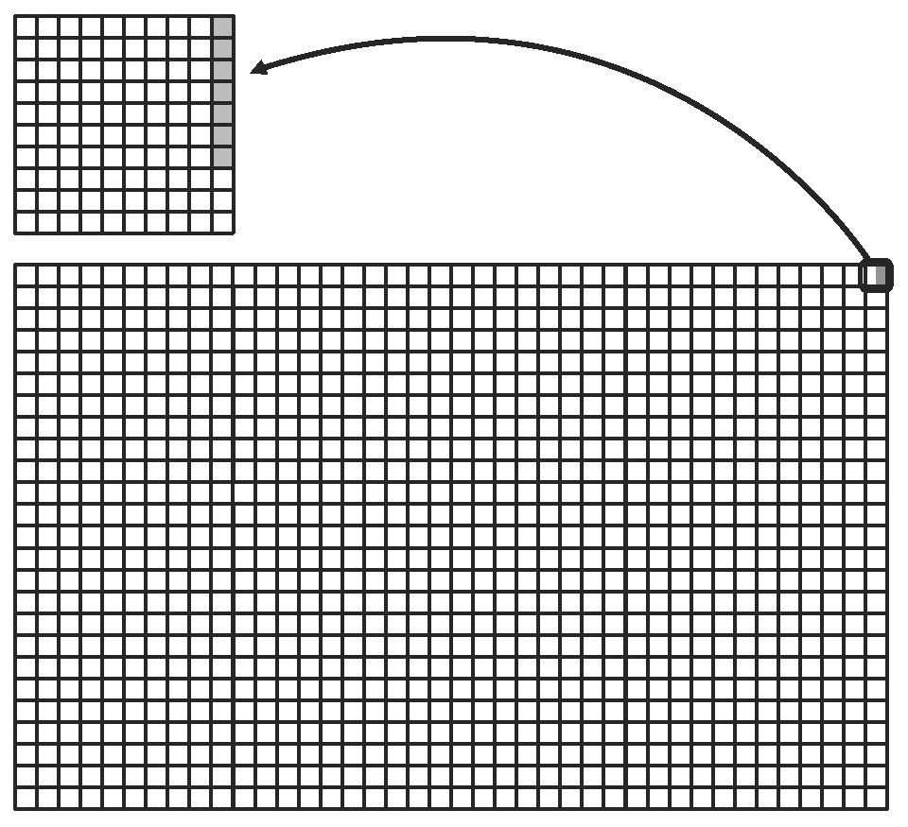
b) . Let each square on a hundred grid represent one thousandth and then shade seven squares.
BLM 4–8 Section 4.2 Extra Practice
1. a) = 100 b) hundredths; 19%
2. a) b)
c)
d)
3. a) b)
c)
d)
4. a) 157.5%; 1.575 b) 8.2%;
c) ; d) ; 0.0078
e) 336%;
5. a) = 1.25 = 125%
b) Area of original picture is 40 cm²; area of enlargement is 70 cm². The area of the picture increased by 57.14%.
BLM 4–9 Section 4.2 Math Link
1. a) 0.689 b) 0.308 c) 0.003
2. a) b) c)

3.
Fresh Water | Percent | Decimal | Fraction
Glaciers | 68.9% | 0.689
Groundwater | 30.8% | 0.308
Lakes and rivers | 0.3% | 0.003
BLM 4–10 Section 4.3 Extra Practice
1. a) 10% is 7; 1% is 0.7; 0.1% is 0.07; 0.2% is 0.14 b) 10% is 1000; 1% is 100; 3% is 300; 0.1% is 10; is $310
2. a) 300 b) 1.2 c) 6000 d) 1.8
3. a) 0.0075; 5.18 b) 3.85; $810.81
c) 0.83875; 201.3
4. a) 262 b) 292.34 c) 4.29 d) $731.94
5. 6.5 ÷ 100 = 0.065; 0.065 × 82 = $5.33. The tax on the pair of shoes is $5.33.
BLM 4–11 Section 4.3 Math Link
1. Answers will vary. Look for at least three ways to reduce water consumption. Examples:
• Install low-flow toilets and showerheads.
• Limit car washing and garden watering.
• Install sinks with automatic shut-off valves.
2. Answers will vary. Look for three water math problems. Examples:
• Jane’s mother is installing a new low-flow toilet that will use 60% less water per flush. How much water is saved if the old toilet used 6 L per flush?
• Anytown is thinking of limiting car washing to two days a month to save 7% more water. If car washing currently uses 10 000 L of water per month, how much water will be used if Anytown imposes this limit?
• Central School has installed sinks with automatic shut-off valves. If the school used to use 2000 L of water each day and the sinks save 3.2%, how much water does the school now use? Ensure that students provide solutions to their problems.
BLM 4–12 Section 4.4 Extra Practice
1. a) combine; backpack b) taxes; backpack
c) tax percents; 100%
2. a) 0.12 × 39.99 = 4.798 = 4.8. The total tax is $4.80.
b) 39.99 + 4.8 = 44.79. The total cost is $44.79.
3. a) 0.12 × 89.99 = 10.7988 = 10.8. The total tax is $10.80.
b) 89.99 + 10.8 = 100.79. The total cost is $100.79.
4. a) 0.12 × 2.99 = 0.3588 = 0.36. The total tax is $0.36.
b) 2.99 + 0.36 = 3.35. The total cost is $3.35.
5. a) 0.12 × 19.99 = 2.3988 = 2.4. The total tax is $2.40.
b) 19.99 + 2.4 = 22.39. The total cost is $22.39.
6. Week 1: 30% of 45 = 13.5; $45 − $13.50 = $31.50. The sale price during Week 1 was $31.50. Week 2: 15% of 31.5 = 4.73; $31.50 − $4.73 = $26.77. The final sale price in Week 2 was $26.77.
7. No. Explanations may vary. Example: The 12% for taxes is being added to 80% of the cost of the item. That is 12% of 80%, which is 9.6%. So, subtracting 20% and then adding 9.6% is the same as subtracting 10.4% off the regular price.
8. a) 0.20 × 129.96 = 25.992; Discount: $25.99
b) 129.96 − 25.99 = 103.97; Sale price: $103.97
c) 0.12 × 103.97 = 12.4764; Taxes: $12.48
d) 103.97 + 12.48 = 116.45; Total cost: $116.45
9. a) 0.20 × 39.99 = 7.998; Discount: $8.00
b) 39.99 − 8 = 31.99; Sale price: $31.99
c) 0.12 × 31.99 = 3.8388; Taxes: $3.84
d) 31.99 + 3.84 = 35.83; Total cost: $35.83
10. a) 0.20 × 4.99 = 0.998; Discount: $1.00
b) 4.99 − 1 = 3.99; Sale price: $3.99
c) 0.12 × 3.99 = 0.4788; Taxes: $0.48
d) 3.99 + 0.48 = 4.47; Total cost: $4.47
11. a) 0.20 × 849.96 = 169.992; Discount: $169.99
b) 849.96 − 169.99 = 679.97; Sale price: $679.97
c) 0.12 × 679.97 = 81.5964; Taxes: $81.60
d) 679.97 + 81.60 = 761.57; Total cost: $761.57
12. a) 0.20 × 17.95 = 3.59; Discount: $3.59
b) 17.95 − 3.59 = 14.36; Sale price: $14.36
c) 0.12 × 14.36 = 1.7232; Taxes: $1.72
d) 14.36 + 1.72 = 16.08; Total cost: $16.08
BLM 4–13 Section 4.4 Math Link
1. a) 6 × 30 = 180. Flushing the toilet 30 times per day uses 180 L of water.
b) . 13.9% of the water used by the toilet is wasted by the dripping faucet.
2. a) 10% b) 1.2% c) 0.75% d) 0.12%
3. 9% of 0.3% = 0.09 × 0.3 = 0.027%. Approximately 0.027% of the world’s fresh water is used by industry.
BLM 4–14 Chapter 4 Test
1. A 2. B 3. A 4. C 5. D
6. a) 0.48; b) 337.5%; c) 0.8; 80%
7. a) 59.2 b) 438.9 c) 58.3%
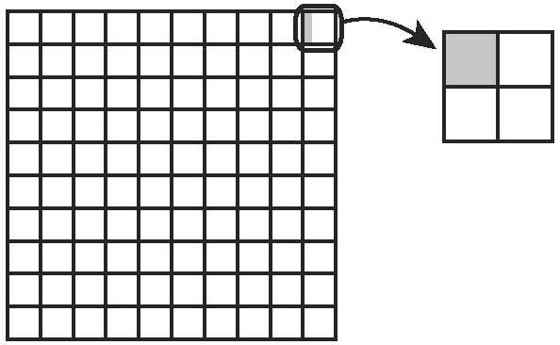
d) 22.5% e) 46.8 f) 0.5
8. a)

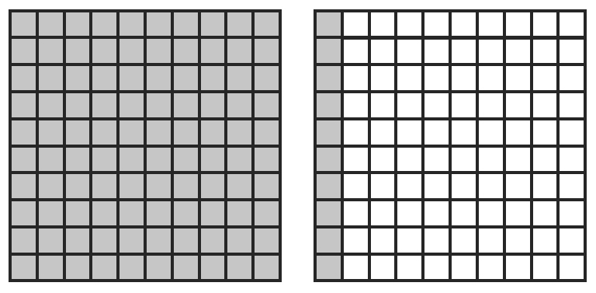
b)

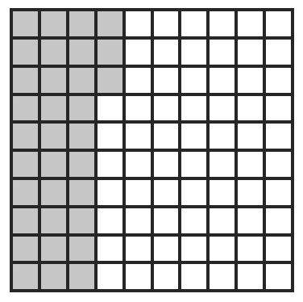
c)

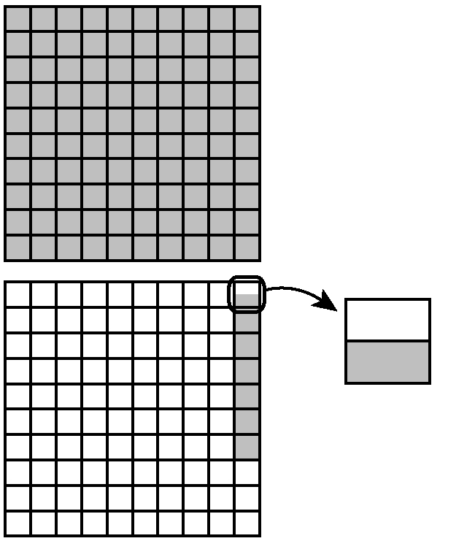
d)

9. 8.64 cm 10. 28.8%
11. The discount on the first day is 15% of $175. 15% of $175 = 0.15 × 175 = 26.25. The discounted price is 175 − 26.25 = 148.75. The discount price on the first day is $148.75.
The discount on the sale price the next day is 10% of $148.75. 10% of $148.75 = 0.10 × 148.75 = 14.88. The discounted price is 148.
75 − 14.88 = 133.87. The discount price after
the two sales is $133.87.
12. Answers will vary. Look for accurate and complete calculations.

