Three-Dimensional Objects

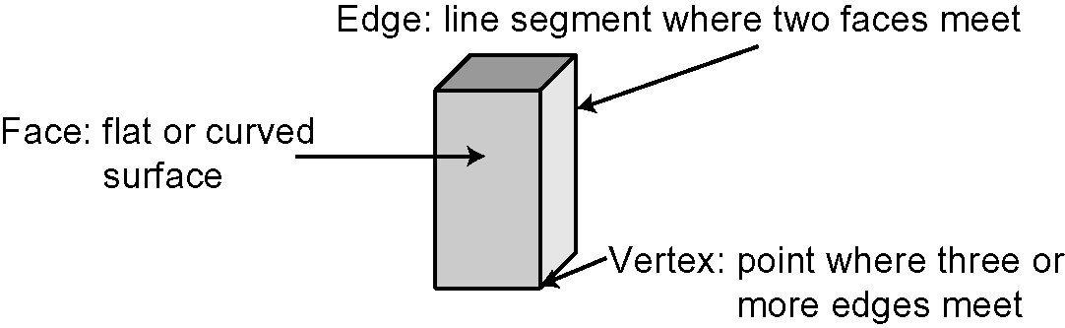
You can describe a three-
dimensional (3-D) object by counting its faces, edges,
and vertices.

1. Identify the name and the number of faces, edges, and vertices for each object.

Object | Name | Faces | Edges | Vertices
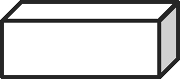
a)
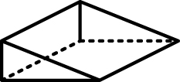
b)
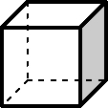
c)

Circles
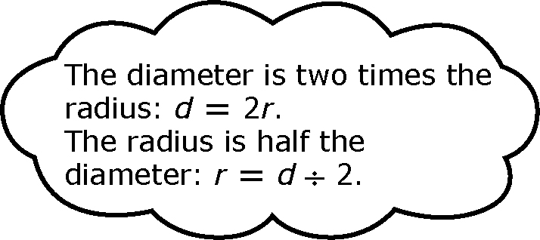
A circle is a set of points that are an equal distance
away from a fixed point, called the centre.
The radius is the distance from the centre of a
circle to the outside edge. The letter r is often
used to represent the radius.
The diameter is the distance across a circle
through its centre. The letter d is often used to
represent the diameter.
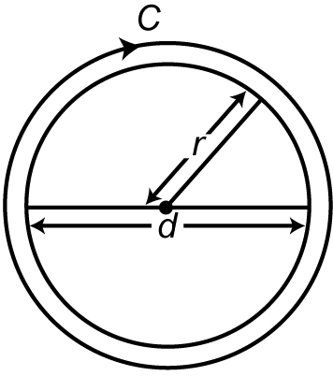
The distance around a circle is called
the circumference. The letter C is
often used to represent the circumference.

To find the circumference of a circle, use the formula C = × d or
C = 2 × × r. Use 3.14 as an approximate value for .
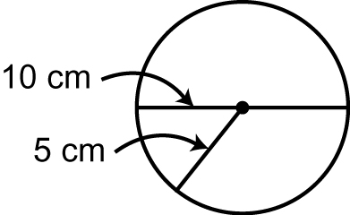
C = × d C = 2 × × r
C ‪≈ 3.14 × 10 C ‪≈ 2 × 3.14 × 5

C ≈ 31.4 C ‪≈ 31.4
C = × d
The circumference is 31.4cm.
C ≈ 3 × 10
‪C ≈ 30

The area, A, of a circle is the space the circle encloses.
To find the area of a circle, use the formula A = × r ² or A = r ²
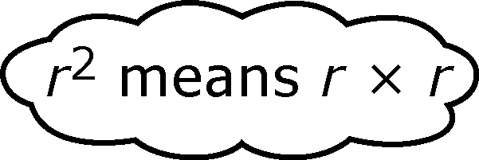
A = × r ²
A ≈ 3.14 × 5 × 5
A ≈ 78.5
The area is 78.5 cm².

2. Find the circumference of each circle to the nearest tenth of a centimetre.  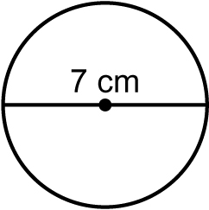  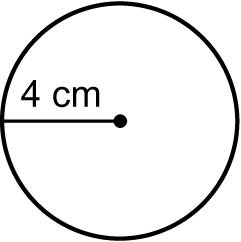  a) b) | 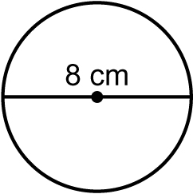  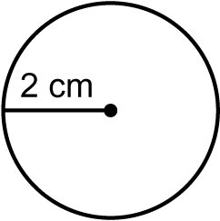  3. Find the area of each circle to the nearest tenth of a centimetre.  a) b)
Area Formulas
The area is the number of square units needed to cover a surface.

Use the formulas to calculate the area of these shapes to the nearest tenth of a centimetre.

4. Rectangle:  A = l × w | a) | 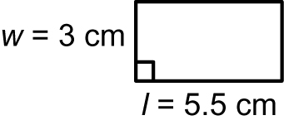 | b) | 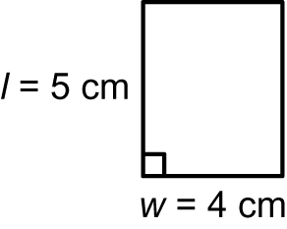

5. Triangle:  A = (b × h) ÷ 2 | a) | 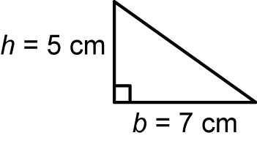 | b) | 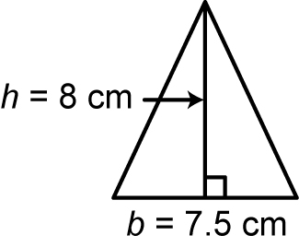

6. Parallelogram:  A = b × h | a) | 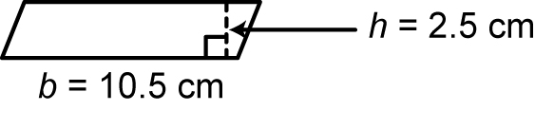 | b) | 