Chapter 5 Warm-Up
Section 5.1

1. What is 0.635 as a percent?  2. What is 249% as a decimal?  3. What is as a decimal?  4. You need to pay 6% PST and 5% GST on an item selling for $75. Estimate and then calculate the final price.  5. Determine the square of 13. | Mental Math  6. Show in lowest terms.  7. Calculate 2.5% of $10 000.  8. Calculate of 500.  9. Estimate 1 of 250.  10. Estimate 5% GST on $149.

Section 5.2

1. Is 50 a perfect square? Explain.  2. Calculate the length of  hypotenuse a.  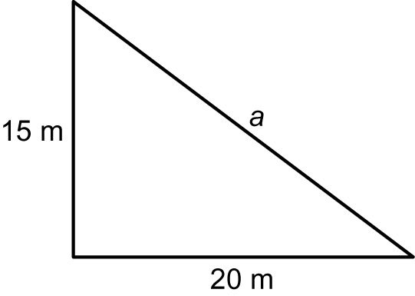  3. Sketch and label the top, front, and sides views of an eraser.  4. Rotate the eraser 90° clockwise. Draw the front view.  5. Sketch the top, front, and side views of this solid.  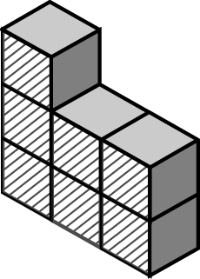 | Mental Math  6. Calculate 5.5% of $2000.  7. Estimate of 300.  For #8 to #10, estimate the missing value.  8.  9.  10.

Section 5.3

1. Determine the square of 7.2.  2. You earn 4 on a $600 bond. What is the bond worth at the end of one year?  3. Sketch the top, front, and side views of this solid.  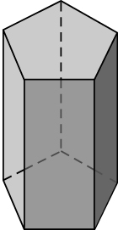  4. If you turn the polyhedron from #3 90° degrees counterclockwise, how would the three views change? Sketch and label each new view. | 5. Sketch a net for a rectangular prism.  Mental Math  6. What figure will this net produce?  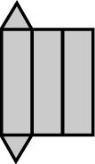  7. Calculate 5.75% of $8000.  8. Calculate 2.5% of 1200.  9. You want to show 50% on a circle graph. How many degrees do you need for the sector?  10. You want to show 33% on a circle graph. How many degrees do you need for the sector?
Section 5.4

1. Draw and label the measurements of the three views of this triangular prism.  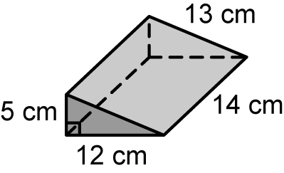  2. Calculate the surface area of the prism in #1.  3. Name the solid shown in these views.  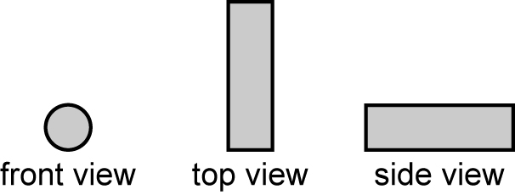  4. A horse that is working has a heart rate of 18 beats in 15 s. Show this as a unit rate. | 5. In a band, the ratio of drums to brass instruments is 1 : 5. What percent of the instruments are drums?  Mental Math  6. You want to show 75% on a circle graph. How many degrees do you need for the sector?  7. Estimate 25.75% of 2500.  For #8 to #10, identify the missing numbers.  8.  9.  10.

