Chapter 5 Problems of the Week
1. The rectangle below is divided into square regions; it represents a design painted by students on a school fence. Find the area of each region on the fence and label the diagram. Find the surface area of the fence.  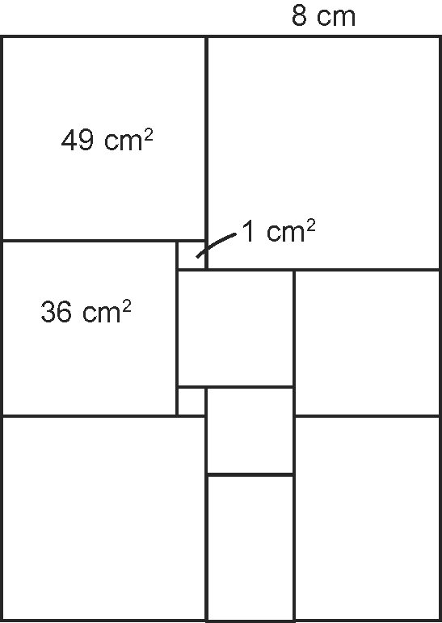 | 2. Two grade eight students were asked to present a strategy for developing a formula for finding the surface area of a right cylinder. They chose a zippered sleeping bag and two Hula Hoops® as manipulatives. Explain how they can use these items in their presentation.
3. A rectangle is formed by folding a square in half. The perimeter of the resulting rectangle is 27 cm. What is the area of the original square? | 4. A total of 24 cubes fill a container.  If the wooden cubes measure 2 cm³, what are all of the possible dimensions of the container?

