Section 5.1 Extra Practice
1. Label the diagram.
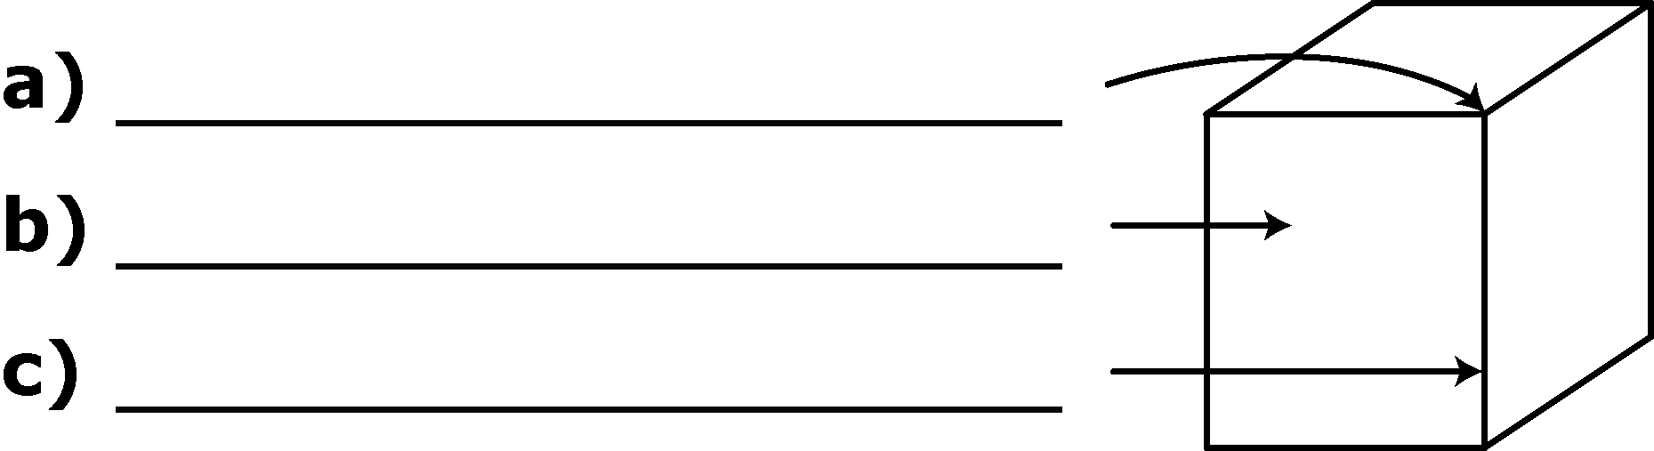
2. Draw the front, side, and top views of the cube from #1 and label each view.

3. Rotate the following objects 90° clockwise, then draw them on the grid paper.
a)
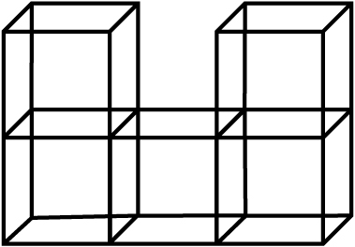 | 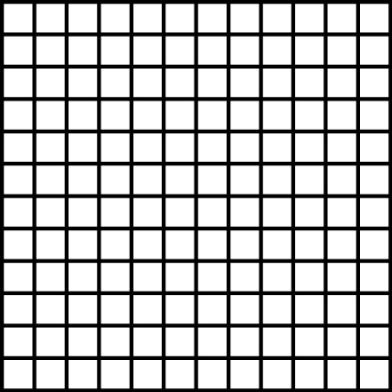

b)
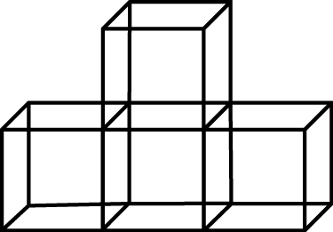

4. Draw the front, side, and top views of the solid on the grid paper.
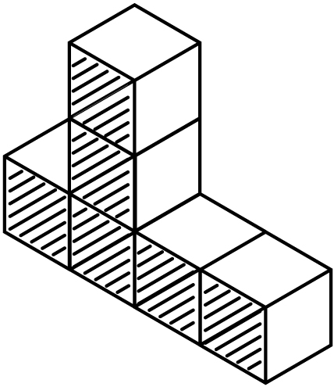 | 