Section 5.2 Extra Practice
1. Fill in each blank.

A net is a ____________________ -dimensional shape that when folded
becomes a ____________________ -dimensional object.

2. Use the grid paper to sketch a net for each object.
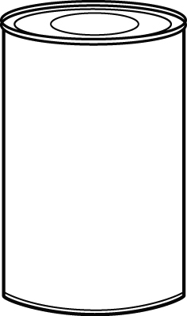
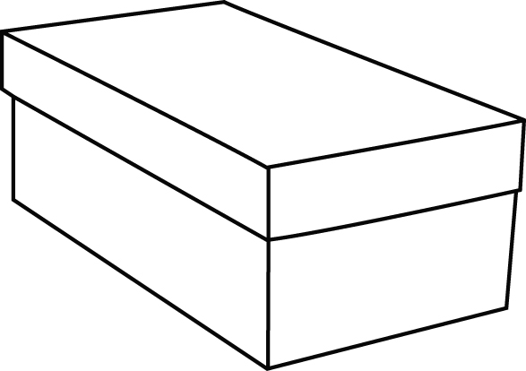
a) b)

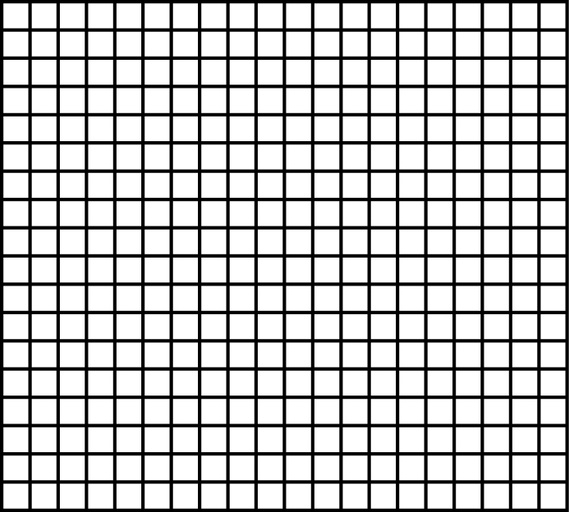

3. Draw the net for each object. Label the measurements on the net.
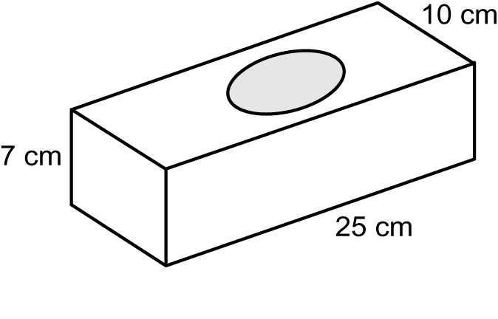
a)

b) Note: C = × d. Round your answer to the nearest whole centimetre.

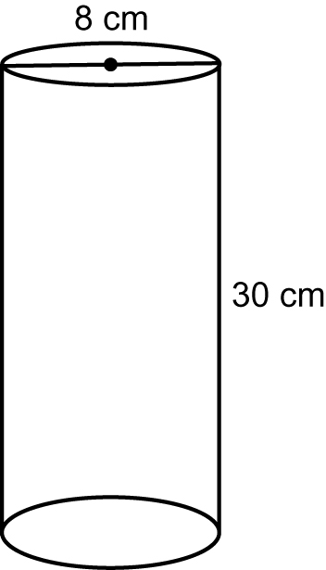

4. Draw the net on grid paper. Then, draw the 3-D object that this net makes.

