Section 5.3 Extra Practice
1. Fill in each blank.
To find the total surface area of a 3-D object:
a) ____________________ the number of faces.
b) Calculate the ____________________ of each face.
c) Find the ____________________ of the surface areas of the faces.

For #2 and #3, calculate the surface area of each prism to the nearest tenth of a centimetre.

2. a) Number of faces ____  b)  c) Total surface area  ____________________ | 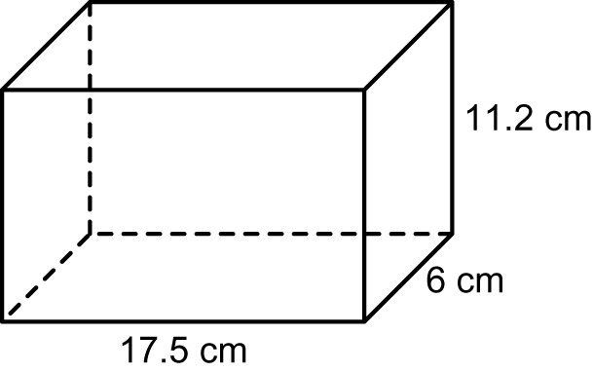

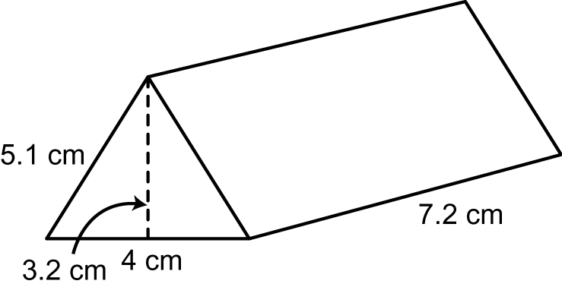
3. a) Number of faces ____
b)
c) Total surface area
____________________

4. Rahim ’ s dad wants to paint the outside of his garage, including the roof.

a) How many sides of the garage
need to be painted? ____
b) Name the two shapes that make up the front and the back side of the garage.
____________________ and
____________________

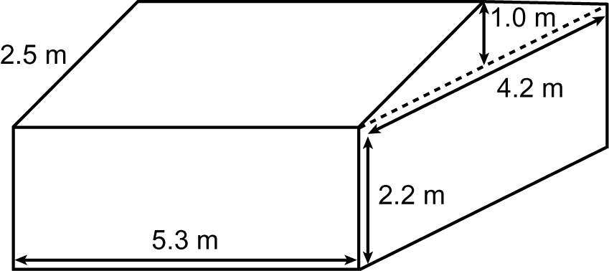

c) Calculate the total surface area that needs to be painted. Show your work. Round your answer to the nearest tenth of a metre.

