Chapter 5 Test
For #1 to #5, choose the best answer.

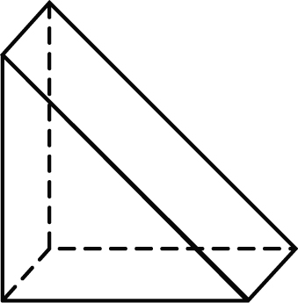
1. What is the name of the following shape?
A cube
B cylinder
C rectangular prism
D triangular prism

2. The diameter and height of a cylinder are each 2 cm. What is the surface area of the cylinder to the nearest hundredth of a square centimetre?
A 15.70 cm² B 18.84 cm² C 31.40 cm² D 37.68 cm²

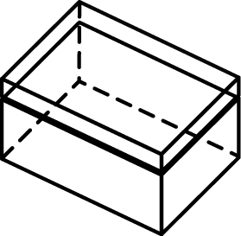
3. What 3-D object has a net like this one?
A cube
B cylinder
C rectangular prism
D triangular prism

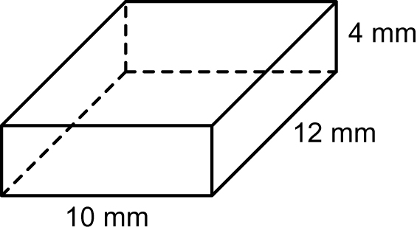
4. What is the surface area of this box?
A 208 mm²
B 296 mm²
C 416 mm²
D 832 mm²

5. What is the length of one side of a cube whose surface area is 600 cm²?
A 10 cm B 15 cm C 20 cm D 60 cm

Short Answer

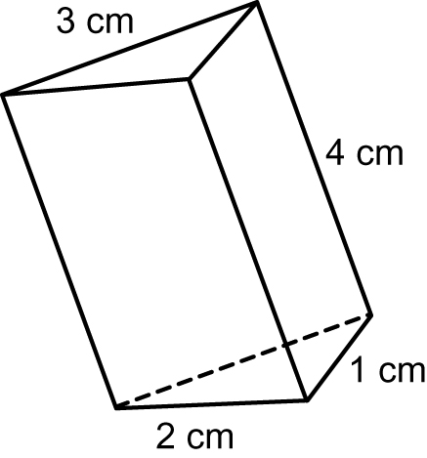
6. An object may have more than one net.
Draw two different nets for this triangular prism.

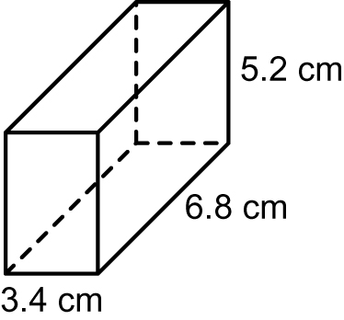
7. Calculate the surface area of the rectangular
prism to the nearest tenth of a square centimetre.

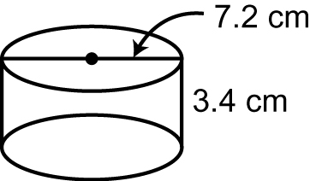
8. Calculate the surface area of the cylinder
to the nearest tenth of a square centimetre.

Extended Response

9. You are designing a covered container in the shape of a rectangular prism for 24 hockey pucks. Each puck has a diameter of 7.6 cm and a height of 2.5 cm.
a) Design two different containers and calculate the surface area of
each one.
b) Which container would you choose to build? Justify your choice.

10. Jon wants to remodel his bedroom. It has a length of 4.2 m, a width of 3.7 m, and a height of 2.5 m. How much will it cost to paint the ceiling and walls, as well as carpet the floor?
• The paint he chooses costs $17 per litre. One litre covers 20 m².
• The carpet he chooses costs $34 per m².

