Chapter 5 BLM Answers

BLM 5–1 Chapter 5 Math Link Introduction
1. Answers will vary. Example: residential,
commercial, industrial
2. Answers will vary. Examples:
• hospital; commercial; square, rectangle
• house; residential; square, triangle, rectangle
3. Answers will vary. Example: fire hydrants,
telephone wires, roads, sidewalks, trees
4. Ensure students accurately sketch an aerial
view of the community, including essential
buildings and other features.
BLM 5–2 Chapter 5 Get Ready
1.
Name | Faces | Edges | Vertices
a) rectangular prism | 6 | 12 | 8
b) triangular prism | 5 | 9 | 6
c) cube | 6 | 12 | 8
2. a) 22 cm b) 12.6 cm
3. a) 50.2 cm² b) 12.6 cm²
4. a) 16.5 cm² b) 20 cm²
5. a) 17.5 cm² b) 30 cm²
6. a) 26.3 cm² b) 50 cm²
BLM 5–3 Chapter 5 Warm-Up

Section 5.1
1. 63.5% 2. 2.49 3. 0.375
4. Front End Estimate: $75 + $7.50 = $83.50
Relative Size Estimate: $75 + $7.50 + $3.75 = $86.25. Calculate: $83.25
5. 169 6.
7. 1% = $100; 0.5% = $50; 2.5% = $250
8. 1% = $5; = $2.50
9. 1% = 2.5; ≈ 0.6; ≈ 3.1
10. 10% = $14.90; 5% = $7.45

Section 5.2
1. No. 7 × 7 = 49; 8 × 8 = 64. This is between
the two perfect squares.
2. 25 m
3. Answers will vary according to the eraser.
Sketches will likely show a rectangular prism.
4. If the original front view is the long face, then the second front view should be the short face.
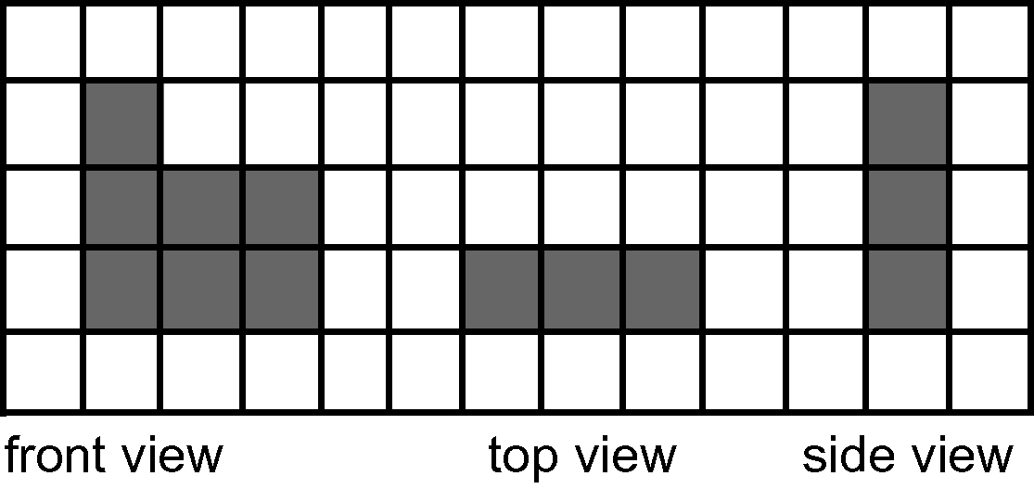
5.

6. 10% = $200; 5% = $100; 1% = $20; 0.5% =
$10; 5.5% = $110
7. 1% = 3; ≈ 0.80; ≈ 0.8
8. ≈ 180 9. ≈ 36 or 40 10. ≈ 280

Section 5.3
1. 51.84 2. $628.50
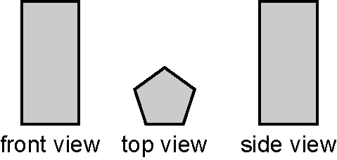
3.

4. Because the front and side views are the same
size, they will look the same as the views in #3.
5. Answers may vary. Example:
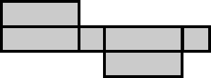
6. a triangular prism
7. 1% = $80; 0.25% = $20; 0.75% = $60; 5%
= $400; 5.75% = $460
8. 1% = $12; 0.5% = $6; 2.5% = $30
9. 180° 10. 120°

Section 5.4
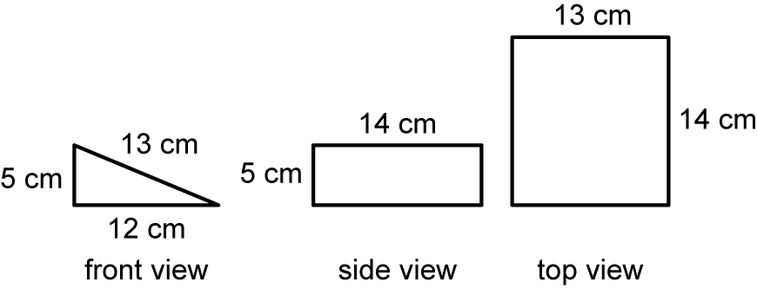
1.

2. front view = 30 cm²; side view = 70 cm²; top
view = 182 cm². There are 2 rectangles of 13 ×
14 = 364 cm². Total = 464 cm².
3. cylinder 4. 72 beats/min 5. 20% 6. 270°
7. 10% = 250; 5% = 125; 25.75% ≈ 625
8. = 18 9. = 7 10. = 15
BLM 5–4 Chapter 5 Problems of the Week
1. The total surface area of the shape is: 20 cm
× 15 cm = 300 cm².
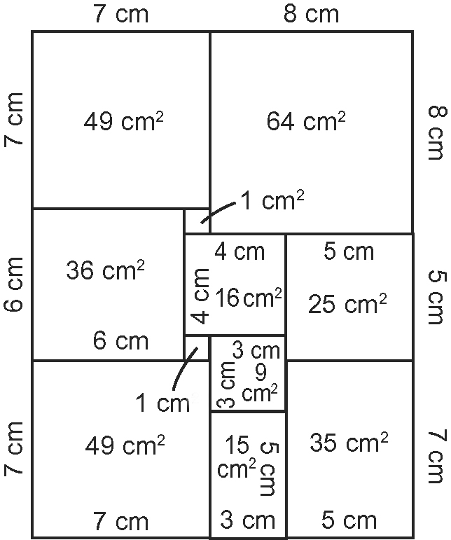
2. Answers will vary. Example: The two Hula Hoops® represent the top and bottom of the cylinder. It is easy to measure the diameter of the hoops, calculate the area, and measure the circumference (use a string). With the zipper closed, the sleeping bag curves around the hoops to form the cylinder. With the zipper open, the curved face of the cylinder can be flattened out to form a rectangle of height h, and length l equal to the circumference of the hoop. The entire surface area is a total of the area of the two circles and the rectangle, just as the formula suggests.
3. 81 cm² . The original square was 9 cm × 9 cm,
with a perimeter of 36 cm. When folded in half
along one of the edges to form a rectangle, two
edges become 4.5 cm, resulting in a perimeter of
2(4.5 cm + 9 cm) = 27 cm.
4. There are six possible measurements for the
containers if orientation does not count: 2 cm × 2
cm × 48 cm; 4 cm × 2 cm × 24 cm; (This would
be the same as 2 cm × 4 cm × 24 cm.); 6 cm ×
2 cm × 16 cm; 8 cm × 2 cm × 12 cm; 4 cm × 4
cm × 12 cm; 4 cm × 6 cm × 8 cm.
BLM 5–6 Section 5.1 Extra Practice
1. a) vertex b) face c) edge
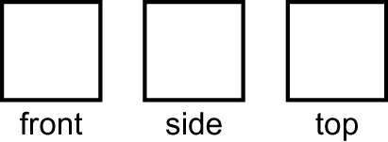
2.

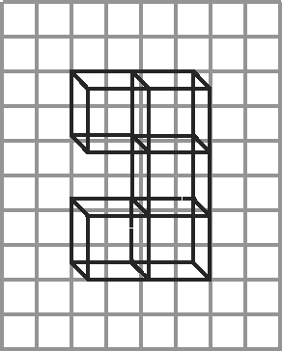
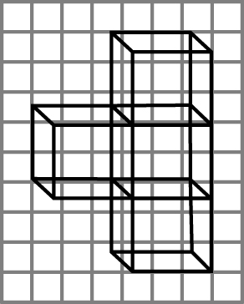
3. a) b)

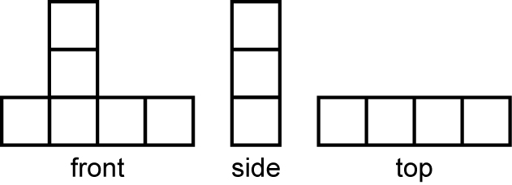
4.

BLM 5–7 Section 5.1 Math Link
1. Answers will vary. Example: house;
residential; square, rectangle, triangle
2., 3. Look for accuracy in drawings.

BLM 5–9 Section 5.2 Extra Practice
1. a) two b) three
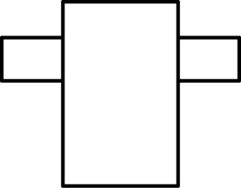
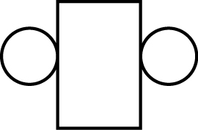
2. a) b)

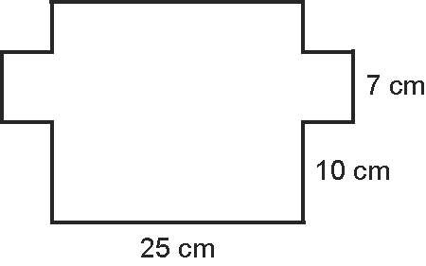
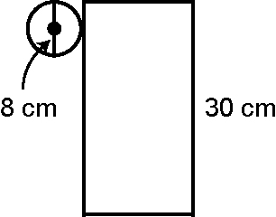
3. a) b)

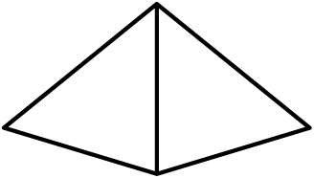
4.

BLM 5–10 Section 5.2 Math Link
1. a), 2. a) Look for an accurate 3-D sketch.
1. b), 2. b) Ensure students accurately draw a net of the building and label the measurements.

BLM 5–11 Section 5.3 Extra Practice
1. count or add; area; sum or total
2. a) 6 b) 392.0 cm²; 134.4 cm²; 210.0 cm²
c) 736.4 cm²
3. a) 5 b) 12.8 cm²; 73.4 cm²; 28.8 cm²
c) 115 cm²
4. a) 6 b) rectangle; triangle c) 72.5 m²
BLM 5–13 Compare the Surface Area of a Prism and a Cylinder
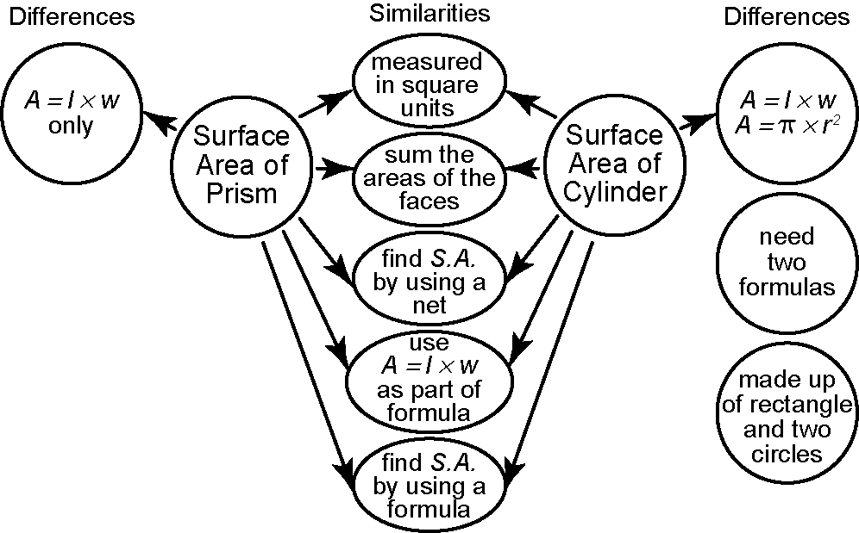

BLM 5–14 Section 5.4 Extra Practice
1. a) rectangle, circles b) diameter 2. half
3. S.A.= 2 × ( × r²) + ( × d × h)
4. Answers may vary. Example:
a) 75 cm²; 150 cm²; 180 cm²; 330 cm²
b) 108 cm²; 216 cm²; 360 cm²; 576 cm²
c) 300 cm²; 600 cm²; 1000 cm²; 1600 cm²
5. a) 345.4 cm² b) 720.31 cm² c) 1888.21 cm²
BLM 5-16 Chapter 5 Test
1. D 2. B 3. A 4. C 5. A
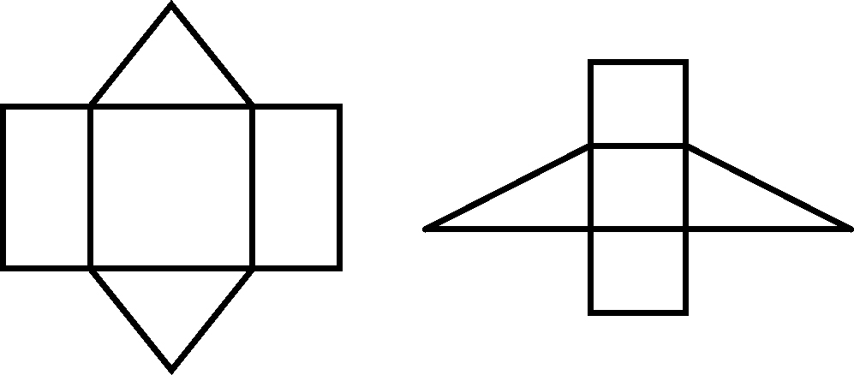
6.

7. 152.3 cm² 8. 158.3 cm²
9. Answers may vary. Example:
a) Container 1: 4 × 3 × 2; S.A. = 1608.16 cm²
Container 2: 3 × 2 × 4; 1453.12 cm²
b) Ensure students justify their choice.
10. Paint S.A. = 55.04 m²; cost: $51; Carpet S.A. = 15.54 m²; cost: $528.36. Total cost = $579.36

