Chapter 6 Math Link Introduction
This worksheet will help you with the Math Link on page 197.

Read the introduction to the Math Link.

1. The sum of two fractions can be represented using diagrams. For example,
+ =
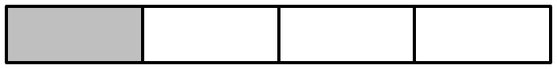


+


=

Represent the sum of the Pacific Marine ecozone ( of the length of Canada’s coastline) and the Northwest Atlantic ecozone ( of the length of Canada’s coastline) with a diagram. What is the sum?

2. The sum of two fractions can also be found using common denominators.
a) What is a common denominator for and ? ____
b) Add the fractions using that common denominator.
+ = =

3. The Montane Cordillera ecozone covers of Canada. The Northern Arctic ecozone covers of Canada. What total fraction of Canada do these two ecozones cover? Show your work.
4. The Prairies ecozone covers the provinces of Alberta, Saskatchewan, and Manitoba. About of the area is in Saskatchewan, and about of the area is in Alberta. What fraction of the area is in Manitoba? Follow the steps below to answer the question.
a) What fraction represents the combined areas of Alberta and Saskatchewan? Show your diagram or work.

b) Write a mathematical statement using your answer to part a) to represent the fraction of the area that is in Manitoba.
___________________________________________________________

Evaluate your expression.
___________________________________________________________

