Add and Subtract Fractions

To add fractions with like denominators, add the numerators.
Each fraction in the sum is a proper fraction, because the denominator is greater than the numerator.

To subtract fractions with unlike denominators, use a common
denominator. This is a common
multiple of the denominators.




Write the answer in lowest terms.

÷2

÷2

1. Add. Write each answer in lowest terms.
a) b) c) d)
2. Subtract. Write each answer in lowest terms.
a) b) c) d)

Add and Subtract Mixed Numbers

A mixed number includes a whole number and a fraction.
Write the improper fraction as a mixed number.

To subtract mixed numbers, use a common denominator.
If the second fraction is bigger than the first, use one of the following methods.
Use an Improper Fraction | Use Regrouping  Regroup 1 whole from .  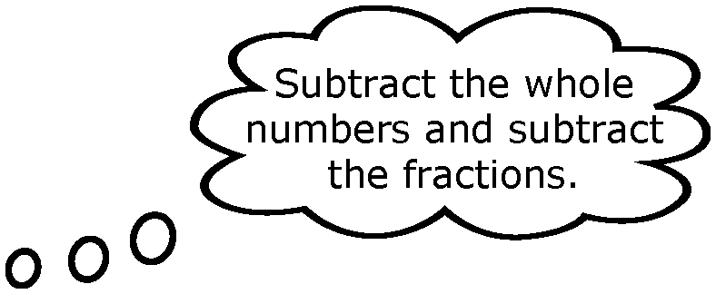

3. Add or subtract. Write each answer in lowest terms.
a) b)
c) d)
e) f)
g) h)

4. Add. Write each answer in lowest terms.
a) b)
c) d)
5. Subtract. Write each answer in lowest terms.
a) b)
c) d)

Order of Operations

The order of operations is the correct sequence of steps for a calculation.
30 − 14 ÷ (5 − 3) × 4 + 6 Do brackets first.
= 30 − 14 ÷ 2 × 4 + 6 Multiply and divide, from left to right.
= 30 − 28 + 6 Add and subtract, from left to right.
= 8

6. Calculate.
a) 3 − 12 ÷ 2 + 4 b) 10 × 3 − 15 ÷ 3
c) 16 ÷ (3 + 5) − 10 ÷ 5 d) 8 + 18 ÷ 3 − 2 × (4 + 1)

