Chapter 6 Warm-Up
Section 6.1

1. Estimate the surface area of this cylinder. Show your thinking.
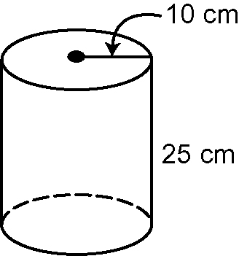
2. Calculate the surface area of the cylinder in #1.
3. Draw a net for the cylinder in #1.
4. Sketch and label the top and side views of the cylinder in #1.
5. Sketch and label the top, front, and side views of your calculator.
Mental Math
6. A circle has a radius of 2 m. Estimate the perimeter of the circle.
7. Estimate the area of the circle
in #6.
8. What is 33% as a fraction?
9. Show 1.25 as a percent and a reduced fraction.
10. Convert to a decimal and a percent.

Section 6.2

For #1 and #2, write the multiplication statement being modelled.
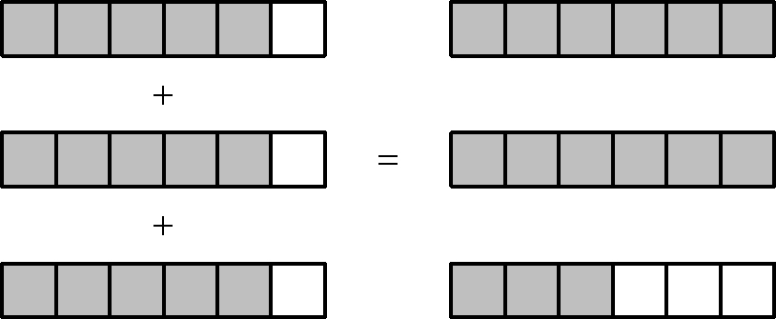
1.

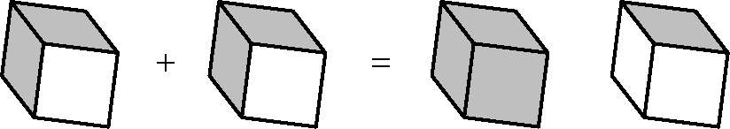
2.

Use manipulatives or diagrams to answer #3 and #4.
3. 4 ×
4. 7 ×
5. All views of a right prism are identical. What kind of right prism is it?
Mental Math
6. A bicycle is on sale for 10% off the original price of $300. What is the sale price?
7. Describe a second way to mentally calculate the sale price.
8. Show as a percent.
9. Show 0.5% on a hundred grid.
10. Show 45.5% on a hundred grid.

Section 6.3

Use manipulatives or diagrams to answer #1 to #5.
1. ÷ 3
2. ÷ 2
3. ÷ 4
4. 5 ×
5. 18 ×

Mental Math
6. How could you do #5 using mental math?
Using the method you developed in #6, do #7 and #8.
7. 8 ×
8. 15 ×
9. Show this number as a percent and a decimal.
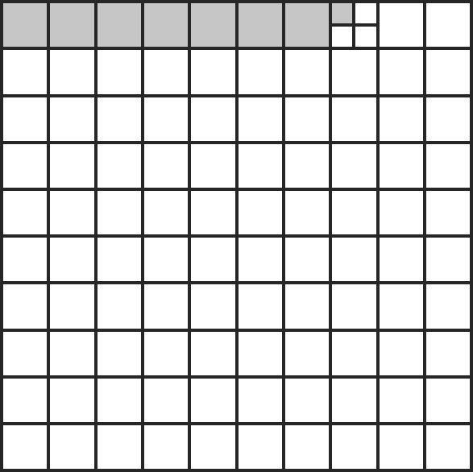
10. Show 105.3% as a decimal.

Section 6.4

Estimate and calculate each product for #1 to #3.
1. ×
2. ×
3. ×
Use manipulatives or diagrams to answer #4 and #5.
4. ÷ 4
5. ÷ 12
Mental Math
6. What is 150% of $20?
7. What is 0.3% of $2000?
8. What is 2.5% of $60 000?
9. Determine .
10. Determine 11².

Section 6.5

1. Express as a mixed number.
a) b)
2. Express as an improper fraction.
a) b)
Use a method of your choice for #3 to #5.
3.
4.
5.
Mental Math
6. Estimate . Show your thinking.
7. Estimate . Show your thinking.
8. Estimate . Show your thinking.
9. Determine 12².
10. Determine 13².

Section 6.6

Use a method of your choice for #1 to #5.
1.
2.
3.
4.
5.
Mental Math
6. Cheese costs $7.98 for 2 kg. What is the unit rate?

Use this visual for #7 to #10.
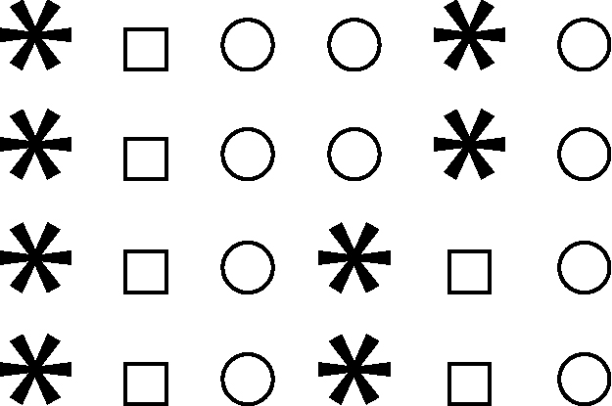

7. What is the ratio of stars to circles to squares?
8. Express the ratio from #7 in lowest terms.
9. Express the ratio of stars to squares as a mixed number in lowest terms.
10. Express the ratio of squares to circles as a fraction in lowest terms.

