Section 6.1 Extra Practice
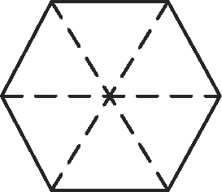
1. What multiplication statement do the manipulatives represent? Assume that a
hexagon such as this one represents one whole.

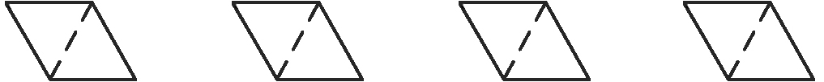
a)
___________________________________________________________

b)
___________________________________________________________

c)
___________________________________________________________

2. What multiplication statement does each diagram represent?
a)
___________________________________________________________
b)
___________________________________________________________
c)
___________________________________________________________

3. Determine the product using the number lines. Write the multiplication statement, including the product, on the blank line.
a) 4 ×
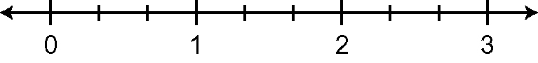
____________________
b) 3 ×
____________________

4. Determine each product.
a) 5 × = ______ b) 3 × = ______ c) 6 × = ______

5. Determine each product.
a) of 24 = ______ b) of 12 = ______ c) of 30 = ______

6. There are 28 students in a class. Three-quarters of the class takes the bus to school. How many students take the bus to school? Show your work.

7. A team won of the 40 games that they played. How many games did they
win? ______

