Section 6.2 Extra Practice
1. Complete the diagrams to determine each quotient.
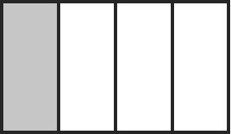
a) ÷ 2 = ______
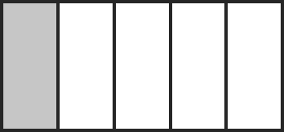
b) ÷ 2 = ______
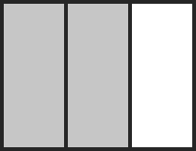
c) ÷ 3 = ______
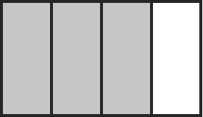
d) ÷ 3 = ______
2. Fill in the blanks.
a) If is divided into two equal parts, how large is each part?
÷ 2 = ______
b) If is divided into two equal parts, how large is each part?
÷ 2 = ______
c) If is divided into three equal parts, how large is each part?
÷ 3 = ______
d) If is divided into three equal parts, how large is each part?
÷ 3 = ______

3. One-fourth of a cake is left. Conrad, Angela, and Francine want to share this portion equally. How much of the cake will they each get?
a) Write a division statement to answer this question. Determine the quotient.
_____________________________________________________________

b) Write a sentence answer.
_____________________________________________________________
_____________________________________________________________

4. Five-sixths of the grade 8 students in a school are taking band. These band students are divided into four equal groups. What fraction of the grade 8 students is in each of these groups?
a) Write a division statement to answer this question. Determine the quotient. Explain your reasoning.
_____________________________________________________________
_____________________________________________________________
b) Write a sentence answer.
_____________________________________________________________
_____________________________________________________________

