Section 6.4 Extra Practice
1. The diagram below models 2 × 3. Use the diagram to complete the questions.
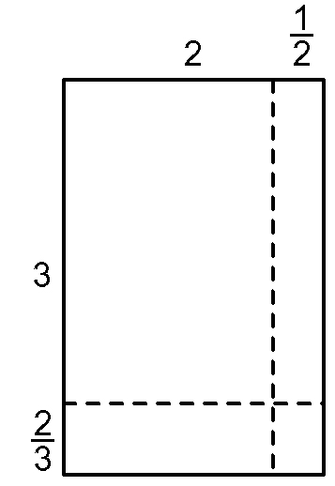
a) Fill in the blanks to find the partial areas. Label the area of each of the regions in the diagram as you calculate it below.
Partial Areas:
2 × 3 = 6
______ × = ______
______ × = ______
× ______ = ______
b) Add the areas: 6 + ____ + ____ + ____+ ____ = ____
c) Estimate the product: ______ × ______ = ______
d) Write the mixed numbers as improper fractions and multiply:
2 = , 3 = , × =

Express the answer in lowest terms. ____________

2. Show the improper fractions as mixed numbers. Write the fraction in lowest terms. The first line is partially completed.
a) = + + + = ____________
b) = ______________________________
c) = _____________________________
d) = _____________________________
3. Complete the table.

 | Multiplication of Mixed Numbers | Multiplication of Improper Fractions | Product Expressed as Improper Fraction | Product Expressed as Mixed Number
Example | 1 × 2 | × |  | 3 = 3
a) | 1 × 1
b) | 2 × 1
c) | 1 × 1
d) | 1 × 2

4. Jasmine worked 3 h a day for five days. How many hours did Jasmine work altogether? Show your work.

