Section 6.5 Extra Practice
1. Fill in the blanks. Then, write the division statement, including the quotient, that matches the diagram.

Example

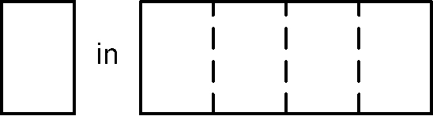
How many s in 1? 1 ÷ = 4


a) How many ______ in ______? ____________

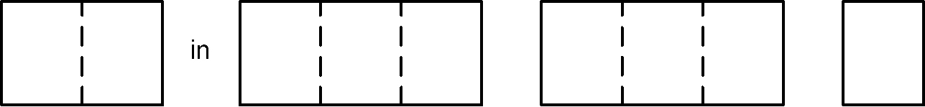
b) How many ______ in ______? ____________

2. Divide using a common denominator. Show your work.
a) ÷ = ____________ b) ÷ = ____________
c) 2 ÷ = ____________ d) 3 ÷ 1 = ____________

3. Write the reciprocal.
a) ________ b) ________ c) 2 ________ d) 4 ________

4. Divide using multiplication. Show your work.
a) ÷ = ____________ b) 2 ÷ 1 = ____________
c) ÷ = ____________ d) 8 ÷ 1 = ____________

5. For each question below, do the following:
• Write the division statement that matches the problem.
• Estimate the answer, showing your work.
• Divide, and then write the sentence answer.
a) How many cup portions are in 1 cups of sugar?
Division Statement | Estimate | Calculation

__________________________________________________________
b) Sabrina has 3 L of ice cream to share equally among herself and her nine friends at her birthday party. How much ice cream will each get?
Division Statement | Estimate | Calculation

__________________________________________________________

