Section 6.5 Math Link
This worksheet will help you with the Math Link on page 229.

1. What is one of the rules for dividing mixed numbers?
______________________________________________________________
______________________________________________________________

2. Use the rule on this question: 5 ÷ 3. Show your work below. What is the quotient? ______

3. To help you decide what operation is needed to answer a question, change the question to a simpler problem by substituting numbers that allow you to compute the answer mentally. Then, determine what operation you should perform. Apply this procedure to the original question. For example,

Original question: The Prairies ecozone includes the Manitoba Plain and the grasslands of southwest Saskatchewan and southeast Alberta. The wettest part of this ecozone is the Manitoba Plain, which has an average annual precipitation of about 70 cm. This amount of precipitation is 2 of the amount in the dry grasslands. What is the average annual precipitation in these grasslands?

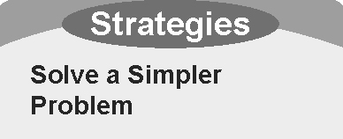
Simpler question: The average annual precipitation in the
Manitoba Plain is 40 cm. This is two times the amount in the
grasslands. What is the precipitation in the grasslands?

The amount of precipitation in the grasslands is half of 40 cm or 20 cm. In other words, the answer is obtained by dividing 40 by 2.

Apply this procedure to answer the original question. Write the mathematical statement you will use.
______________________________________________________________

What is the answer? ______ Show your work below.

