Chapter 6 Test
Do not use a calculator for this test.

For #1 to #5, select the best answer.

1. What is 4 as an improper fraction?
A B C D
2. What is as a mixed number?
A 1 B 1 C 2 D 2
3. Which expression does the fraction strip represent?
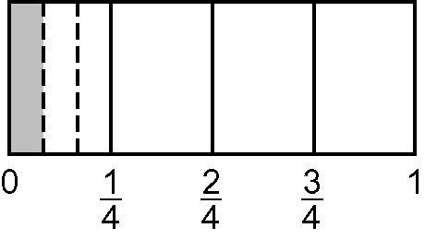
A ÷ 4 B ÷ 3 C ÷ 6 D ÷ 5
4. Which expression does the number line represent?
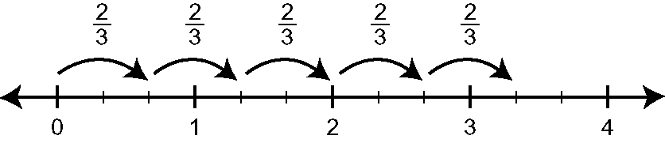
A × 3 B × 4 C × 11 D × 5
5. Which expression has as an answer?
A 2 ÷ 1 B 1 × 1 C 1 × 1 D 2 ÷ 5

Short Answer
6. Draw a diagram to model this division. In your own words, explain the diagram.
÷ = 4
7. Evaluate.
a) × 4 b) 1 × 3 c) ÷
d) 5 ÷ 3 e) ÷ + f) + × –
8. Three friends share a chocolate bar. The first friend takes of the bar and the second takes of the amount that is left. How much of the original bar will the third person receive?
9. Trent feeds his cattle of a square bale each. He has 84 cattle. How many bales will he need to feed his cattle?
10. Bonnie’s snowmobile uses of a litre of gas to travel 12 kilometres. How far can she travel using 20 L of gas?
11. Mr. Stewart has 28 licorice sticks. Each student in his class receives 1 of a licorice stick. How many students are in his class?

Extended Response
12. In each of her 24 training sessions, Michelle ran of a 5-km trail and walked the rest.
a) What is the distance Michelle ran in one session?
b) What is the total distance Michelle walked in the 24 sessions?

