Chapter 6 BLM Answers

BLM 6–1 Chapter 6 Math Link Introduction
1. 2. a) 10 b) =
3. 4. a) b) 1 − =
BLM 6–2 Chapter 6 Get Ready
1. a) b) c) d)
2. a) b) c) d)
3. a) 3 b) 6 c) 1 d) 2
e) 8 f) 5 g) 3 h)
4. a) 3 b) 4 c) 4 d) 7
5. a) 2 b) 2 c) d) 1
6. a) 1 b) 25 c) 0 d) 4
BLM 6–3 Chapter 6 Warm-Up
Section 6.1
1. Answers will vary. Example:
Area of circles ≈100 × 3 × 2 ≈ 600 cm²
Area of rectangle ≈ 20 × 3 × 25 ≈ 1500 cm²
Surface area ≈ 2100 cm²
2. 2198 cm²
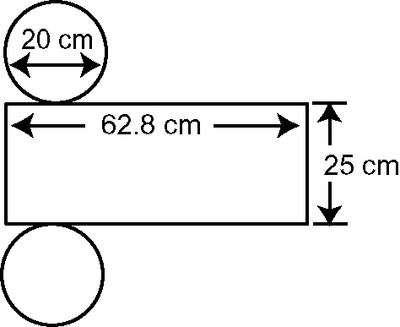
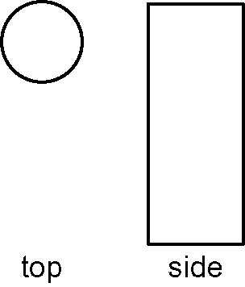
3. 4.

5. Answers will vary. Make sure that the three views are labelled.
6. 12 m 7. 12 m² 8. 9. 125%, 1
10. 0.88, 88%
Section 6.2
1. 3 × = = 2 = 2
2. 2 × = = 1 3. = 1 = 1
4. = 3 5. a cube 6. $270
7. Answers will vary. Examples:
• Divide $300 by 10 and then subtract the answer from $300.
• Multiply $300 by 0.9: 9 × 3 = 27 and add a zero.
8. 62.5%

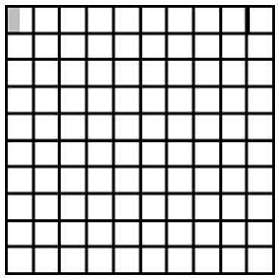
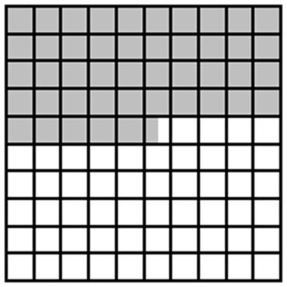
9. 10.

Section 6.3
1. 2. 3. = 4. = 2
5. = 2
6. Answers will vary. Example: Use patterning. It takes 9 ninths to make 1 whole. 18 is 2 × 9. Therefore, the answer is 2.
7. 2 8. 3 9. 7.25%; 0.0725 10. 1.053
Section 6.4
1. Estimates may vary. Example: 0; =
2. Estimates may vary. Example: 0;
3. Estimates may vary. Example:;
4. = 5. 6. $30 7. $6
8. $1500 9. 9 10. 121
Section 6.5
1. a) 3 b) 7 2. a) b)
3. = 4 = 4 4. = 2 = 2
5. = 9
6. 8² = 64 7. 10² = 100
9² = 81 11² = 121
≈ 8.6 ≈ 10.7
8. 6² = 36 9. 144 10. 169
7² = 49
≈ 6.2

Section 6.6
1. 2. 3. = 11 4. = 1
5. = 2 6. $3.99 7. 8 : 10 : 6
8. 4 : 5 : 3 9. = 1 10. =
BLM 6–4 Chapter 6 Problems of the Week
1. a) Since the product for the first apple is 60g, and the product for the second apple is 51g, the first apple will have the largest bruise.

b) Answers will vary. Example: Other factors may be what kind of surface they fall on (rocks, grass, etc.).
2. a) cm b) Team 1 card: cm²,
Team 2 card: cm², Team 3 card: cm². Team 3 card exceeds specifications.
3. 18 m 4. The pool is full. of the pool still needs to be filled. 5. a) 24 b) 6
6. The 10 cm × 12 cm and the 8 cm × 9.6 cm picture. Both of these ratios, when compared as a fraction, are equal to 0.83.
7. Dirk’s mother is correct. He drank L of lemonade.
8. of the pool is pumped; still needs to be pumped; h to empty the pool
BLM 6–6 Section 6.1 Extra Practice
1. a) 4 × b) 3 × c) 5 ×
2. a) 3 × b) 2 × c) 3 ×
3. a) , and an appropriately marked number line
b) , and an appropriately marked number line
4. a) b) c)
5. a) 6 b) 8 c) 21 6. 21 7. 25
BLM 6–7 Section 6.1 Math Link
1. 2. a) 25 b) 75 c) 4 d) Answers may vary. Example: 3 × 25
3. a) 2; 6 b) 4; 12 c) 6; 18 d) 5; 15
4. 5 5. 15

BLM 6–10 Section 6.2 Extra Practice
1. a) , and correctly marked fraction strip
b) , and correctly marked fraction strip
c) , and correctly marked fraction strip
d) or , and correctly marked fraction strip
2. a) b) c) d)
3. a) ÷ 3 =
b) They would each get of the cake.
4. a) ÷ 4 = b) of the grade 8 students would be in each of the groups.

BLM 6–11 Section 6.2 Math Link
1. , and appropriately drawn pattern blocks
2. , and appropriately drawn fraction strips
3. , and appropriately drawn number line
4. a) ÷ 2 b)
BLM 6–12 Section 6.3 Extra Practice
1. a) halves, thirds, or thirds, halves
b) quarters, thirds, or thirds, quarters
c) less d) 0, , 1 e) numerator, numerator, denominator, denominator
2. a) , and a correctly marked rectangle
b) , and a correctly marked rectangle
3. a) × 1 = ; b) × 1 = ;
c) × = ;
4. of Mr. Saari’s is on a “rep” team.
BLM 6–13 Section 6.3 Math Link
1. 2. 3. Rule: Multiply the numerators and multiply the denominators; .
4. Answers will vary. Example: I prefer using the rule because it is just basic multiplication.
BLM 6–14 Section 6.4 Extra Practice
1. a) 2 × = ; 3 × = ; × =
b) 6 + 1 + 1 +
= 8 + + +
= 8 = 9
c) Estimates may vary. Example: 3 × 4 = 12
d) ;; × = = 9
2. a) = 3
b) + + + + = 4
c) + + = 2 = 2
d) + + + = 3 = 3
3. a) × ; ; 5
b) × ;; 3 = 3
c) × ;; 2 d) × ;; 4
4. h
BLM 6–15 Section 6.4 Math Link
1. 2. Express them as improper fractions and then multiply the numerators and multiply the denominators.
3. Answers will vary. Example: I like diagrams better for simple equations. 4.
BLM 6–17 Section 6.5 Extra Practice
1. a) ; 1; 1 ÷ = 3
b) ; 2; 2 ÷ = 3
2. a) 6 b) 1 c) 3 d) 3
3. a) 3 b) or c) d)
4. a) b) 1 c) 5 d) 4
5. a) 1 ÷ ; 2 ÷ 1 = 2. There are two portions.
b) 3 ÷ 10; 3 ÷ 10 = . Each will get .
BLM 6–18 Section 6.5 Math Link
1. Answers will vary. Example: Change them to improper fractions, write them with a common denominator, and divide the numerators.
2. 1 3. 70 ÷ 2; 25 cm
BLM 6–19 Section 6.6 Extra Practice
1. brackets, multiplication/division, addition/subtraction
2. a) F; 5 − 3 × = 3
b) F; 2 − 2 × = 1 c) T
3. a) b) c)2
4. a) 200 × + (275 − 200) × ; 35.
The total discount was $35.
b) 20 ÷ + 18 ÷ ; 55. There were 55 students in total.

BLM 6–20 Section 6.6 Math Link
1. Answers are in italics. For the last two lines, answers will vary. Samples are provided.
Clue | Suggested  Operation
of 20 | multiplication
equally shared | division
earned time-and-a-half | multiplication
fraction of | division
part of | division
as many as | multiplication
times as long | multiplication
quotient | division
product | multiplication

2. a) Answers will vary. Example: A car can travel 70 km on of a tank of gas. How far can the car travel on 3 tanks of gas?
b) Estimates may vary. Example:
a tank = 70 km
1 tank = 140 m
3 tanks = 420 km
c) How many half tanks are in 3 tanks?
3 ÷ = 6
How far can you go on that many half tanks?
6 × 72 = 420 km
d) Division, to find the number of half tanks in 3 tanks. Multiplication, to calculate the distance travelled. e) Answers will vary.
3. a) Larger. Estimates will vary. Example: 180
b) division c) 50 ÷ = 200
d) Answers will vary.
BLM 6–21 Chapter 6 Test
1. C 2. B 3. B 4. D 5. D
6. Answers may vary. Example:
of the rectangle goes into of the rectangle 4 times.
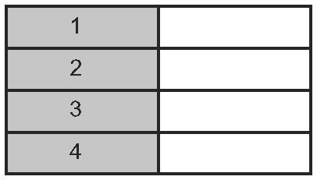

7. a) 2 b) 5 c) 4 d) 1 e) f)
8. 9. 24 10. 300 km
11. 24 students 12. a) 4 km b) 33 km

