Identifying Right Cylinders and Right Prisms
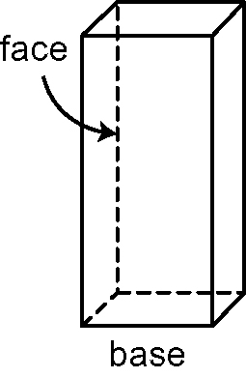
Right prisms and right cylinders have lateral faces
that meet the base at 90°.
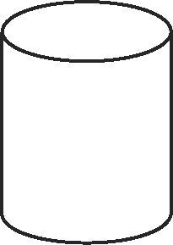 | 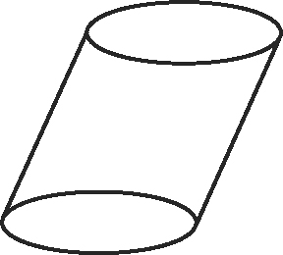
This is a right cylinder. This is not a right cylinder.

1. Identify the right prisms and right cylinders. Explain how you know.
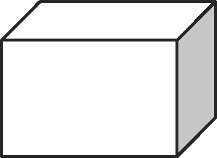
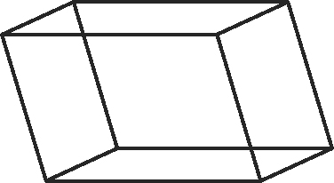
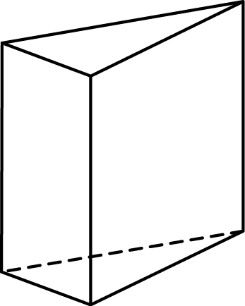
a) b) c)

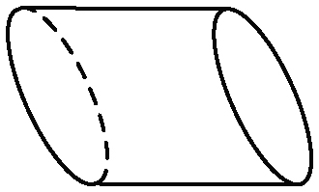
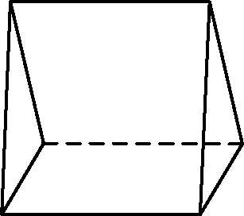
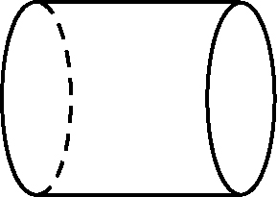
d) e) f)

Use Mental Math

Mental mathematics includes estimating answers mentally.
When asked to estimate, give an approximate but carefully
thought-out answer.
To estimate 58 × 3.7, use numbers that are easy to work with.
50 × 3 = 150 Use front-end estimation.
60 × 4 = 240 Use relative size estimation.
60 × 3 = 180 Round one up and the other down.
The answer to 58 × 3.7 is between 150 and 240.

2. Estimate each answer. Show your thinking.
a) 7.6 × 24 b) 96 × 8.1 c) 2.9 × 68
Calculating Area

Area measures the region inside a two-dimensional space.
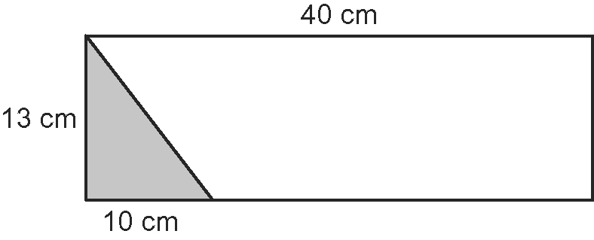
This rectangle has a shaded triangle.
What is the area of the remaining part
of the rectangle?

Area of rectangle = l × w
A = 40 × 13
A = 520
The area of the rectangle is 520 cm².
Area of triangle = (b × h) ÷ 2
A = (10 × 13) ÷ 2
A = 130 ÷ 2
A = 65
The area of the triangle is 65 cm².
Area of unshaded region = Area of rectangle − Area of triangle
A = 520 − 65
A = 455
The area of the unshaded region is 455 cm².

3. Calculate the area of each shaded region.
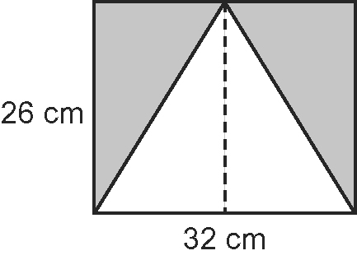
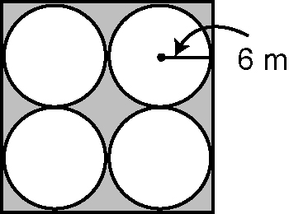
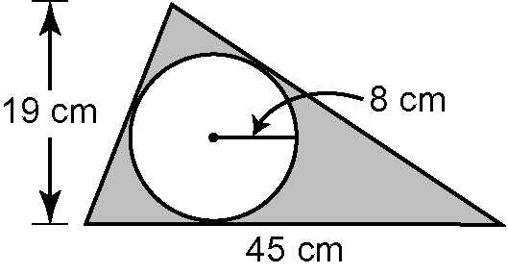
a) b) c)

Repeated Multiplication

6² can be written as 6 × 6.  6² = 6 × 6  {repeated multiplication}  = 36 | 2³ can be written as 2 × 2 × 2.  2³ = 2 × 2 × 2  = 8
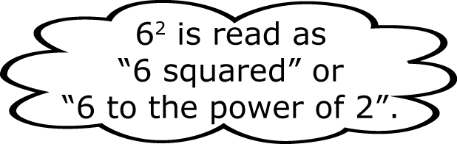
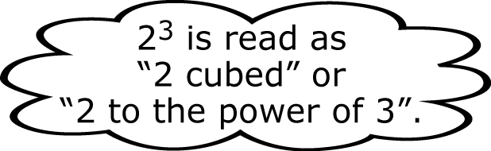

4. Write as repeated multiplication, then calculate each answer.  a) 4³ b) 3⁵ c) 7² d) 5⁴ | 5. Is 3⁴ the same as 4³? Justify your response.

