Chapter 7 Warm-Up
Section 7.1

1. Tabitha is adding scoop of bran to each horse's ration. She has 4 scoops of bran and is feeding 18 horses. Does she have enough bran?
2. Use another method to solve the problem in #1.
3. A juice pitcher is full. You need of the juice in the pitcher for a punch. How much juice will be left in the pitcher?
4. What shape will this net create?
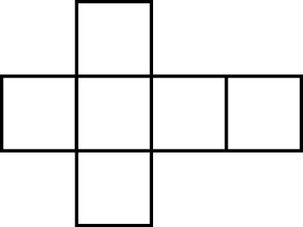
5. Draw another possible net for the figure in #4.

Mental Math
6. a) How many s are in 2?
b) How many s are in 3?
c) How many s are in 7?
d) What method helps you do this mentally?
7. a) Solve × 2.
b) Solve × 3.
c) Solve × 7.
d) What method helps you solve these mentally?
8. If the figure in #4 has a side length of 5 cm, what is the surface area of the figure? Show your thinking.
9. Your aunt offers to give you 150% of what you save. You save $500. How much does your aunt give you?
10. Your uncle offers to give you 0.1% more than your aunt did. What does your uncle give you?

Section 7.2

1. What is the volume of this right rectangular prism?
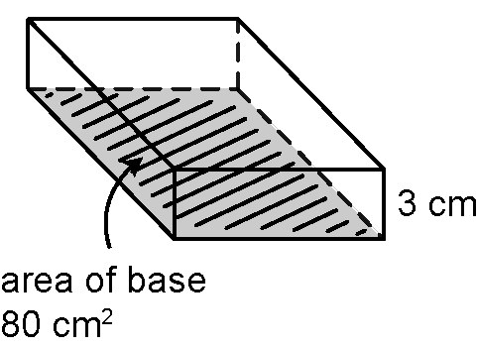
2. This is the same rectangular prism as in #1.
a) What is the volume?
b) How do you know without calculating?
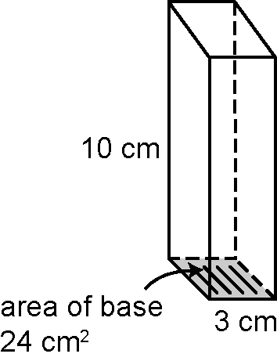
3. What is the volume of this right triangular prism?
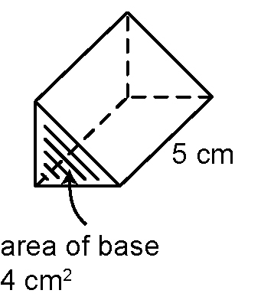
4. What is the volume of this cylinder?
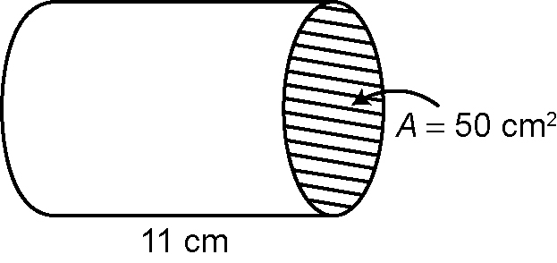
5. Here are three views of an object. Draw the object.
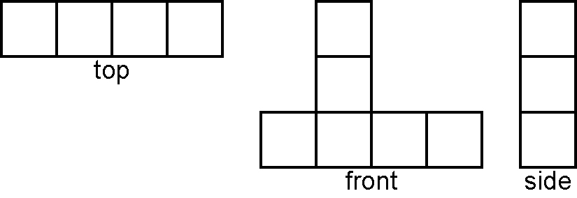
Mental Math
6. You sell $150 worth of gifts and receive 25% of your sales.
a) How much do you receive? Show your thinking.
b) You collect 5% GST on your sales. How much GST do you collect?
7. Show as a percent.
For #8 and #9, use hundred grids to represent each percent.
8. 2.25%
9. 162%
10. Mentally estimate.

Section 7.3

For #1 and #2, calculate the volume of the right prisms.
1. Show your answer to two decimal places.
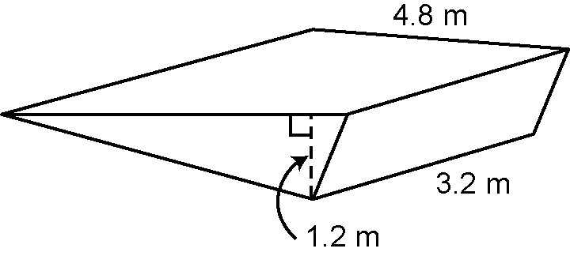
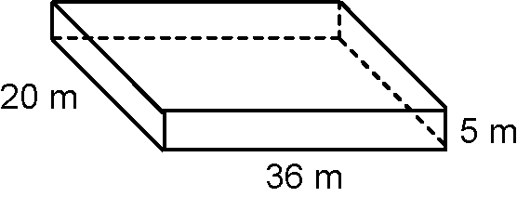
2.

Use this visual to answer #3 to #6.
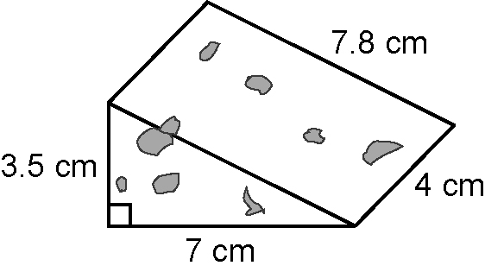
3. Calculate the volume of this chunk of cheese.
4. At a party, you serve of the cheese. What volume do you serve? Round your answer to one decimal place.
5. What is the minimum piece of wrapping you need to cover the cheese? Show your thinking.
Mental Math
6. Estimate an answer to #5 to check the reasonableness of your calculations.
7. Mentally calculate 16 × .
8. Mentally calculate 24 × .
9. Show this number as a percent and a decimal.
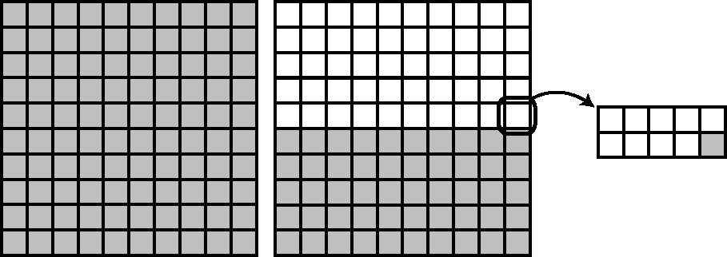
10. What is 66% as a fraction?

Section 7.4

For #1 and #2, estimate and then calculate the volume of each cylinder. Show your thinking. Round your answer to the nearest whole unit.
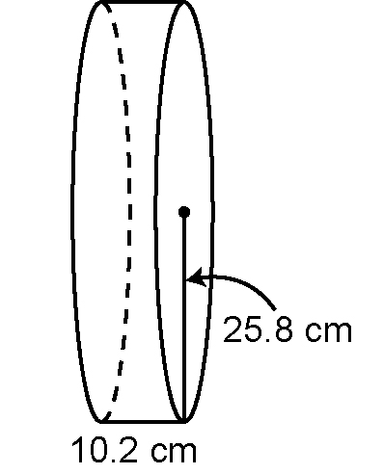
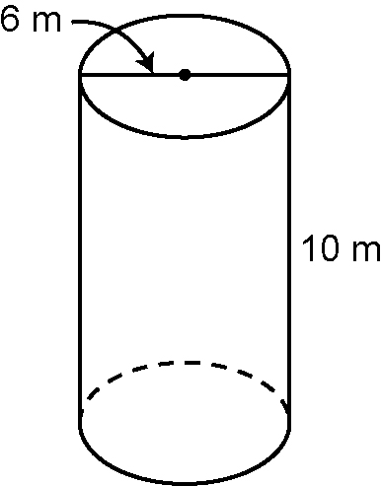
1. 2.

For #3 to #5, use the following data from a grade 8 survey.
Favourite Saturday Activity | Votes
Computer games | 18
Outdoor sports | 19
Riding (includes  bikes and horses) | 21
Visiting friends | 24
Total | 82

3. Display the data using a bar graph.
4. Display the data using a circle graph.
5. Which graph best displays the data? Explain.
Mental Math
6. The volume of a cylinder is
400 cm³. The area of its base
is 40 cm². How high is the cylinder?
7. The volume of a cylinder is
1800 cm³. It is 15 cm high.
What is the area of its base?
For #8 to #10, determine the missing values.
8.
9. 3
10.

