Section 7.1 Extra Practice
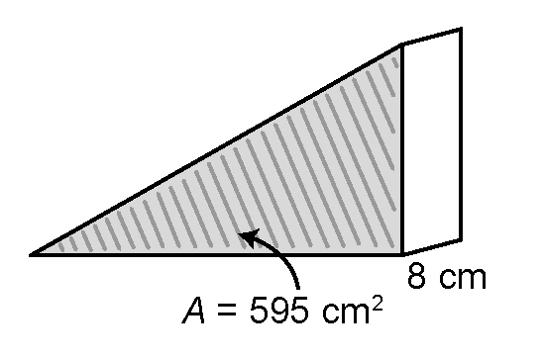
1. Determine the volume of each rectangular prism.
a) | 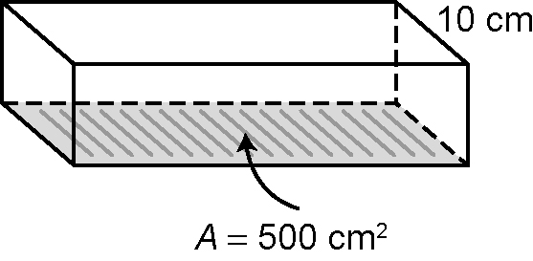 | b) | 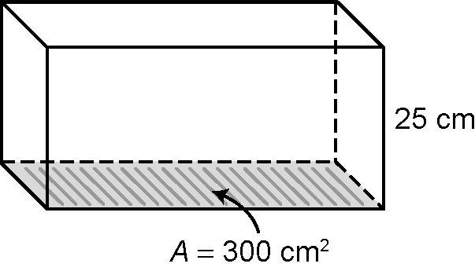 | c)
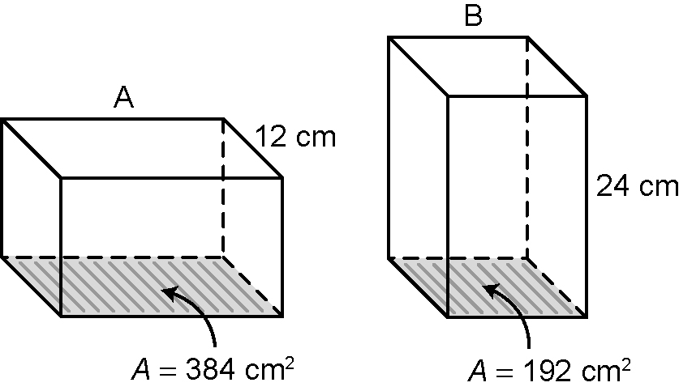
2. a) What is the volume of Box A?

b) What is the volume of Box B?

c) Are their volumes the same? Explain.
_____________________________________________________________
_____________________________________________________________

3. What is the height of each rectangular prism?
a) volume = 108 cm³, area of base = 12 cm² ____________________
b) volume = 80 cm³, area of base = 16 cm² ____________________
c) area of base = 110 cm², volume = 110 cm³ ____________________

4. The Canola Oil Company is designing cans for its oil. Their cans hold 1 L, which is 1000 cm³. The area of the base of their can is 80 cm². How tall is the can? Show your answer to one decimal place.

