Section 7.2 Extra Practice
1. Determine the volume of each cube.
a) | 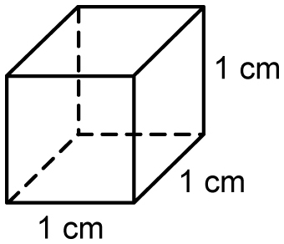 | b) | 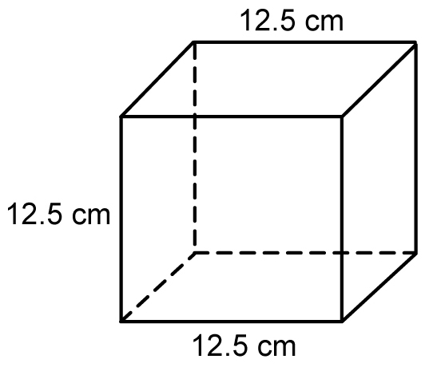 | c) | 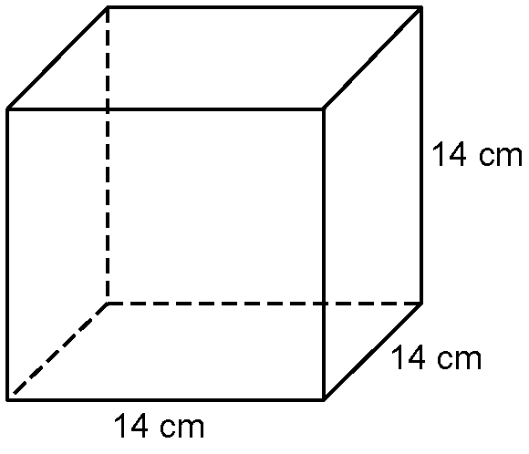
2. What is the volume of each right triangular prism?
a) | 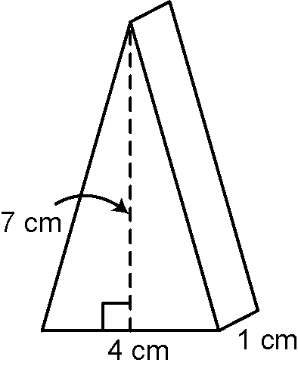 | b) | 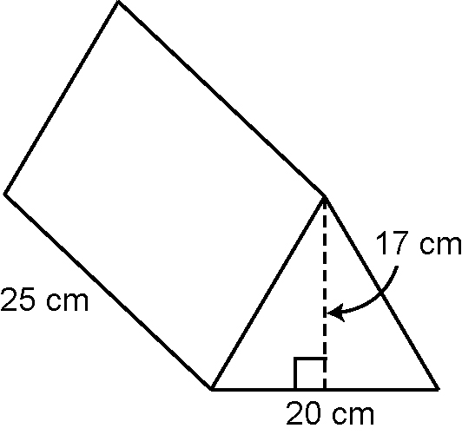 | c) | 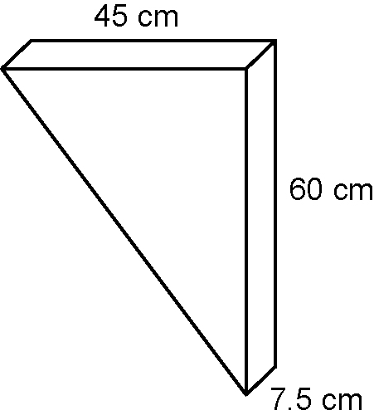

3. Determine the volume of the contents of each right prism.
a) full  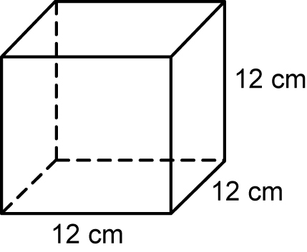 | b) full  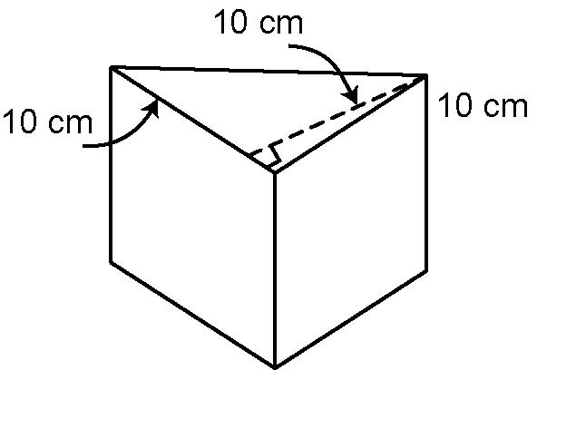 | c) full  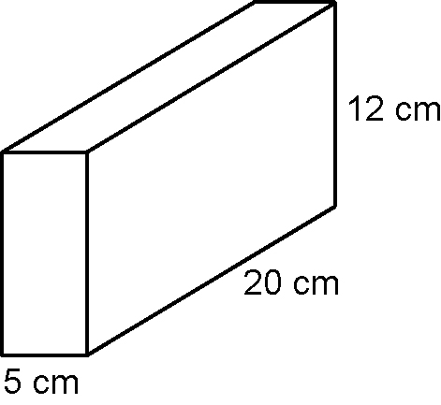
4. What is the area of the base of each right triangular prism?
a) volume = 90 cm³, height = 10 cm
b) volume = 864 cm³, height = 6 cm
c) volume = 1 cm³, height = 1 cm

