Section 7.2 Math Link
This worksheet will help you with the Math Link on page 261.

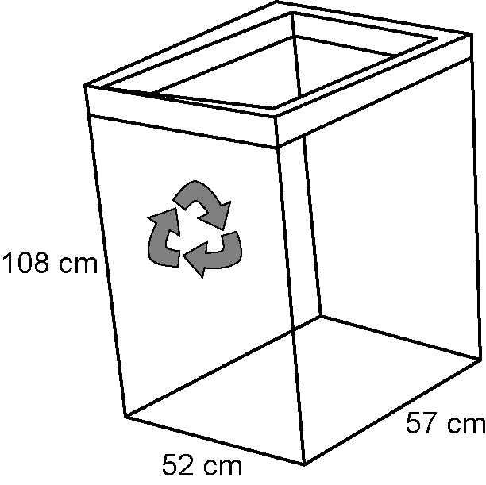
The Parks Committee is considering putting
these recycling bins throughout the park.

1. What is the shape of this bin?
____________________
2. What is the volume of the bin?
Show your calculations.

3. Twelve of these bins are placed in the park. What is the total volume of the 12 bins? Show your calculations.

4. The 12 bins are filled to the top and emptied twice each week. What is the total volume of waste recycled each week? Show your calculations.

