Section 7.3 Extra Practice
For #1 to #3, show your calculations in your notebook.
1. Determine the volume of each cylinder.
a) | 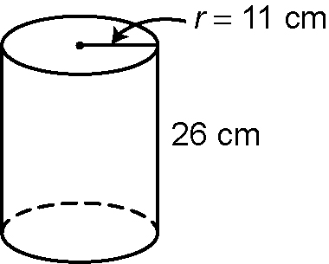 | b) | 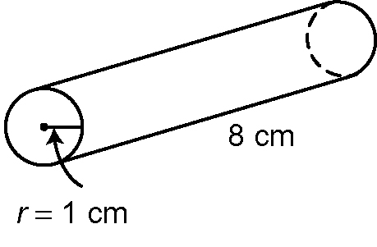 | c) | 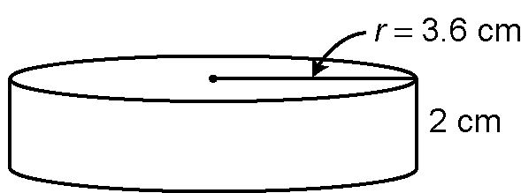
2. What is the volume of each cylinder?
a) | 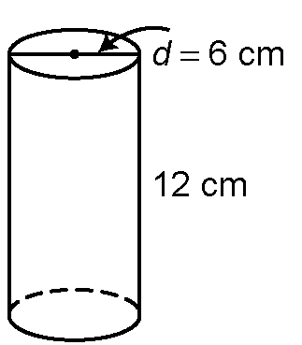 | b) | 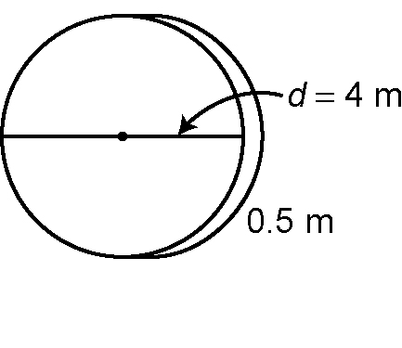 | c) | 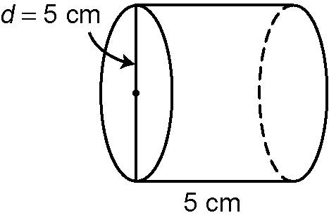

3. What is the radius of each cylinder?
a) height = 10 cm, volume = 502.4 cm³
b) height = 8 cm, volume = 1230.88 cm³
c) height = 5 cm, volume = 2653.3 cm³
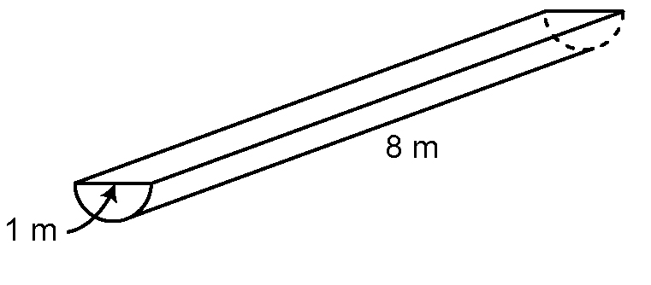
4. Determine the volume of this
semi-circular trough.

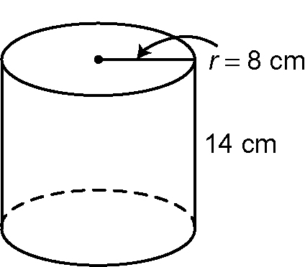
5. Avery thinks that if you want to double the
volume of this cylinder, you must double the
height of it. Monica believes that to double the
volume, you must double the radius. Prove
who is right.

